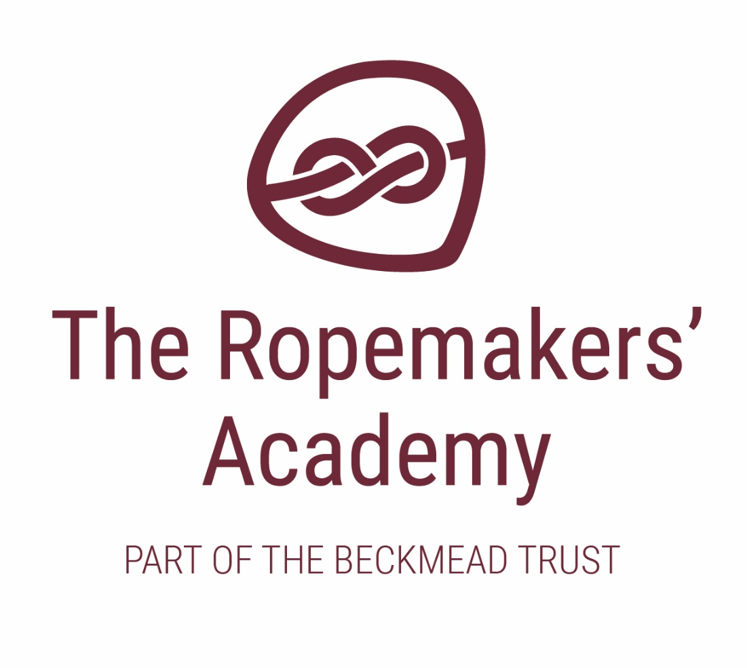

EQUALITY POLICY & OBJECTIVES

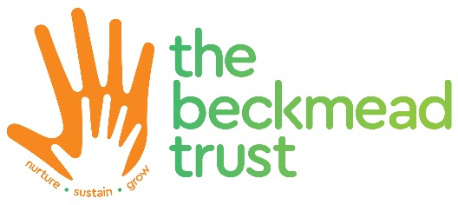

Name of Policy | Equality Information and Objectives
Policy Level | Trust
Date of Issue | July 2018
Author | Board of Trustees
Date of Next Review | January 2022
Signature | Dr Jonty Clark
Date of Signature | September 2018

Table of Contents
1. Aims 4
2. Legislation and guidance 4
3. Roles and responsibilities 4
4. Eliminating discrimination 5
5. Advancing equality of opportunity 5
6. Fostering good relations 6
7. Equality considerations in decision-making 6
8. The Beckmead Trust Equality objectives 6
9. Monitoring arrangements 7
10. Links with other policies 7

1. Aims
The Ropemakers’ Academy aims to meet its obligations under the public sector equality duty by having due regard to the need to:
- Eliminate discrimination and other conduct that is prohibited by the Equality Act 2010
- Advance equality of opportunity between people who share a protected characteristic and people who do not share it
- Foster good relations across all characteristics – between people who share a protected characteristic and people who do not share it.

2. Legislation and guidance
This document meets the requirements under the following legislation:
- The Equality Act 2010, which introduced the public sector equality duty and protects people from discrimination
- The Equality Act 2010 (Specific Duties) Regulations 2011, which require Schools to publish information to demonstrate how they are complying with the public sector equality duty and to publish equality objectives.
This document is also based on Department for Education (DfE) guidance: The Equality Act 2010 and Schools.
This document also complies with our funding agreement and articles of association.

3. Roles and responsibilities

The Board of Trustees/Local Governing Body will:
- Ensure that the equality information and objectives as set out in this statement are published and communicated throughout the School, including to staff, pupils and parents/carers, and that they are reviewed and updated at least once every four years
- Delegate responsibility for monitoring the achievement of the objectives on a daily basis to the Headteacher
- Meet with the designated member of staff for equality every [frequency], and other relevant staff members, to discuss any issues and how these are being addressed
- Ensure they’re familiar with all relevant legislation and the contents of this document
- Attend appropriate equality and diversity training
- Report back to the full Board of Trustees/Local Governing Body regarding any issues.

The Headteacher will:
- Promote knowledge and understanding of the equality objectives amongst staff and pupils
- Monitor success in achieving the objectives and report back to governors.

The designated member of staff for equality will:
- Support the Headteacher in promoting knowledge and understanding of the equality objectives amongst staff and pupils
- Meet with the equality link governor every [frequency] to raise and discuss any issues (delete if not applicable)
- Support the Headteacher in identifying any staff training needs, and deliver training as necessary.
All School staff are expected to have regard to this document and to work to achieve the objectives as set out in section 8.

4. Eliminating discrimination
The School is aware of its obligations under the Equality Act 2010 and complies with non-discrimination provisions.
Where relevant, our policies include reference to the importance of avoiding discrimination and other prohibited conduct.
Staff and governors are regularly reminded of their responsibilities under the Equality Act, for example during meetings. Where this has been discussed during a meeting it is recorded in the meeting minutes.
New staff receive training on the Equality Act as part of their induction, and all staff receive refresher training every September.
The School has a designated member of staff for monitoring equality issues. This is presently the Headteacher, Simon Hawthorne.

5. Advancing equality of opportunity
As set out in the DfE guidance on the Equality Act, the School aims to advance equality of opportunity by:
- Removing or minimising disadvantages suffered by people which are connected to a particular characteristic they have (e.g. pupils with disabilities, or gay pupils who are being subjected to homophobic bullying)
- Taking steps to meet the particular needs of people who have a particular characteristic (e.g. enabling Muslim pupils to pray at prescribed times)
- Encouraging people who have a particular characteristic to participate fully in any activities (e.g. encouraging all pupils to be involved in the full range of School societies)
In fulfilling this aspect of the duty, the School will:

- Publish attainment data each academic year showing how pupils with different characteristics are performing
- Analyse the above data to determine strengths and areas for improvement, implement actions in response and publish this information
- Make evidence available identifying improvements for specific groups (e.g. declines in incidents of homophobic or transphobic bullying)
- Publish further data about any issues associated with particular protected characteristics, identifying any issues which could affect our own pupils.

6. Fostering good relations
The Ropemakers’ Academy aims to foster good relations between those who share a protected characteristic and those who do not share it by:
- Promoting tolerance, friendship and understanding of a range of religions and cultures through different aspects of our curriculum. This includes teaching in RE, citizenship and personal, social, health and economic (PSHE) education, but also activities in other curriculum areas. For example, as part of teaching and learning in English/reading, pupils will be introduced to literature from a range of cultures
- Holding assemblies dealing with relevant issues. Pupils will be encouraged to take a lead in such assemblies and we will also invite external speakers to contribute
- Working with our local community. This includes inviting leaders of local faith groups to speak at assemblies, and organising school trips and activities based around the local community
- Encouraging and implementing initiatives to deal with tensions between different groups of pupils within the school. For example, our school council will have representatives from different year groups and is formed of pupils from a range of backgrounds. All pupils are encouraged to participate in the school’s activities, such as sports activities. We also work with parents/carers to promote knowledge and understanding of different cultures
- We have developed links with people and groups who have specialist knowledge about particular characteristics, which helps inform and develop our approach.

7. Equality considerations in decision-making
The Ropemakers’ Academy ensures it has due regard to equality considerations whenever significant decisions are made.
The school always considers the impact of significant decisions on particular groups. For example, when a school trip or activity is being planned, we consider whether the trip:
- Cuts across any religious holidays
- Is accessible to pupils with disabilities
- Has equivalent facilities for boys and girls.
The school keeps a written record (known as an Equality Impact Assessment) to show we have actively considered our equality duties and asked ourselves relevant questions. This is recorded at the same time as the risk assessment when planning School trips and activities. The record is completed by the member of staff organising the activity and is stored electronically with the completed risk assessment.

8. The Ropemakers’ Academy Equality Objectives
We are required to publish equality objectives that we will work to fulfil, to indicate what we are actively doing in school to improve equality across the academy.
The Headteacher will work with the school community to promote and fuldil these objectives, which will be reviewed at least annually to ensure that they are representative of the school community and their needs.

Our objectives from September 2020 are as follows:
Objective: | Target group(s): | Action: | Who’s responsible? | By:  from and to:
For pupils to understand they have rights, how they can exercise their rights and understand how rights link to responsibilities | All pupils and staff | To ensure that all school systems are shared and communicated to pupils, and to set out pupil rights through PSHE curriculum and pastoral events | Headteacher & Teaching Staff | June 2021
Increase the diversity of pupils/students involved in the  decision-making processes of the school | Minority, marginalised and vulnerable pupils/students | Ensure the formation of a School Council and/or pupil voice processes within the school, and that it represents all groups  Produce pupil survey with suitable accessibility | Headteacher | Dec 2020  June 2021
Identification of equalities training needs in relation to protected  characteristics  Improved data collection and analysis on staffing issues  Staff reporting improved sense of inclusion | Applicants and all school staff including volunteers | Work with ESCC Equalities and School Heath Profile team to ensure good quality data collection of school community.  Work with BMT HR team to gather equality information relating to staff  Analysis of staff training completed in relation to equality | Headteacher/ESCC Equality Team/ES School Health team | July 2021
Improved ability by  pupils/students to  handle difficult  situations and a  reduction in classroom  disruption | Pupils/students with social,  emotional and mental health  needs. | Train staff to deliver small group work sessions to  support targeted  pupils/students in  developing social and  emotional skills | Headteacher/  selected staff

9. Monitoring arrangements

This policy document and the objectives will be reviewed by Board of Trustees/LGB at least annually, and will be approved by the Headteacher. In addition, the Headteacher will ensure that equality impact assessment is an ongoing process, with the results shared with the school community, including the Board of Trustees/LGB annually.

10. How we will conduct equality impact assessment

As a school we carry out rigorous ongoing monitoring and analysis of all pupils and their progress which is reported in termly and annually so the Headteacher, Board of Trustees/LGB and class teachers can use the information to ensure the appropriate progress is made by all pupils regardless of race, disability, socio-economic background, belief or gender. Through analysis by the Head teacher, SLT, SENDCO and Subject leaders we are aware of any groups or individuals who are not making at least expected progress.

Evidence of this process will be found on the school tracking system, teacher’s assessment

records and on the School Development Plan.

In addition, we will use the following activities and communication streams to communicate and monitor the impact of our equality processes and our progress towards our objectives:

Our pupils/students

• School Council meetings – monthly

• Pupil Voice Questionnaires

• PSHE – Circle Time

Our Staff

• Teaching Assistant meetings – monthly (includes MDSAs)

• Staff Meetings – weekly

Our School Governors

• Full Governing Body meetings

• School Visits by appropriate Governor to monitor implementation of Equalities Policy

Parents/Carers

• Parent Questionnaire

• Newsletters

• School Website

• Parent Consultation Meetings

11. Links with other policies
This document links to the following policies:
- Accessibility plan
- Risk assessment.

