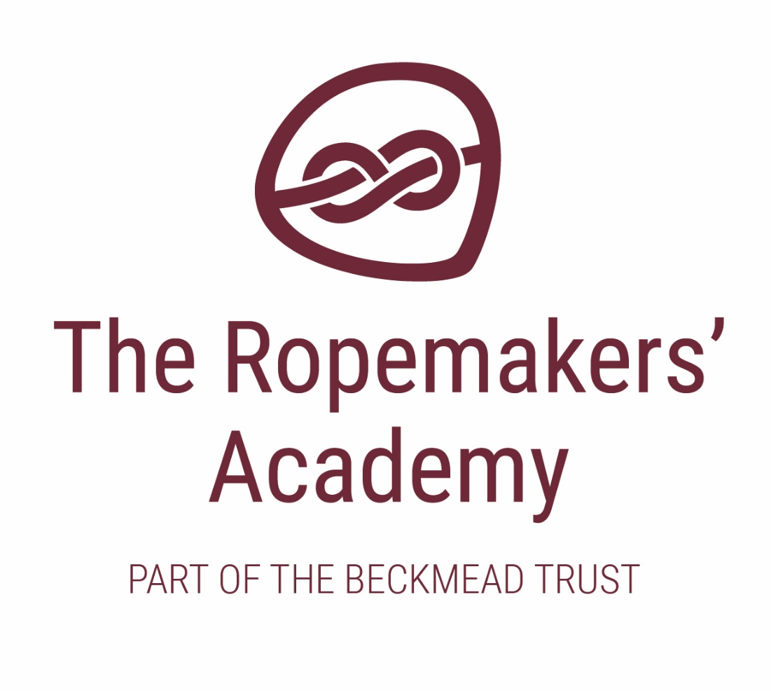

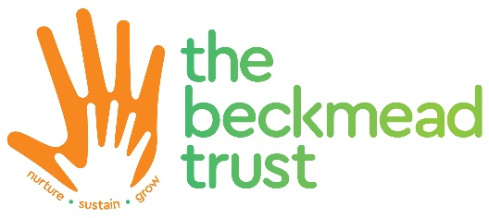
CURRICULUM POLICY

ACADEMIC YEAR | AUTHOR | ROLE | DATE OF NEXT REVIEW
2020-21 | Simon Hawthorne | Headteacher | September 2021

Introduction
The Ropemakers’ Academy curriculum includes all the planned activities that are organised in order to promote learning, personal growth and development of the whole child. It comprises not only the formal requirements of the National Curriculum, but also the wide range of activities that the school organises in order to enrich the experience of our children. At the heart of this across the family of schools, is a nurturing based education.
This policy sets out the broad curriculum offer and approaches with more detailed subject specific outlines for each school site available through the school website, for example the range and content of accredited KS4 courses currently offered is available on the school website.
The curriculum across the Beckmead Trust, which The Ropemakers’ curriculum reflects, is evolving according to the needs of our children and to the aspirations of the staff and the local community of each of the school, and we are continually reviewing and improving the curriculum we offer to our children to ensure we remain focused on this.

Values
Our curriculum is underpinned by the core shared values that run across each all school sites. The curriculum is the means by which the school achieves its objective of educating children in the knowledge, skills and understanding that they need in order to lead fulfilling lives. We value children’s uniqueness, we listen to the views of individual children, and we promote respect for diverse cultures. We value the spiritual and moral development of each person, as well as their intellectual and physical growth.
We value the importance of each person in our community, and we organise our curriculum to promote inclusion, cooperation and understanding among all members of our community. We value the rights enjoyed by each person in our society. We respect each child in our school for who they are, and we treat them with fairness and honesty.
We want to enable each person to be successful, and we provide equal opportunities for all our pupils. We will strive to meet the needs of all our children, and to ensure that we meet all statutory requirements regarding inclusion. We value our environment, and we want to teach our pupils, through our curriculum, how we should take care of the world, not only for ourselves, but also for future generations.

British Values
At The Ropemakers’ Academy, we actively promote a culture of mutual respect and tolerance, democracy, the rule of law, equal opportunities and freedom. British values permeate throughout the school curriculum and support the development of the whole child. Further information on the delivery of this can be found in the SMSC overview.

Aims and objectives
We aim to teach children how to grow into positive, responsible people, who can work and co-operate with others while developing their knowledge and skills, so that they can realise their true potential.
- to enable all children to learn and develop their skills to the best of their ability
- to be able to live and work co-operatively with others.
- to promote a positive attitude towards learning, so that children enjoy coming to school, and acquire a solid basis for lifelong learning
- to fulfil all the requirements of the National Curriculum and the East Sussex Agreed Syllabus for Religious Education
- to teach children the basic skills of Maths, English, science and computing
- to enable children to be creative and to develop their own thinking
- to enable children to be positive citizens in their community and wider society
- to enable children to have respect for themselves and high self-esteem

Organisation and Planning
A nurture based education is central to our approach across the Beckmead Trust and as such has an effect on how we organise, deliver and plan the curriculum at The Ropemakers’ Academy. Each class operates in a way that attends to the nurture needs of the children within it. With the younger children this is based on the traditional nurture group model where the majority of teaching and learning is delivered by the same, familiar teacher and two teaching assistants. This approach becomes gradually less formalised as the children progress up the school such that in key stage 4 elements of nurture are incorporated into a more traditional class format. Here students transition to specialist teachers and facilities in order to access the curriculum according to their individual curriculum pathway.
The curriculum is broadly planned in three phases. We agree a long-term outline for each key stage. In the primary phase this indicates what topics are to be taught in each term, and to which groups of children. In the secondary phase at KS4 this will denote the curriculum offer in particular access to accredited courses.
Our medium-term plans, give clear detailed guidance on the objectives and teaching strategies that we use when teaching each topic or subject. Our short-term plans are those that our teachers write on a weekly basis. These set out the learning objectives for each session, and identify what resources and activities we are going to use in the lesson.
Primary
Our curriculum aims to facilitate the teaching of children with SEMH as set out in the schools vision statement. The curriculum is a driver for children to develop their communication skills, social skills, manage their own feelings and behaviour and to make good choices with adult support.
The curriculum is delivered through nurture based classes of 6-7 pupils with one teacher and two teaching assistants. Other professionals such as Speech, Play (including sand play therapy), Occupational and Music therapists contribute not only through specific therapeutic interventions but also by supporting identified curriculum areas for example the pre-teaching of subject or topic specific vocabulary by a SaLT.
The primary curriculum is planned as separate subjects in accordance with the objectives outlined within the National Curriculum. The aim of our primary curriculum is to provide creative, interesting and accessible lessons across the family of schools. Each year group has specific topics and objectives to be taught. The long term plans provide the outcomes, for each topic, to support planning and ensure consistency.
English is taught through a text led approach where teachers base English work around a shared book or text. The English long-term plan identifies the genres to be taught in each year group in order to avoid repetition and enable progression. We constantly update our text sources using recommendations from the CLPE database. In addition teachers supplement this through individualised daily interventions strategies including Read write Inc., Rapid Phonics, Toe by Toe and precision teaching for spellings.
Maths is taught through the online Abacus scheme with teachers individualising planning to take account of the wide range of need. In line with literacy, specific 1-1 interventions are put in place to boost the achievement for pupils in maths.
Our primary curriculum offers:
• Daily English and maths lessons across all primary sites.
• Science Lessons delivered from the Pearson's Science Bug schemes of work. Teachers adapt the planning and resources to where necessary.
• Computing taught using the Switched on Computing ICT schemes of work by Rising Stars.
• Foundation subjects taught through school specific schemes of work
• RE delivered in line with the East Sussex agreed syllabus including celebrating the main religious festivals in weekly assemblies.
• Weekly food technology lessons themed to develop knowledge of different food and cooking techniques and skills.
• Weekly enrichment activities (some offsite) such as Forest skills, swimming, horse riding, community safety and awareness (year 6) and cycling.
• Weekly social skills sessions.
• Weekly PSHE lessons taught through bespoke PSHE scheme of work using a range of resources for different age groups which include Kaleidoscope, Learning 4life, NSPCC materials, ASDAN and others
• Enrichment and themed weeks are also planned throughout the year for special events such as Internet Safety, Anti-bullying and Black History.

Secondary Key stage 3 and 4
The secondary curriculum is the next stage in the learning and development of pupils within the Beckmead Family of Schools. Building on the core elements of the primary plan, the secondary phase looks to introduce new skills, develop and build on existing ones, develop more flexibility ways of learning and provide qualification routes. Ultimately we are aiming to enable all our pupils to work towards achieving a range of appropriate qualifications that will allow them to access post 16 education, apprenticeships and work.
In KS3 the curriculum is delivered, as in primary, through nurture classes with 6-7 pupils being led by a team of one teacher and 2 teaching assistants. For specialist subjects, including Science, art, and Food technology students are able to access the specialist areas away from the nurture classroom environment. As well as the benefits of accessing teachers with specialist subject specific knowledge this also helps promote more flexible learning for our students gradually becoming more familiar with being taught by differing adults.
As with the primary area of the family, other professionals such as Speech, Play, Occupational and Music therapists contribute not only through specific therapeutic interventions but also by supporting identified curriculum areas. SaLT is also available to specific pupils based on their needs or through group based social communication lessons; this is particularly relevant for our pupils with ASD.
In KS4, pupils study a broad core curriculum comprising of Maths, English, Science, IT, citizenship, PE and vocational learning then 2 additional option subjects. The specific makeup of the KS4 curriculum offer varies each year depending on the nature of the learning needs of the pupils in the year 10 and 11 year group. Accredited courses are appropriate to the needs of the learners across the key stage with qualifications ranging from Entry Level through to GCSE. All Key stage 4 pupils also access vocational based learning course in specialist vocational areas including catering, brick laying, motor mechanics, painting and decorating, multi-skills and carpentry. These courses run over 2 years and pupils are able to utilise them in developing pathways into further education and develop more work based skills.
Specialised staff support pupils with the college application process linking with local colleges and our own Post 16 provision to enable successful application for pupils.
The secondary curriculum offer may differ slightly from site to site but this has been broadly summarised in the tables below:

Year 7,8 & 9

Subject | Lessons in a week
English | 5
Maths | 5
Science | 2 (3 in Yr9)
ICT | 1
PE/Sport | 2
Humanities (History, Geography, RE, Drama) | 2
PSHE/Citizenship | 2
Art | 2
Carousel (Including Music, Design/Tech, Graphics) | 2
Food Tech | 2
Golden Time | 1
Assembly | 1
Intervention & IEP Targets | 1
Offsite / Enrichment (horse riding, sailing, gym, swimming, allotment, theatre) | 2
TOTAL | 30

Year 10 +11

Subject / Qualification | Lessons in a week
English (Entry Level / Functional Skills / GCSE) | 5
Maths (Entry Level / Functional Skills / GCSE) | 4
Science (Entry Level / GCSE) | 4
ICT (Functional Skills) | 1
PE/Sport (not assessed) | 1
ASDAN AoPE | 2
Enterprise (BTEC) | 3
OPTION: Art (GCSE) or Media (BTEC L1/L2) or Sport (BTEC L1/L2 | 3
Hospitality and Catering (ABC) - College | 3
Construction – (carpentry, brick laying, multi-skills) (ABC) – College | 3
Reflection, Targets and Reward Time | 1
TOTAL | 30

Monitoring and Review
The Local Governing Body’s Curriculum Committee is responsible for monitoring the way the school’s curriculum is implemented. The class teacher is responsible for the day to day organisation of the curriculum. The head of each school and or the assistant head monitor the lesson planning of all teachers during the year.
The governing body will receive an annual report on:
- The standards reached in each subject compared with national benchmarks
- The standards achieved at the end of each key stage taking into account any important variations between groups of pupils, subjects, courses and trends over time, compared with appropriate benchmarks

