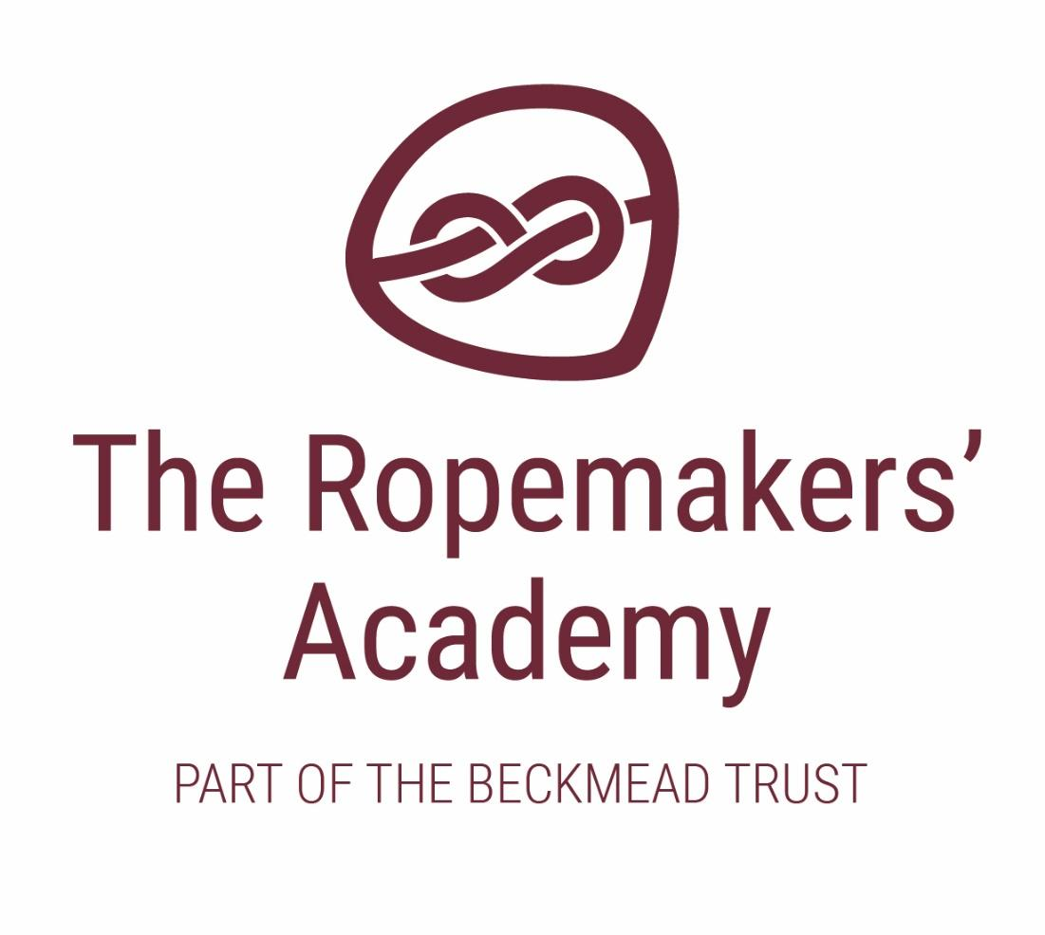

COMPLAINTS POLICY

ACADEMIC YEAR | AUTHOR | ROLE | DATE OF APPROVAL AND NEXT REVIEW
2020-21 | Simon Hawthorne | Headteacher | Approved by the LGB 25 March 2021  Next Review - March 2022

Introduction

At The Ropemakers’ Academy we actively welcome the views and opinions of all members of our community.

From time to time parents, carers, and others connected with The Ropemakers’ Academy will become aware of matters which cause them concern. To resolve such situations, the Board of Governors has a school complaints procedure.

This procedure does not apply to issues concerning admissions, exclusion appeals or grievances by staff. These are the subject of separate complaints procedures. Copies of these procedures can be obtained from the school office.

The Ropemakers’ Academy will give careful consideration to all expressions of concern and complaints and will deal with them fairly and honestly. We will provide sufficient opportunity for any concern or complaint to be fully discussed, and aim to resolve it through open dialogue and mutual understanding.

For the purposes of clarity, the term ‘Board of Governors’ will apply to the Beckmead Board of Trustees until such time as they ratify a scheme of delegation to an appointed Local Governing Body. This policy will be updated accordingly when this happens.

The intention of this procedure is that it should:

- Usually be possible to resolve your concerns by informal means;
- Be straight forward for you to use and understand
- Respect your desire for confidentiality and impartiality
- Allow your concerns and complaints to be handled swiftly, with established time limits
- Keep you informed of progress throughout the process using correct procedures
- Address all the points of your concern or complaint, providing an effective response
- Inform future practice in The Ropemakers’ Academy and across the Trust’s schools so that the concern is unlikely to recur.

General principles:

- This procedure is intended to allow you to confidently raise a concern or complaint relating to The Ropemakers’ Academy, or the services that it provides.
- To enable a proper informed investigation, concerns or complaints should be brought to the attention of The Ropemakers’ Academy as soon as possible. (In general, any matter raised more than 3 months after the event, being complained of, may not be considered except in special circumstances.)
- An anonymous concern or complaint will not be investigated under this procedure, unless there are exceptional circumstances.
- The Ropemakers’ Academy will treat your concern or complaint as confidential and you are asked to do likewise.

Raising a concern or complaint

Informal stage

- It is normally appropriate to communicate directly with the member of staff concerned. Many concerns, worries or doubts can be resolved by clarification or providing information. It is anticipated that most complaints will be quickly resolved informally.

- With more serious concerns, a request for an informal discussion with the Headteacher may be desirable before making a formal complaint (or the Chair of Governors if the concern is about the Headteacher). A request for an informal meeting form is provided to assist you. (APPENDIX 1) This should be addressed to the Headteacher (or Chair of Governors) via The Ropemakers’ Academy, Reef Way, Hailsham, BN27 1FB. Please give as much detail as possible about your concern so that a decision can be made about asking anyone else to attend the meeting.

If you are uncertain about who to contact, please seek advice from The Ropemakers’ Academy office or the clerk to the Board of Governors.

The Headteacher (or Chair of Governors) will invite you to a meeting to clarify your concerns and to explore the possibility of an informal resolution. If you accept that invitation, you may be accompanied by a friend, if you wish, to assist you in explaining the nature of your concerns. In most cases a meeting will be arranged with five school working days from the receipt of the letter.

If you feel that your concern has been explained satisfactorily or a shared understanding has been reached, it is possible that your complaint will be resolved informally through the meeting with the Headteacher (or Chair). Most concerns are resolved informally.

Formal stage 1

If your concern or complaint is not resolved at the informal stage you may choose to put a formal complaint in writing and send it to the Headteacher, who will be responsible for ensuring that it is investigated appropriately.

If the complaint is about the Headteacher, your formal complaint should be sent to the clerk to the board of Governors, for the attention of the Chair of The Ropemakers’ Academy Local Board of Governors.

A complaint form is provided to assist you. (APPENDIX 2) You should include details which might assist the investigation, such as names of potential witnesses, dates and times of events, and copies of relevant documents. The Headteacher (or Chair) may invite you to meet them as part of the formal investigation process. It is very important that you include a clear statement of the actions that you would like The Ropemakers’ Academy to take to resolve your concern.

Please pass the completed form, and any other papers you wish to include, in a sealed envelope to The Ropemakers’ Academy Office, Reef Way, Hailsham, East Sussex, BN27 1FB. The envelope should be addressed to the Executive Head teacher, or to the clerk to the Board of Governors, as appropriate. The receipt of your complaint will be recorded and your complaint will be acknowledged within two school working days.

Arrangements will be made for the matter to be fully investigated. Any investigation will begin as soon as possible. You will be informed in writing of the anticipated timescale for the completion of the investigation, which would normally be within fifteen school working days. When it has been concluded, you will be informed in writing of the outcome.
If it becomes apparent that the complaint is a staff disciplinary or capability issue, then the matter will be dealt with by following the appropriate procedure rather than the complaints procedure. You will be notified if this is the case with your complaint, but you are not entitled to know which procedure or the final outcome.

Formal stage 2

If your complaint was investigated by the Headteacher and you are not satisfied with the outcome of your complaint, you may write to the Chair of Governors requesting that the board of Governors reviews the process followed by The Ropemakers’ Academy, in handling the complaint. You may ask that a further investigation is carried out and outlining the reasons why you are not satisfied. Any such request should be made within ten school working days of receiving notice of the outcome. It should include a statement specifying the failures to follow the procedure which have caused you to seek a review. A Review Request form is provided for your convenience and you may include additional documents if you wish.

Any review request that is based solely on dissatisfaction with the outcome, rather than an identified failure to deal with a complaint according to procedure, will not be accepted.

The Chair of Governors will make arrangements for the matter to be investigated (this may be the Chair or another governor who has not been involved in the process previously) and arrange access to the records of the investigation carried out by the Headteacher. Any investigation will begin as soon as possible. You will be informed in writing of the anticipated timescale for the completion of the investigation, which would normally be within fifteen school working days.

You will then be informed as to when the panel will meet to consider the complaint and you will be invited to attend. Notes of the meeting, for the use of the panel, will be taken by the clerk to the Governors. When it has been concluded, you will be informed in writing of its outcome.

If your complaint was about the Headteacher, therefore the Chair of Governors has already conducted the investigation, you may write to the clerk to the Governors requesting that a panel of Governors investigate the complaint and outlining the reasons why you are not satisfied with the outcome of your complaint. The clerk to the Governors will make arrangements for the matter to be investigated and the panel will also have access to the records of the investigation carried out by the Chair of Governors. Any investigation will begin as soon as possible. You will be informed in writing of the anticipated timescale for the completion of the investigation, which would normally be within fifteen school days, and when the panel will meet to consider the complaint. You will be invited to attend. Notes of the meeting, for the use of the panel, will be taken by the clerk to the Governors. When it has been concluded, you will be informed in writing of its outcome.

Board of Governors Review process

The review of the process followed by The Ropemakers’ Academy will be conducted by a panel of three members of the Board of Governors who have not been previously involved in the complaint. (In exceptional circumstances an independent governor may be on the panel) This will usually take place within fifteen Beckmead Family of Schools working days of receipt of a written review request.

Persons invited to the review meeting will be yourself and accompanying person, the panel of three Governors, the investigator, Headteacher and the clerk to Governors.

The review will usually be conducted through a consideration of written submissions, and Governors will invite you and your accompanying person to The Ropemakers’ Academy Board of Governors review meeting. Written evidence from all parties concerned will be shared in a Hearing Pack at least five school working days with everyone involved. You may make oral representations to the panel and this will be supported sympathetically. The Executive Headteacher may also request to make oral representations to the panel. The panel will give consideration to any witnesses that either party wish to be interviewed by the investigator or attend the relevant part of the hearing.

The procedure adopted will be:

- The panel will receive your written review request form and any other written evidence which you include.
- The panel will invite representatives of The Ropemakers’ Academy (usually the Headteacher and/or the Chair of Governors/investigating officer), as appropriate, to make a written response to the complaint.
- The panel will also access the records kept of the previous stages of the complaints process followed.
- The panel will let you know when your complaint is to be considered. You will be invited to meet them, you will be given seven school working days’ notice. As the panel meeting is intended to review the investigation process, examine additional evidence and establish a satisfactory outcome. Notes of the meeting, for the use of the panel, will be taken by the clerk to the Governors.
- The complaints’ panel will make their decision in private and write to you with their findings and any recommendations within five school working days from the date of the meeting.

The matter will then be closed as far as The Ropemakers’ Academy is concerned.

Record keeping

Notes will be taken of any meetings, telephone calls or written communication which takes place during the concerns/complaints process. These will be confidential to those involved but will be made available to Governors’ panels in the event of a review being requested. The Clerk to Governors will maintain the Governor Review Panel hearing notes and evidence in a separate file.

Serious and Persistent Complaints

There are occasions when persons behave in an unreasonable manner when raising and/or pursuing concerns. The consequences are that their actions begin to impact negatively on the day-to-day running of The Ropemakers’ Academy and directly or indirectly the overall well-being of the children or staff in The Ropemakers’ Academy.

Department of Education Complaints

Making a complaint to the Department should only happen once other routes have been followed. If you feel your complaint is still unresolved then you can forward your complaint to the Department for Education via their online complaints form.

Monitoring and review

The Local Board of Governors and the Headteacher monitor the Complaints Procedure, in order to ensure that all concerns and complaints are handled properly. They will also consult with the main Beckmead Trust Board of Trustees.
The Headteacher will examine logs of all concerns and complaints and analyse any trends. The school leadership team will discuss these trends and decide on any action that may be needed.

The Headteacher logs all formal complaints received by The Ropemakers’ Academy and records how they were resolved. Governors examine this log on a termly basis and consider the need for any changes to the Procedure.

Availability

A copy of this policy is available to all parents and carers on request and is also on The Ropemakers’ Academy website.

Addendum (Jan 2021) - Handling Complaints during the coronavirus outbreak

We acknowledge that the pressures caused by coronavirus (COVID-19) might affect schools’ usual processes and timescales for complaints. However, schools should still consider complaints, particularly those relating to the provision of remote education. Guidance to support effective delivery of remote education is available.

Contact your local council or call the police on 101 if you’re told a child is at risk.

Schools and complainants can contact DfE for more information about school complaints.

Ofsted will consider complaints from parents that relate to the school as a whole. This includes complaints about:

- the quality of education being provided, including remote education
- pupils’ wellbeing and safety

Ofsted normally expects parents to seek to resolve any concerns with the school in the first instance.

APPENDIX 1
The Ropemakers’ Academy Complaints Procedure
Please complete and return to the Executive Headteacher or the Chair of Governors who will acknowledge receipt and explain what action will be taken.

Informal Meeting Request Form
I wish to meet to discuss the following matter:
Brief details of topic to be discussed
Dates/times when it would be most convenient for a meeting
Your name:
Pupil’s name:
Your relationship to the pupil:
Address:

Postcode:
Day time telephone number: Evening telephone number: Email address:
Office use
Date form received: Date acknowledgement sent:
Received by: Sent by:

APPENDIX 2
Please complete and return to the Headteacher or the Chair of Governors who will acknowledge receipt and explain what action will be taken.

Formal Concern and Complaint Form
Pupil’s name:
Your relationship to the pupil:
Address: | Day time telephone number:
 | Evening telephone number
 | email address:
Postcode:
Please give details of your concern or complaint (including dates, times, details of witnesses etc) to allow the matter to be fully investigated) :

You may continue on separate sheets or add any documents, if you wish
Number of additional sheets attached:

What action have you already taken to try and resolve your concern or complaint? Who did you speak to and what was the response?
What actions do you feel might resolve the problem at this stage?
Signature: | Date:
THE ROPEMAKERS’ ACADEMY ADMIN USE

Date received: | By whom:
Date acknowledgement sent: | By whom:
Complaint referred to: | By whom:

APPENDIX 3
Board of Governors Panel Review Request Form
Please complete and return to the Headteacher or the Chair of Governors who will acknowledge receipt and explain what action will be taken.

Pupil’s name:
Your relationship to the pupil:
Address: | Day time telephone number:
 | Evening telephone number
 | email address:
Postcode:
Dear

I submitted a complaint to The Ropemakers’ Academy on …………………………………………….
and I am dissatisfied by the procedure that has been followed.
My complaint was submitted on and I received a response from
…………………………………………………….. on …………………………………………
I have attached copies of my formal complaint and the response(s) received from The Ropemakers’ Academy.
I am dissatisfied with the way the procedure was carried out because:

You may continue on separate sheets or add any documents, if you wish
Number of additional sheets attached:

What actions do you feel might resolve the problem at this stage?
Signature: | Date:
THE ROPEMAKERS’ ACADEMY USE

Date received: | By whom:
Date acknowledgement sent: | By whom:
Complaint referred to: | By whom:

Appendix 4 Concerns and Complaints not within the scope of the procedure
Our Complaints Procedure will cover all complaints about any provision of facilities or services that a school provides with the exceptions listed below. The separate statutory procedures that apply to the exceptions are listed below.

Complaints not within the scope of the Complaints Procedure
Exceptions | Who to contact
- Admissions to schools  - Statutory assessments (EHCP)  - School re-organisation proposals  - Matters likely to require a Child Protection Investigation | Concerns should be raised direct with local authorities (LA).  The LA is the admissions authority for Beckmead.
- Exclusion of pupils from school | Further information about raising concerns about exclusions can be found at: www.gov.uk/school-school- exclusions/exclusions
- Whistleblowing | - The school has an internal whistleblowing procedure for their employees and voluntary staff.  - Other concerns should be raised direct with Ofsted by telephone on: 03001233155, via email at: whistleblowing@ofsted.gov.uk or by writing to:  WBHL, Ofsted Piccadilly Gate Store Street  Manchester M1 2WD.  - The department of education is also a prescribed body for whistleblowing in education.
- Staff grievances and disciplinary procedures | These matters will invoke the school’s internal grievance procedures. Complainants will not be informed of the outcome of any investigation.
- Complaints about services provided by other providers who may use school premises or facilities. | Providers should have their own complaints procedure to deal with complaints about service. They should be contacted direct.

