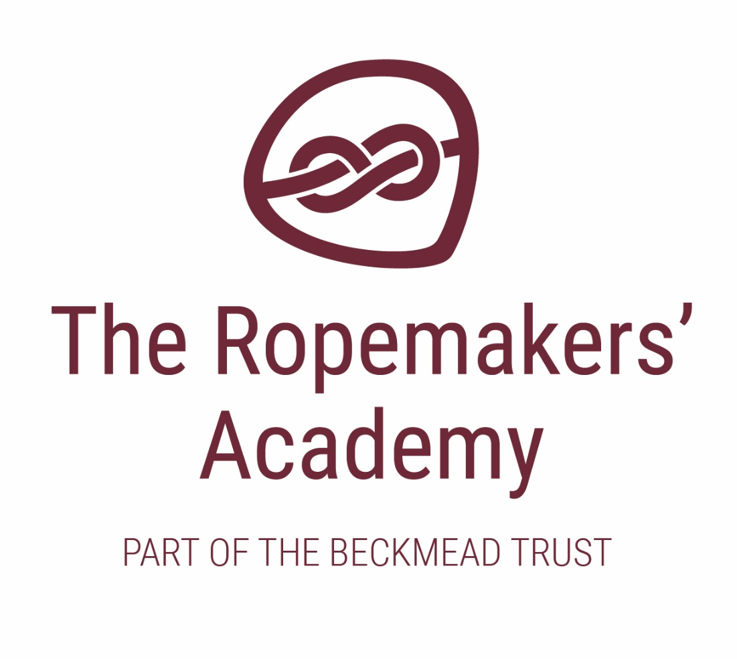

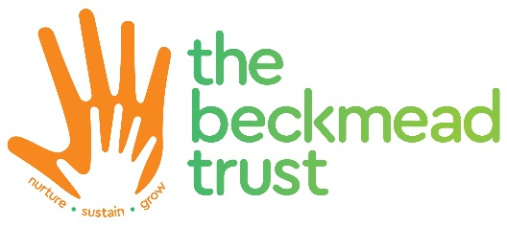
VISION & VALUES STATEMENT

ACADEMIC YEAR | AUTHOR | ROLE | DATE OF NEXT REVIEW
2020-21 | Simon Hawthorne | Headteacher | September 2021

At Ropemakers’ Academy school, we seek to create a cohesive, compassionate community, in which children can develop relationship skills, emotional literacy, health and wellbeing.

The Ropemakers’ Academy Mission Statement is:

“To deliver exceptional education and support for traumatised children and young people identified as having SEMH or autism and challenging behaviour.”

Our vision is aligned with the four key values across all schools in The Beckmead Trust, namely to ensure through everything we do that our children and members of our community have:

- A sense of feeling loved, cared for and valued at all times

We provide this through a number of approaches:

- We demonstrate unconditional positive regard – this means that we respect and accept all members of our school community, especially our pupils, without judgement or evaluation.

- Any actions we take towards our pupils are borne out of empathy, compassion and care; our interactions with our pupils are about purpose, not power.

- All individuals are worthy of recognition and are valued.

- The opportunity to flourish, not just within our setting, but in the wider community and into adulthood

- We recognise that allowing our pupils to flourish is the ultimate expression of on-going growth.

- Through our education plan we strive to equip our pupils to live virtuously, aspire to and acquire good life chances and choices.

- We all work together to nurture a desire to thrive among everyone in our our school community

- An understanding and experience of social justice, around fairness, equality and democracy

We achieve this in a range of ways:

- Demonstrating, recognising and celebrating fairness.

- We model and build systems to create, promote and maintain equality.

- We provide platforms and procedures so that we actively listen to the views of everyone in our community, so that we ensure that we are providing democracy for our pupils and their families.

- Taking time to explain our processes, reviewing them and making changes to improve them.

- A feeling of belonging within our community, and a sense of self identity within the wider context of their lives.

We achieve this through:

- Building a community ethos within our school, creating a strong sense for everyone of belonging.

- Developing and maintaining processes and providing experiences that allow distinct individual identities to develop and prosper under a wider, collective sense of identity.

- Extending opportunities for our pupils to experience safety and security within a sense of family.

- Developing living, organic communities that fuse education and care and believe in social pedagogy - education in the widest sense, a holistic approach towards children's experiential learning.

We will fulfil our mission, and reinforce and embed our vision and its associated values in The Ropemakers’ Academy through our aims of:

- Installing and delivering a stimulating, relevant, and exciting curriculum that our pupils can access, engage in and make excellent progression through in order to allow them to thrive.
- Providing sustainable outcomes and qualifications for our pupils to allow them positive transitions into, within and out of the school.
- Delivering excellence in professional learning and development .
- Deploying dynamic, empathic, ambitious leadership and governance across the community for the benefit of all.
- Embedding sound business and financial systems that support sustainable excellence and growth.
- Developing and maintaining a nurturing approach across our schools that is accessible for all and allows collective expansion.

