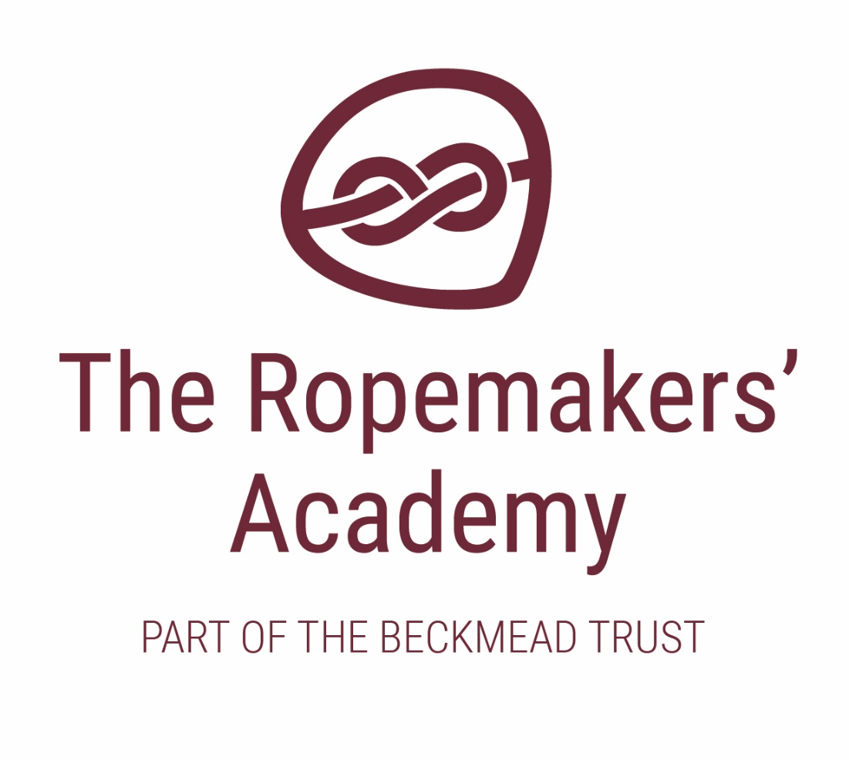

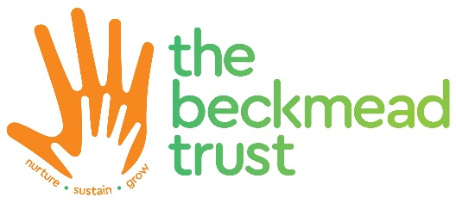
Spiritual, Moral, Social and Cultural & British Values Policy

ACADEMIC YEAR | AUTHOR | ROLE | DATE OF NEXT REVIEW
2020-21 | Simon Hawthorne | Headteacher | September 2021

This policy should be read in conjunction with the following policies:

- Behaviour Management Policy
- PSHE Policy

Introduction
At The Ropemakers’ Academy, we recognise our statutory duty to encourage our pupils’ spiritual, moral, social and cultural development. We understand that every child has a valuable contribution to make to the life of our school, and beyond. It is our intention to create good local, national and global citizens, who develop good character, resilience and grit. The spiritual, moral, social and cultural elements of pupils’ development are inter-related, and it should not be forgotten that there is much overlap between them, not least in respect of spirituality and its links to pupils’ attitudes, morals, behaviour in society and cultural understanding.

Vision, Values and Ethos
At Ropemakers’ Academy school, we seek to create a cohesive, compassionate community, in which children can develop relationship skills, emotional literacy, health and wellbeing. The Ropemakers’ Academy our vision is to:

“To deliver exceptional education and support for traumatised children and young people identified as having SEMH or autism and challenging behaviour.”

Our values are aligned with the four key aims across our Trust, namely to ensure through everything we do that our children have:

- a sense of feeling loved, cared for and valued at all times
- the opportunity to flourish, not just within our setting, but in the wider community and into adulthood
- an understanding and experience of social justice, around fairness, equality and democracy
- a feeling of belonging within our community, and a sense of self identity within the wider context of their lives.

British Values

Throughout the work we do in school around the development of our pupils’ SMSC understanding, we also ensure that within we take into account our need to develop their understanding of specific fundamental British values, namely:

• an understanding of how citizens can influence decision-making through the democratic process;

• an appreciation that living under the rule of law protects individual citizens and is essential for their wellbeing and safety

• an understanding that there is a separation of power between the executive and the judiciary, and that while some public bodies such as the police and the army can be held to account through Parliament, others such as the courts maintain independence;

• an understanding that the freedom to choose and hold other faiths and beliefs is protected in law;

• an acceptance that other people having different faiths or beliefs to oneself (or having none) should be accepted and tolerated, and should not be the cause of prejudicial or discriminatory behaviour; and

• an understanding of the importance of identifying and combatting discrimination

We achieve all of this through ensuring that children learn about their spiritual, moral, social and cultural development both within our curriculum and through explicit experiences, as detailed below:

Spiritual Development
Spiritual development is not the imposition of a religious faith or to religion in general. However, spiritual development may lead to the acceptance of a faith or it may not. The development of an individual’s own personal spirituality is a journey or a quest which seeks to know, develop and understand one’s own inner- self.
At The Ropemakers’ Academy, we will encourage children’s spiritual development by:

- giving children the opportunity to explore values and beliefs, including religious beliefs, and the way in which they impact on peoples’ lives;
- encouraging our pupils to explore and develop what animates themselves and others;
- giving children the opportunity to understand human feelings and emotions, the way they impact on people and how an understanding of them can be helpful;
- developing a climate or ethos within which all children can grow and flourish, enjoying individual liberty and mutual respect;
- accommodating difference and respecting the integrity of individuals, including tolerance of those with different faiths and beliefs;
- promoting learning opportunities which value children’s questions, encourage deeper questions and give them space for their own thoughts, ideas and concerns;

Moral Development
We aim to enable pupils to build a framework of moral values which regulates their personal behaviour. We also help them to understand the expectations of society’s shared and agreed values, including democracy, justice and the rule of law and how these change over time. We recognise the need to help our pupils to balance their right to an opinion and to freedom of speech, with their respect and tolerance of others’ values and beliefs.
At Ropemakers’ Academy, we will encourage children’s moral development by:
- providing opportunities for reflection and the development of their own opinions;
- helping them to recognise and resolve the moral issues and dilemmas implicit in a given context;
- enabling them to make and act upon informed choices, taking right and wrong into account;
- understanding that there are issues where there is disagreement or conflict and respecting others’ views;
- encouraging them to take pride in themselves and their work;
- developing the personal skills and qualities necessary to manage situations, such as being able to:
  - make decisions;
  - reflect on and change personal behaviour;
  - resist peer pressure;
  - show respect and compassion for themselves, others and the environment;
  - challenge behaviour which does not reflect this code, such as dishonesty, injustice, discrimination and the misuse of power;
  - abide by “fair play”, being good winners and losers, in games, rules and life.

Social Development
We develop in our children a growing understanding of the part that they play within the school community and wider society, both now and in the future.
Through their social development, we encourage children to relate positively to others, participate fully in the community and develop an understanding of good citizenship.

At Ropemakers’ Academy, we will encourage children’s social development by:
- developing an understanding and respect of others, their opinions, beliefs and customs;
- developing an understanding of society’s institutions, structures and characteristics, including democracy and the rule of law.
- encouraging them to have a sense of pride in their community;
- nurturing the development of the inter-personal skills necessary for successful relationships.
- helping them to use restorative approaches with their peers increasingly independently;
- encouraging them to think about the impact of their own and others’ actions on others;
- developing good teamwork skills through opportunities to co-operate and share;
- expecting good manners and courteous behaviour;
- providing opportunities for children to develop self-confidence;
- providing opportunities for the development of interpersonal skills.

Cultural Development

Cultural development at Ropemakers’ Academy is about children understanding and appreciating their own culture and other cultures in their community, Britain and throughout the world. It is an exploration of how we are the same and how we are different; how we came to be the way we are and how we are changing. Cultural development at our school is key to developing community cohesion and pride as well as curiosity and wonder at the world. Promoting pupils’ cultural development is intimately linked with our schools’ attempts to value cultural diversity and prevent racism.

At Ropemakers’ Academy, we will encourage children’s cultural development by:
- helping children to understand and feel comfortable in a variety of cultures and be able to operate in the emerging world culture of shared experiences provided by television, travel and the internet;
- helping children to understand that cultures are always evolving and coping with change;
- providing pupils with the knowledge of and appreciation of the key features of their own cultural traditions and practices and of other major cultural groups within their own community and the wider world;
- developing an understanding of, as well as celebrating and embracing, the diversity of cultural, spiritual, social and moral traditions and practices within their community and the wider world;
- developing the knowledge, skills, understanding, qualities and attitudes they need to understand, appreciate and contribute to culture in the form of music, art, drama, literature and faith;
- providing opportunities to nurture the cultural development of our children in all creative areas across the curriculum;
- encouraging a personal response to a range of cultural activities;
- exposing children to a wealth of stimuli from their own culture and those of others, taught through the whole curriculum with visits and visitors to support this teaching;
- encouraging participation in and appreciation of the wealth of cultural traditions and the beliefs associated with different communities.

