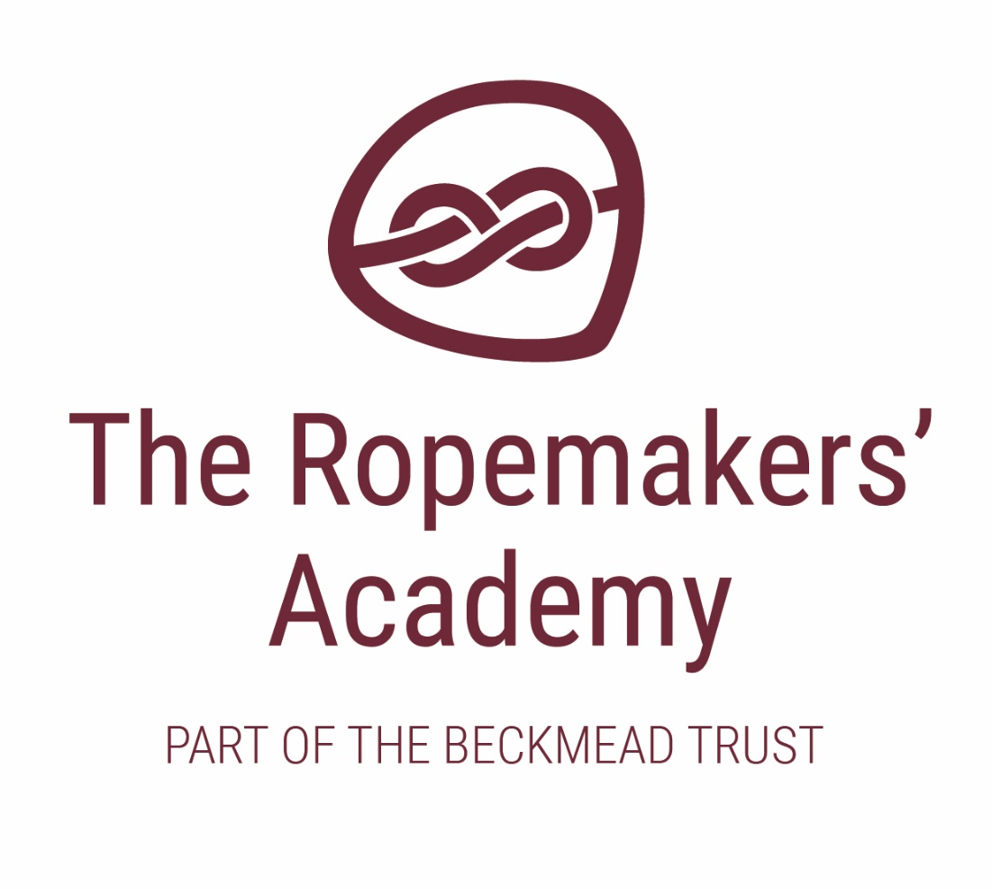

Preventing Extremism and
Radicalisation Policy

ACADEMIC YEAR | AUTHOR | ROLE | DATE OF NEXT REVIEW
2020-21 | Simon Hawthorne | Headteacher | September 2021

Introduction

The Ropemakers’ Academy is committed to providing a secure environment
for pupils, where children feel safe and are kept safe. All adults at Ropemakers
recognise that safeguarding is everyone’s responsibility irrespective of the role they undertake or whether their role has direct contact or responsibility for children or not.

In adhering to this policy, and the procedures therein, staff and visitors will contribute to The Ropemakers’ Academy delivery of the outcomes to all children, as set out in s10 (2) of the Children Act 2004.

This Preventing Extremism and Radicalisation Safeguarding Policy is one element within our overall school arrangements to Safeguard and Promote the Welfare of all Children in line with our statutory duties set out at s175 of the Education Act 2002 (s157 of the Education Act 2002.)

Our school’s Preventing Extremism and Radicalisation Policy also draws upon the guidance contained in the “Pan Sussex Child Protection Procedures” and DfE Guidance “Keeping Children Safe in Education, 2019”; and specifically DCSF Resources “Learning Together to be Safe”, “Prevent: Resources Guide”, “Tackling Extremism in the UK”, DfE’s “Teaching Approaches that help Build Resilience to Extremism among Young People” and Peter Clarke’s Report of July 2014.

School Ethos and Practice

When operating this policy our School uses the following accepted Governmental definition of extremism which is:

‘Vocal or active opposition to fundamental British values, including democracy, the rule of law, individual liberty and mutual respect and tolerance of different faiths and beliefs; and/or calls for the death of members of our armed forces, whether in this country or overseas’.

There is no place for extremist views of any kind in our school, whether from internal sources, pupils, staff or governors, or external sources - school community, external agencies or individuals. Our pupils see our school as a safe place where they can explore controversial issues safely and where our teachers encourage and facilitate this – we have a duty to ensure this happens.

As a school we recognise that extremism and exposure to extremist materials and influences can lead to poor outcomes for children and so should be addressed as a safeguarding concern as set out in this policy. We also recognise that if we fail to challenge extremist views we are failing to protect our pupils.

Extremists of all persuasions aim to develop destructive relationships between different communities by promoting division, fear and mistrust of others based on ignorance or prejudice and thereby limiting the life chances of young people. Education is a powerful weapon against this; equipping young people with the knowledge, skills and critical thinking, to challenge and debate in an informed way.
Therefore, we will provide a broad and balanced curriculum, delivered by
skilled professionals, so that our pupils are enriched, understand and become tolerant of difference and diversity and also to ensure that they thrive, feel valued and not marginalized.

Furthermore we are aware that young people can be exposed to extremist influences
or prejudiced views from an early age which emanate from a variety of sources and media, including via the internet, and at times pupils may themselves reflect or display views that may be discriminatory, prejudiced or extremist, including using derogatory language.

Any prejudice, discrimination or extremist views, including derogatory language, displayed by pupils or staff will always be challenged and where appropriate dealt with in line with our Behaviour Policy for pupils and the Staff Code of Conduct. Where misconduct by a teacher is proven the matter will be referred to the National College for Teaching and Leadership for their consideration as to whether to a Prohibition Order is warranted.

As part of wider safeguarding responsibilities school staff will be alert to:

- Disclosures by pupils of their exposure to the extremist actions, views or materials of
- others outside of school, such as in their homes or community groups, especially
- where pupils have not actively sought these out.

- Graffiti symbols, writing or art work promoting extremist messages or images

- Pupils accessing extremist material online, including through social networking sites

- Parental reports of changes in behaviour, friendship or actions and requests for
- Assistance

- Partner schools, local authority services, and police reports of issues affecting pupils in other schools or settings

- Pupils voicing opinions drawn from extremist ideologies and narratives

- Use of extremist or ‘hate’ terms to exclude others or incite violence

- Intolerance of difference, whether secular or religious or, in line with our equalities policy, views based on, but not exclusive to, gender, disability, homophobia, race, colour or culture

- Attempts to impose extremist views or practices on others

- Anti-Western or Anti-British views

Our school will closely follow any locally agreed procedure as set out by the Local Authority and/or the Local Safeguarding Children Board’s agreed processes and criteria for safeguarding individuals vulnerable to extremism and radicalisation.

Teaching Approaches

We will all strive to eradicate the myths and assumptions that can lead to some young people becoming alienated and disempowered, especially where the narrow approaches children may experience elsewhere may make it harder for them to challenge or question these radical influences. In our school this will be achieved by good teaching, primarily via PSHE and through our approaches to SMSC; but also by adopting the methods outlined in the Government’s guidance ‘Teaching approaches that help build resilience to extremism among young people’ DfE 2011.

We will ensure that all of our teaching approaches help our pupils build resilience to extremism and give pupils a positive sense of identity through the development of critical thinking skills.

We will ensure that all of our staff are equipped to recognise extremism and are skilled and confident enough to challenge it.

We will be flexible enough to adapt our teaching approaches, as appropriate, so as to address specific issues so as to become even more relevant to the current issues of extremism and radicalisation. In doing so we will apply the ‘key ingredients’ for success following the three broad categories of:

- Making a connection with young people through good [teaching] design and a pupil centred approach.

- Facilitating a ‘safe space’ for dialogue

- Equipping our pupils with the appropriate skills, knowledge, understanding and
- awareness for resilience.

Therefore, this approach will be embedded within the ethos of our school so that pupils know and understand what safe and acceptable behaviour is in the context of extremism and radicalisation. This will work in conjunction with our schools approach to the spiritual, moral, social and cultural development of pupils as defined in OfSTED’s School Inspection Handbook and will include the sound use of assemblies to help further promote this rounded development of our pupils.

Our goal is to build mutual respect and understanding and to promote the use of dialogue not violence as a form of conflict resolution. We will achieve this by using a curriculum that includes:

- Citizenship programmes

- Open discussion and debate

- Work on anti-violence and a restorative approach addressed throughout curriculum

- Focussed educational programmes

We will also work with local partners, families and communities in our efforts to ensure our school understands and embraces our local context and values in challenging extremist views and to assist in the broadening of our pupil’s experiences and horizons. We will help support pupils who may be vulnerable to such influences as part of our wider safeguarding responsibilities and where we believe a pupil is being directly affected by extremist materials or influences we will ensure that that pupil is offered mentoring. Additionally, in such instances our school will seek external support from the Local Authority and/or local partnership structures working to prevent extremism.

We will promote the values of democracy, the rule of law, individual liberty, mutual
respect and tolerance for those with different faiths and beliefs. We will teach and encourage pupils to respect one another and to respect and tolerate difference, especially those of a different faith or no faith. It is indeed our most fundamental responsibility to keep our pupils safe and prepare them for life in modern multi-cultural Britain and globally.

Use of External Agencies and Speakers

We encourage the use of external agencies or speakers to enrich the
experiences of our pupils, however we will positively vet those external agencies, individuals or speakers who we engage to provide such learning opportunities or experiences for our pupils.

Such vetting is to ensure that we do not unwittingly use agencies that contradict each other with their messages or that are inconsistent with, or are in complete opposition to, the school’s values and ethos. We must be aware that in some instances the work of external agencies may not directly be connected with the rest of the school curriculum so we need to ensure that this work is of benefit to pupils.

Our school will assess the suitability and effectiveness of input from external agencies or individuals to ensure that:

- Any messages communicated to pupils are consistent with the ethos of the school and do not marginalise any communities, groups or individuals

- Any messages do not seek to glorify criminal activity or violent extremism or seek to radicalise pupils through extreme or narrow views of faith, religion or culture or other ideologies

- Activities are properly embedded in the curriculum and clearly mapped to schemes of work to avoid contradictory messages or duplication.

- Activities are matched to the needs of pupils

- Activities are carefully evaluated by schools to ensure that they are effective

We also recognise however, that the ethos of our school is to encourage pupils to understand opposing views and ideologies, appropriate to their age, understanding and abilities, and to be able to actively engage with them in informed debate, and we may use external agencies or speakers to facilitate and support this.

Therefore by delivering a broad and balanced curriculum, augmented by the use of external sources where appropriate, we will strive to ensure our pupils recognise risk and build resilience to manage any such risk themselves where appropriate to their age and ability but also to help pupils develop the critical thinking skills needed to engage in informed debate.

Whistle Blowing

Where there are concerns of extremism or radicalisation Pupils and Staff will be encouraged to make use of our internal systems to Whistle Blow or raise any issue in confidence.

Please refer to School Whistle Blowing Policy.

Safeguarding and Child Protection

Please refer to our Child Protection Policy for the full procedural framework on our Child Protection duties.

Staff will be alert to the fact that Extremism and Radicalisation is a safeguarding issue and so there may be some instances where a child or children may be
at direct risk of harm or neglect. For example; this could be due to a child displaying risky behaviours in terms of the activities they are involved in or the groups they are associated with or staff may be aware of information about a child’s family that may equally place a child at risk of harm. (These examples are for illustration and are not definitive or exhaustive) Therefore all adults working at the school (including visiting staff, volunteers’ contractors, and students on placement) are required to report instances where they believe a child may be at risk of harm or neglect to the Designated Safeguarding Lead and/or Headteacher.

Role of the Designated Safeguarding Lead (DSL)

The DSL is: Simon Hawthorne

The Deputy DSL is: TBC

The DSL works in line with the responsibilities as set out in the DfE Guidance ‘Keeping Children Safe in Education’.

The DSL is the focus person and local ‘expert’ for school staff, and
others, who may have concerns about an individual child’s safety or well-being and is the first point of contact for external agencies

In line with Recommendation 2 of Peter Clarke’s Report; the role of the
DSL will be extended, at the appropriate time, to include the
responsibilities of the PREVENT strand of the Government’s counter-terrorism strategy.

Training

Whole school in-service training on Safeguarding and Child Protection will be organised for staff and governors at least annually and will comply with the prevailing arrangements agreed by the Local Authority and Local Safeguarding Children Board and will, in part, include training on extremism and radicalisation and its safeguarding implications. Tis training will also include a requirement for all staff to undertake the Home Office online Prevent Training module.

The DSL will attend training courses as necessary and the appropriate inter-agency training organised by the Local Safeguarding Children Board at least every two years, again this will include training on extremism and radicalisation and its safeguarding implications.

Recruitment

The arrangements for recruiting all staff, permanent and volunteers, to our school will follow guidance for safer recruitment best practice in education settings, including, but not limited to, ensuring that DBS checks are always made at the appropriate level, that references are always received and checked and that we complete and maintain a single central record of such vetting checks.

We will apply safer recruitment best practice principles and sound employment practice in general and in doing so will deny opportunities for inappropriate recruitment or advancement.

We will be alert to the possibility that persons may seek to gain positions within our school so as to unduly influence our schools character and ethos. We are aware that such persons seek to limit the opportunities for our pupils thereby rendering them vulnerable to extremist views and radicalisation as a consequence.

Therefore, by adhering to safer recruitment best practice techniques and by ensuring that there is an ongoing culture of vigilance within our school and staff team we will minimise the opportunities for extremist views to prevail.

Role of Governing Body

The Governing Body of our School will undertake appropriate training to ensure that they are clear about their role and the parameters of their responsibilities as Governors, including their statutory safeguarding duties.

The Governing Body of our school will support the ethos and values of our school and will support the school in tackling extremism and radicalisation.

In line with Recommendation 13 of Peter Clarke’s report details of our Governing Body will be published on our school website to promote transparency.

In line with the provisions set out in the DfE guidance ‘Keeping Children Safe in Education, 2019’ the governing body will challenge the school’s senior management team on the delivery of this policy and monitor its effectiveness.

Governors will review this policy regularly (annually) and may amend and adopt it
outside of this timeframe in accordance with any new legislation or guidance or in response to any quality assurance recommendations pertaining to the delivery of this policy and the overall safeguarding arrangements made.

