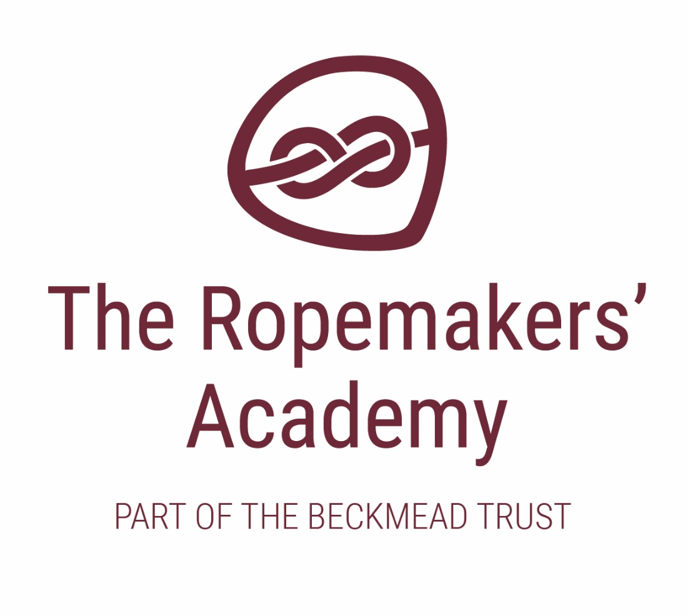

SEND POLICY AND INFORMATION REPORT



|  |  |
| --- | --- |
| Name of Policy | SEND Policy and Information report |
| Policy Level | Trust |
| Date of Issue | July 2018 |
| Author | Board of Trustees |
| Date of Next Review | September 2020 |
| Signature | Dr Jonty Clark |
| Date of Signature | September 2018 |

Table of Contents

1. Aims 4

2. Legislation and guidance 4

3. Definitions 4

4. Roles and responsibilities 4

5. SEND Information Report 6

6. Monitoring arrangements 9

7. Links with other policies and documents 10

1. Aims

Our SEN policy and information report aims to:

* Set out how The Ropemakers’ Academy will support and make provision for pupils with special educational needs and disabilities. (SEND)
* Explain the roles and responsibilities of everyone involved in providing for pupils with SEND.
* Develop the aims and vision of a specific SEND Trust which embraces children with a variety of impairments.
* Promote equality, tolerance and sustainable outcomes for children in receipt of additional support during their schooling.

2. Legislation and guidance

This policy and information report is based on the statutory Special Educational Needs and Disability (SEND) Code of Practice and the following legislation:

* Part 3 of the Children and Families Act 2014, which sets out Schools’ responsibilities for pupils with SEN and disabilities
* The Special Educational Needs and Disability Regulations 2014, which set out Schools’ responsibilities for education, health and care (EHC) plans, SEN co-ordinators (SENCOs) and the SEN information report.

This policy also complies with our funding agreement and articles of association.

3. Definitions

A pupil has SEND if they have a learning difficulty or disability which calls for special educational provision to be made for them.

They have a learning difficulty or disability if they have:

* A significantly greater difficulty in learning than the majority of others of the same age, or
* A disability which prevents or hinders them from making use of facilities of a kind generally provided for others of the same age in mainstream Schools.

Special educational provision is educational or training provision that is additional to, or different from, that made generally for other children or young people of the same age who are placed in mainstream Schools.

4. Roles and responsibilities

4.1 The SENCO

Not all of the schools in the Trust will have a specific or standalone SENCO. The nurture model of education and care frequently means that classroom staff or school leaders will undertake the duties of a SENCO due to the resourcing of the special school and the detailed relationships this funding enables.

Irrespective of school structure, those fulfilling SENCO duties will:

* Work with the SLT and SEN governor to determine the strategic development of the SEN policy and provision in the School
* Have day-to-day responsibility for the operation of this SEN policy and the co-ordination of specific provision made to support individual pupils with SEN, including those who have EHC plans (the majority of children attending Beckmead Trust schools).
* Provide professional guidance to colleagues and work with staff, parents/carers, and other agencies to ensure that pupils with SEN receive appropriate support and high quality teaching
* Advise on the graduated approach to providing SEN support
* Advise on the deployment of the School’s delegated budget and other resources to meet pupils’ needs effectively
* Be the point of contact for external agencies, especially the local authority and its support services
* Liaise with potential next providers of education to ensure pupils and their parents/carers are informed about options and a smooth transition is planned
* Work with the Head and Board of Trustees to ensure that the School meets its responsibilities under the Equality Act 2010 with regard to reasonable adjustments and access arrangements
* Ensure the School keeps the records of all pupils with SEN up to date.

**The SENCO of The Ropemakers’ Academy is Simon Hawthorne**

4.2 The SEND governor / Trustee

This colleague will:

* Help to raise awareness of SEN issues at LGB and/or Board of Trustees meetings
* Monitor the quality and effectiveness of SEN and disability provision within the school and update the Board of Trustees on this
* Work with the Headteacher and SENCO to determine the strategic development of the SEND policy and provision in the School.

4.3 The Headteacher

The Headteacher will:

* Work with the SENCO and SEN governor to determine the strategic development of the SEN policy and provision in the School
* Have overall responsibility for the provision and progress of learners with SEND

4.4 Class teachers

Each class teacher is responsible for:

* The progress and development of every pupil in their class
* Working closely with any teaching assistants or specialist staff to plan and assess the impact of support and interventions and how they can be linked to classroom teaching
* Working with the SENCO to review each pupil’s progress and development and decide on any changes to provision
* Ensuring they follow this SEN policy.
* Contributing to the EHCP annual review process as required

5. SEND Information Report

5.1 The kinds of SEN that are provided for

The Ropemakers’ Academy is primarily a school that support children with social, emotional and mental health needs. However, we also provide additional and/or different provision for a range of needs, including:

* Cognition and learning needs, such as dyslexia or dyspraxia
* Communication and interaction needs such as autistic spectrum disorder, Asperger’s Syndrome, and speech and language difficulties
* Sensory and/or physical needs such as visual impairments, hearing impairments, processing difficulties, and epilepsy
* Moderate learning difficulties

5.2 Identifying pupils with SEN and assessing their needs

We will assess each pupil’s current skills and levels of attainment on entry, which will build on previous settings, professional diagnosis and Key Stages, where appropriate. Class teachers will make regular assessments of progress for all pupils and identify those whose progress:

* Is significantly slower than that of their peers starting from the same baseline
* Fails to match or better the child’s previous rate of progress
* Fails to close the attainment gap between the child and their peers
* Widens the attainment gap

This may include progress in areas other than attainment, for example, social needs and behaviour.

5.3 Consulting and involving pupils and parents/carers

The Ropemakers’ Academy will discuss on admission and induction the views of the pupil and their parents/carers about how we can best meet their special educational needs. These conversations will make sure that:

* Everyone develops a good understanding of the pupil’s areas of strength and difficulty
* We take into account the parents/carers’ concerns and expertise.
* Everyone understands the agreed outcomes sought for the child

Everyone is clear on what the next steps are

5.4 Assessing and reviewing pupils' progress towards outcomes

We will follow the graduated approach and the four-part cycle of:



This means that we will work with you and your child to ensure that we:

* assess your child’s needs
* plan support for them, focusing on outcomes
* do those support provisions that we identify, and
* formally review these provisions at least three times a year

The class or subject teacher will work with the SENCO and other professionals to carry out a clear analysis of the pupil’s needs. This will draw on:

* The teacher’s assessment and experience of the pupil
* Their previous progress and attainment and behaviour
* Other teachers’ assessments, where relevant
* The individual’s development in comparison to their peers and national data
* The views and experience of parents/carers
* The pupil’s own views
* Advice from external support services.

The assessment will be reviewed regularly as well as being scrutinised and adapted through the Annual Review and IEP cycles.

All teachers and support staff who work with the pupil will be made aware of their needs, the outcomes sought, the support provided, and any teaching strategies or approaches that are required. We will regularly review the effectiveness of the support and interventions and their impact on the pupil’s progress.

5.5 Supporting pupils moving between phases and preparing for adulthood

We will share information with the School, college, or other setting the pupil is moving to. We will agree with parents/carers and pupils which information will be shared as part of this.

5.6 Our approach to teaching pupils with SEND

High quality teaching is our first step in responding to pupils who have SEND. This will be differentiated for individual pupils.

We will also provide a range of interventions that include the following: nurture, behaviourism, therapeutic interventions, small group and individualised learning, differentiated pedagogy and curriculum, sensory specific environments, and social and physical care.

5.7 Adaptations to the curriculum and learning environment

The table below outlines some of our typical approaches across the categories of need:

|  |  |  |  |
| --- | --- | --- | --- |
| **SEND Category** | **Universal Support:**  **(Classroom)** | **Targeted Support:**  **(School-based additional intervention)** | **Specialist Support:**  **(Outside agency intervention)** |
| **Communication & Interaction** | Quality First Teaching  Visual aids and resources  Assistive technology | Teaching Assistants delivery of Speech and Language Therapy programmes  Speech, language and communication needs (SLCN) questionnaire | Children’s integrated therapy services (CITES)  Speech and Language Therapy Service  CLASS |
| **Cognition & Learning** | Quality First Teaching  Whole school literacy strategy  Classroom based literacy support such as writing or spelling guides  Differentiated Teaching  Assistive technology and online teaching programmes  Teaching Assistant support | TA focused deployment  Phonics programmes such as Read Write Inc. or Fresh Start  SRA Corrective Reading programme  Dyslexia Screener Test  TA focused deployment  Catch Up Numeracy Sessions  Maths intervention programmes | Educational Psychologist input  SpLD teacher 1:1  CLASS Support |
| **Social, Emotional & Mental Health Needs** | Whole school behaviour policy  Subject and pastoral reporting mechanisms  Nurturing and therapeutic interaction approaches  Learning breaks and time out strategies  Access to calm room | Identified key adult support  Place to Talk/Place to Be  Parent workshops  Lunch Clubs  Stonewall Programme  Boxall Profile  Juniper Nurture Room | Educational Psychologist  Child and adolescent mental health services (CAMHS)  ESBAS Support  My Time Now  The Virtual School  Young Carers  In house therapy |
| **Sensory and/or Physical Needs** | Accessibility plan  Classroom layout design | Adapted environments as directed by specialist services  Jump Ahead  Physiotherapy programmes delivered by INAs | ESCC Sensory Needs service  CLASS |

5.8 Additional support for learning

We have many specialist staff across the Beckmead Trust who will support us at The Ropemakers’ Academy who are trained in specific areas such as literacy, numeracy, behaviour, Occupational Therapy, Speech, Language and Communication, play, self-care, nurture, sensory needs and autism. In addition, we will work with outside agencies across the Local Authority to seek their support and recommendations

5.9 Evaluating the effectiveness of SEN provision

We evaluate the effectiveness of provision for pupils with SEN by:

* Reviewing pupils’ individual progress towards their goals constantly
* Ongoing review of the impact of interventions
* Pupil questionnaires, informal feedback and pupil Councils.
* Using provision maps to measure progress
* Holding annual reviews for pupils with EHC plans.

5.10 Working with other agencies.

The schools and provisions within the Beckmead Trust are committed to working with external agencies to enhance the welfare of pupils and maximise the effectiveness of the work of the school. These agencies will include social care, CAMHS, YOS, EP service, Police.

5.11 Complaints about SEN provision

Complaints about SEN provision in our School should be made to the Headteacher in the first instance. They will then be referred to the School’s complaints policy.

The parents/carers of pupils with disabilities have the right to make disability discrimination claims to the first-tier SEND tribunal if they believe that our School has discriminated against their children. They can make a claim about alleged discrimination regarding:

* Exclusions
* Provision of education and associated services
* Making reasonable adjustments, including the provision of auxiliary aids and services

6. Monitoring arrangements

Day to day monitoring of the implementation of the requirements of this policy and information will be carried out in school by the Headteacher/SENCO.

This policy and information report will be reviewed by the Board of Trustees every year. It will also be updated if any changes to the information are made during the year.

It will be approved by the Board of Trustees.

7. Links with other policies and documents

This policy links to our policies on:

* Accessibility plan
* Behaviour
* Equality information and objectives
* Supporting pupils with medical conditions.