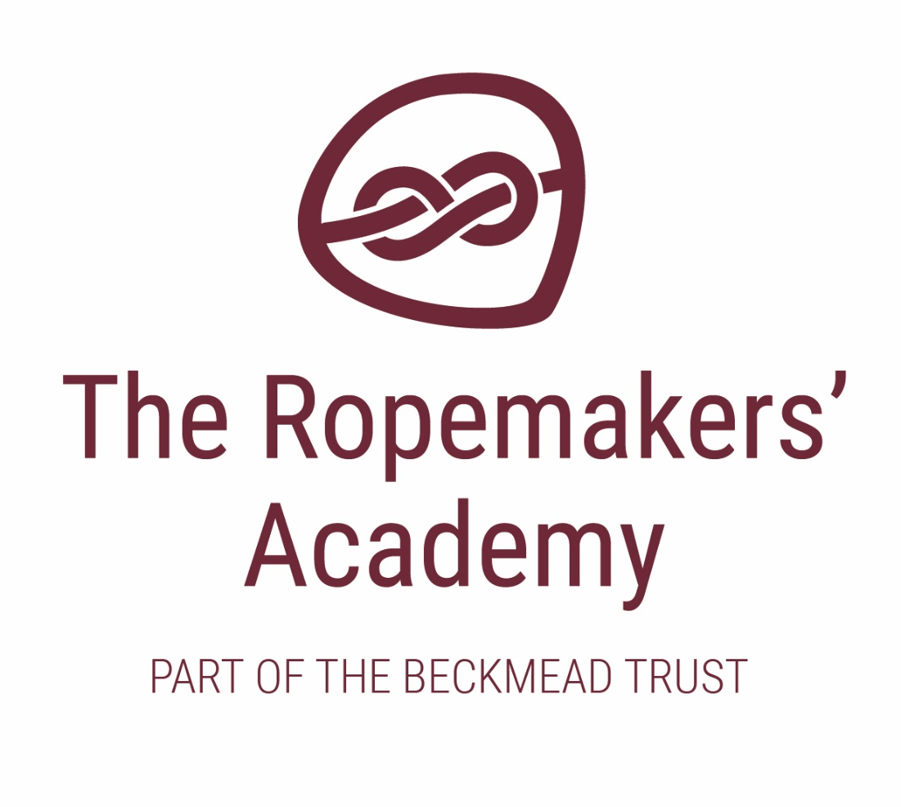

ENGLISH AS AN ADDITIONAL LANGUAGE (EAL) POLICY

ACADEMIC YEAR | AUTHOR | ROLE | DATE OF NEXT REVIEW
2020-21 | Simon Hawthorne | Headteacher | September 2021

Roles and Responsibilities

  - The responsibility for the implementation of this policy and provision rests with the Headteacher.
  - It is important to note that every member of staff is responsible for ensuring that this
policy is fully implemented and that in situations not covered by this policy, staff must act in the best interests of the pupil, as any responsible parent would act.
  - The welfare of pupils will be paramount.

Introduction

  - The Ropemakers’ Academy seeks to provide a safe, supportive, secure, motivated and challenging environment to enable all staff and pupils, including those with English as an additional language, to succeed academically, socially and emotionally.

  - All pupils need to feel safe, accepted and valued in order to learn. For pupils who are learning English as an additional language, this includes recognising and valuing their home language and background. We are aware that bilingualism is a strength and that EAL pupils have a valuable contribution to make. We take a whole academy approach, including ethos, curriculum, education against racism and promoting language awareness.

  - This policy aims to raise awareness of the academy’s obligations and to support the planning, organisation, teaching and assessment procedures, and the use of resources and strategies to meet the needs of pupils who have English as an additional language (EAL) and so to raise pupil achievement.

Key Principles of additional language acquisition
  - EAL pupils are entitled to the full Academy Curriculum programmes of learning and all their teachers have a responsibility for teaching English as well as other subject content.

  - Access to learning requires attention to words and meanings embodied in each curriculum area. Meanings and understanding cannot be assumed but must be made explicit.

  - Language is central to our identity. Therefore, the home languages of all pupils and staff should be recognised and valued. Pupils should be encouraged to maintain their home language and use in the academy environment wherever possible.

  - Although many pupils acquire the ability to communicate on a day to day basis in English quite quickly, the level of language needed for academic study is much deeper and more detailed, and can require continuing support for up to ten years.

  - Language develops best when used in purposeful contexts across the curriculum.

  - The language demands of learning tasks need to be identified and included in planning.

  - Teaching and support staff play a crucial role in modelling uses of language.

  - Knowledge and skills developed in learning the first language aid the acquisition of additional languages.
  - A clear distinction should be made between EAL and Special Needs

Educational Needs Assessment

  - All EAL pupils are entitled to assessments as required.

  - Additional specialist support may be required to visit the academy. The Ropemakers’ Academy will engage these agencies to support our pupils as required. They will assess and monitor pupils, give support and guidance to staff and direct support to prioritised pupils.

  - Staff have regular coaching time to discuss pupil progress, needs and targets.

  - Progress in the acquisition of English is regularly assessed and monitored.

  - Consideration and sensitivity is given to the appropriateness of testing EAL pupils at the earlier stages of English acquisition.

Planning, Monitoring and Evaluation
.
  - We will ensure that targets for EAL pupils are appropriate, challenging and reviewed on a regular basis and that they are not confused with any additional SEN targets.

  - Planning for EAL pupils will incorporate both curriculum and EAL specific objectives.

  - Staff will regularly observe, assess and record information about pupils’ developing use of language.

  - When planning the curriculum, staff will take account of the linguistic, cultural and religious backgrounds of families.

Teaching Strategies
  - Classroom activities will have clear learning objectives and use appropriate materials and support to enable pupils to participate in lessons.

  - Key language features of each curriculum area, eg key vocabulary, uses of language, forms of text, will be identified and presented.

  - Enhanced opportunities will be provided for speaking and listening, including both process and presentational talk, and use made of drama techniques and role play wherever possible. Pupils will have access to effective staff and peer models of spoken language.

  - Additional visual support will be provided, eg posters, pictures, photographs, objects, demonstration, use of gesture.
  - Additional verbal support will be provided, eg repetition, modelling, peer support.

  - Use will be made of collaborative activities that involve purposeful talk and encourage and support active participation.

  - Where possible, learning progression will move from the concrete to the abstract.

  - Discussion will be provided before, during and after reading and writing activities.

  - Scaffolding will be provided as necessary for language and learning, eg talk frames, writing frames.

Parental/Community Involvement
Staff will strive to encourage parental and community involvement by:

  - Providing a welcoming induction process for newly arrived pupils and their families/carers.

  - Using plain English and translators and interpreters, where appropriate and available, to ensure good spoken and written communications.

  - Identifying linguistic, cultural and religious background of pupils and establishing contact with wider community where possible.

  - Celebrating and acknowledging the achievements of EAL pupils in the wider community.

  - Recognising and encouraging the use of first language.

  - Helping parents understand how they can support their children at home, especially by continuing the development of their first language.

