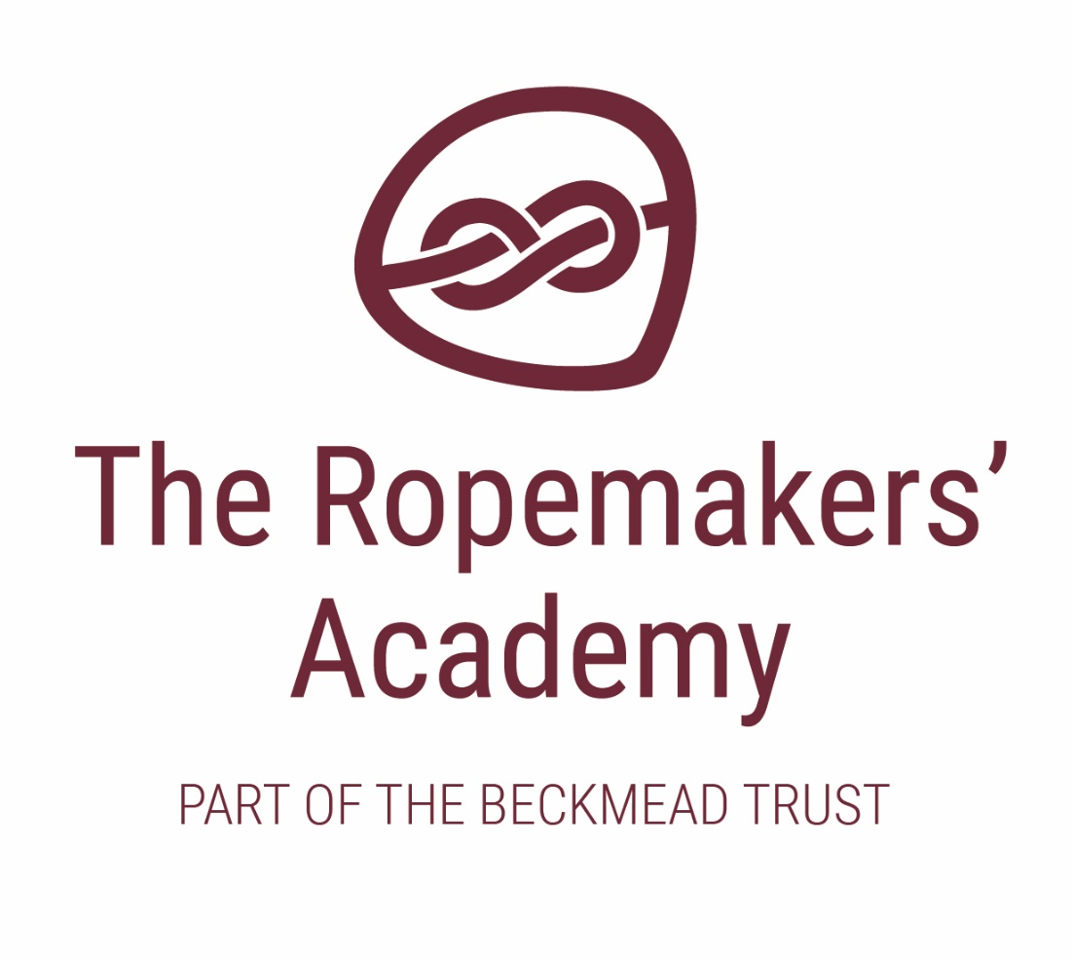

SAFER RECRUITMENT POLICY

ACADEMIC YEAR | AUTHOR | ROLE | DATE OF NEXT REVIEW
2020-21 | Simon Hawthorne | Headteacher | September 2021

1 General principles

The Ropemakers’ Academy recognises safer recruitment practices are an essential part of creating a safe environment for children and will ensure that staff working in the school/college are suitable to do so and do not pose any kind of risk to children.

The school will follow the Keeping Children Safe in Education guidance (DfE 2019).

- We will carry out extensive checks and enquiries on applicants for all positions, including voluntary and support roles and governors and those involved in the management of an independent school, in accordance with statutory requirements. This will be carried out initially by the Beckmead Trust HR Central team, and in time will transition to be conducted by The Ropemakers’ Academy own administration team supported by the Central HR team.

- No staff member, volunteer, governor or anyone involved in the management of a school will be allowed to take up posts until all checks and enquiries required for that position have been satisfactorily completed, including Section 128 checks relating to the recruitment of governors.

- Checks with the Disclosure and Barring Service will be carried out at the level appropriate to the candidate’s role in the school (see section 4).

- All job advertisements and application forms will clearly state that the role is a safeguarding role and that applicants will be expected to agree to undergo DBS and other checks as part of safer recruitment practices.

- Staff and governors who normally sit on interview panels will be trained in safer recruitment and no interview should go ahead unless at least one member of the panel has undertaken safer recruitment training. Schools will take up the accredited safer recruitment training offered through the East Sussex Safeguarding Children Board or another suitably accredited training provider.

- Although the Headteacher will have day-to-day responsibility for the recruitment of staff, the Governing Board will ensure that they maintain an overview of recruitment systems in order to scrutinise practise and ensure all statutory checks are carried out.

- Staff in our school/Trust responsible for carrying out recruitment checks will ensure they have a copy of any relevant documents or take relevant issue numbers from documents as proof that the document has been seen.

- Checks will be taken out on existing staff where concerns arise regarding their suitability to work with children or a person moves into a post that is a regulated activity.

- In schools, the Headteacher will be responsible for keeping a single central record of all staff and volunteers (including governors) who work at the school.

- The single central records will include details of all checks carried out and the outcome of these checks or any certificates obtained

- When we employ salaried trainee teachers, we will ensure that all necessary checks are carried out on the trainees, including DBS checks, and that the outcome of these checks is recorded on the single central record.

- For trainee teachers that are fee-funded, the school will obtain written confirmation from the training provider that the necessary checks have been carried out and that the trainee has been judged to be suitable to work with children.

- Where staff are recruited via third parties such as employment agencies, the Headteacher of The Ropemakers’ Academy will:

  - seek written confirmation from the agency that the agency has carried out all necessary checks on the individual
  - request written confirmation of the outcome of all checks
  - request written confirmation that an enhanced DBS certificate has been received by the agency
  - check the identity of agency staff when they first present for work to ensure they are person against whom the checks were taken out.

2 Checks to be taken out

The school will verify the following information for all new staff:

- The applicant’s identity must be verified from their passport or other photographic ID and proof of address must be provided.

- The applicant’s right to work in the UK must be evidenced through documentation. Only original documentation should be accepted and its validity checked in the presence of the applicant.

- Where the applicant will be involved in regulated activity, an enhanced DBS check will be taken out, including information from the barred list. If the applicant will begin work before an enhanced DBS check can be completed, a barred list check will be obtained.

- In the case of teaching staff, checks will be made on the applicant’s academic and vocational qualifications and further checks made on Teacher Regulation Agency (TRA) Teacher Services system to ensure they are not prohibited from teaching under a teacher prohibition order.

- As we are a free school/academy, checks will be made to ensure any member of staff or trustee involved in the management of the school is not barred from doing so under a section 128 direction.

- Where the applicant has been living abroad, similar enquiries will be made in the country of origin relating to the applicant’s qualifications and suitability to teach via the TRA Teacher Services system.

We will also take account of the following central government guidance:
Criminal records checks for overseas applicants - Publications - GOV.UK
Employing overseas-trained teachers from outside the EEA - Publications - GOV.UK

- Enquiries will be made regarding the applicant’s state of physical and mental health to the extent that it may affect their capacity to carry out their role.

- The school will keep copies of the following documents on staff personnel files; initially these will be held with the Trust’s Central HR team:

  - documents used as proof of identity such as passports or driving licences;
  - a summary of the DBS certificate (from September 2018 a copy of the DBS certificate may be kept on file);
  - documents that prove the staff member’s right to work in the UK (failure to do so can result in a fine for employing illegal workers).

3 References

- Applicants will be asked to provide a full employment history and details of at least two referees, including previous and recent employers, and who should be a senior member of staff with the authority to provide references. References from colleagues / friends will not be acceptable.

- All references will be taken up prior to interview and will be requested directly from the referee, including references for internal candidates. Referees will be contacted to resolve any issues that emerge from the references provided.

- References will be taken up from current employers only; if the applicant is not currently employed, verification of will be sought from their previous school/college as to the dates the applicant was employed and the reasons for leaving the post.

- Any information provided by applicants as part of an application process will be verified with independent sources and any reference received electronically will be checked to verify the originating source.

4 DBS checks

In order to ensure that people who work in the school/college are suitable to do so and are not barred from working with children, the school/college will apply to the Disclosure and Barring Service (DBS) for police checks and other barred list information as part of the recruitment process.

Full DBS checks which include barred list checks will only be taken out on individuals who are involved in regulated activity. This is defined as close, unsupervised contact on a regular basis involving activities such as:

- teaching
- training
- supervising
- care
- guidance and advice
- driving a vehicle
- personal or intimate care.

The activity must be carried out regularly as part of the staff member’s day to day responsibilities and the checks will be reasonable in order to safeguard children.

Full DBS checks with barred list checks will also be carried out on permanent staff members working at the school/college or unpaid volunteers who regularly work unsupervised at the school/college and whose work means they have an opportunity for regular contact with children.

Other staff, contractors and supervised volunteers who have opportunities for regular contact with children but do not carry out a regulated activity will be subject to an enhanced DBS check but not barred list checks.

Decisions on whether a person is carrying out a regulated activity or whether their role provides opportunities for regular contact with children requiring a DBS check will be made by whoever is responsible for recruitment in the school, for example the head teacher or governor, and the following will be taken into consideration when deciding on this.

- the age of the children;
- their level of vulnerability;
- the numbers of children in the group;
- the nature of the role;
- opportunities for contact with the children.

The school has robust procedures for day to day staff management and supervision and clear procedures for reporting and acting on concerns. Staff carrying out roles involving regulated activity will be suitably supervised on a regular basis by senior staff carrying out a similar role.

The school/college will ensure that all DBS checks carried out on staff are renewed after 3 years of the original DBS disclosure.

5 Volunteers

The Headteacher will ensure that the following are carried out in relation to unpaid volunteers such as parents who accompany pupils on school outings or provide help in the classroom:

- All volunteers will be required to undergo a recruitment process, such as references, DBS and other checks and interviews that is appropriate and proportional to the duties assigned to them.

- Volunteers who are carrying out a regulated activity, for example being left unsupervised with children or providing personal care to children should be subject to an enhanced DBS check, including barred list information.

- New volunteers who are not carrying out regulated activity but who have an opportunity for regular contact with children will be subject to an enhanced DBS check but this may not include a barred list check.

- For other volunteers who are not carrying out regulated activity and do not have regular contact with children, the head teacher/principal will carry out a risk assessment to decide whether an enhanced DBS check should be carried out depending on:
  - the nature of the role
  - what information is already known about the volunteer?
  - what references from work or volunteering activity the volunteer has provided regarding suitability?
  - whether the role is eligible for an enhanced DBS check.

- We will ensure that all volunteers are competent to carry out the duties assigned to them and are only assigned duties that are suitable to their qualification and experience.

- Volunteers carrying out regulated activity but for whom a DBS check has not been carried out will be suitably supervised by teaching staff at all times at a level that ensures the safety of pupils. Where necessary, a suitable risk assessment will be put in place to support this.

- All volunteers will be fully inducted in relation to all school policies and procedures.

6 Alternative Provision

Sometimes it may be necessary for a pupil to be placed temporarily in another educational setting, for example, on a course in a local college. The Ropemakers’ Academy remains responsible for the safeguarding of children of any pupils they place in Alternative Provision.
Whenever the school places a pupil with an Alternative Provider, the school will obtain written confirmation of the provider’s safeguarding and child protection policies and that all relevant vetting and barring checks on individuals working at the establishment have been carried out.
All pupils placed in Alternative Provision will be visited regularly.

