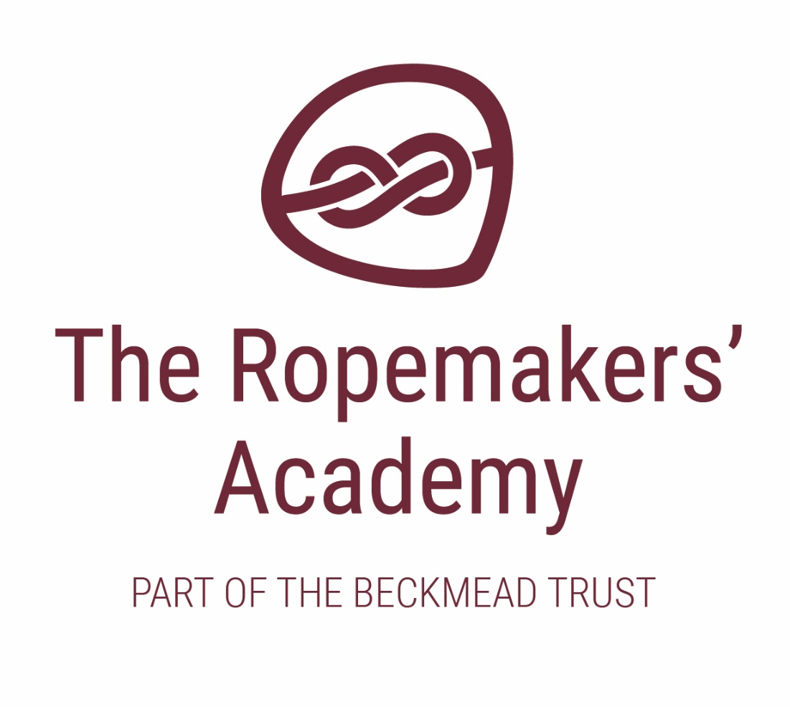

ADMISSIONS POLICY

Name of Policy | Admissions Arrangements
Policy Level | Trust
Date of Issue | July 2018
Author | Board of Trustees
Date of Next Review | September 2020
Signature | Dr Jonty Clark
Date of Signature | September 2018

Table of Contents
1. Aims 4
2. Legislation and statutory requirements 4
3. Definitions 4
4. How to apply 5
5. Requests for admission outside the normal age group 5
6. Allocation of places 5
7. In-year admissions 6
8. Appeals 6
9. Monitoring arrangements 6

1. Aims

This policy aims to:
- Explain how to apply for a place at the Ropemakers’ Academy
- Set out the school’s arrangements for allocating places to the pupils who apply
- Explain how to appeal against a decision not to offer your child a place.

2. Legislation and statutory requirements

This policy is based on the following advice from the Department for Education (DfE):
- School Admissions Code
- School Admission Appeals Code.
As an academy, the School is required by its funding agreement to comply with these codes, and with the law relating to admissions as set out in the School Standards and Framework Act 1998.
This policy complies with our funding agreement and articles of association.
The member schools of The Beckmead Trust will have a designated number of pupils on roll. These pupil numbers may be made up with a number of children from other local authorities who may have needed a school place when one was available at a Trust School. Member schools of the Trust in partnership with LA’s will recoup monies directly for these placements. It is important that all the schools are as near to capacity as possible at all times to mitigate any possible reduction in funding.
The Ropemakers’ Academy has places for 80 pupils from the ages of 4 – 16, and is co-educational, accepting both male and female students.

3. Definitions

The normal admissions round is the period during which parents/carers would apply for state-funded School places at the School’s normal point of entry, using the common application form provided by their home local authority.
Looked after children are children who, at the time of making an application to a School, are:
- In the care of a local authority, or
- Being provided with accommodation by a local authority in exercise of its social services functions.
Previously looked after children are children who were looked after, but ceased to be so because they:
- Were adopted under the Adoption Act 1976 or the Adoption and Children Act 2002, or
- Became subject to a child arrangements order, or
- Became subject to a special guardianship order.
A child reaches compulsory School age on the prescribed day following his or her fifth birthday (or on his or her fifth birthday if it falls on a prescribed day). The prescribed days are 31 December, 31 March and 31 August.

4. How to apply

For applications in the normal admissions round you should use the application form provided by East Sussex local authority school admissions team. As a special school we can only accept pupils who are in receipt of an Education Health and Care Plan (EHCP) and the East Sussex Inclusion, Special Educational Needs and Disabilities (ISEND) team are responsible for allocating pupils to us.
You can work with the support of the SEN team within your Local Authority if your child is in receipt of an Education, Health and Care Plan (EHCP) or is in the process of receiving a plan.
You will receive an offer for a School place directly from your local authority. They will consult with us as a school to ensure that we are able to meet your child’s needs.

5. Requests for admission outside the normal age group

Parents/carers are entitled to request a place for their child outside of their normal age group.
Decisions on requests for admission outside the normal age group will be made on the basis of the circumstances of each case and in the best interests of the child concerned. In accordance with the School Admissions Code, this will include taking account of:
- Parents/carers’ views
- Information about the child’s academic, social and emotional development
- Where relevant, their medical history and the views of a medical professional
- Whether they have previously been educated out of their normal age group
- Whether they may naturally have fallen into a lower age group if it were not for being born prematurely
- The Headteacher’s views

Wherever possible, requests for admission outside a child’s normal age group will be processed as part of the main admissions round. They will be considered on the basis of the admission arrangements laid out in this policy. Applications will not be treated as a lower priority if parents/carers have made a request for a child to be admitted outside the normal age group.
Parents/carers will always be informed of the reasons for any decision on the year group a child should be admitted to. Parents/carers do not have a right to appeal if they are offered a place at the School but it is not in their preferred age group.

6. Allocation of places
Admission number
The School has an agreed admission number of pupils which is determined by the agreed number on roll. (80) The school will occasionally exceed this number if it is possible to do so whilst maintaining an outstanding level of education and care for all children and staff.

7. In-year admissions
You can apply for a place for your child at any time outside the normal admissions round. As is the case in the normal admissions round, all children whose EHCP names the school will be admitted as long as an appropriate vacancy exists.
Likewise, if there are spaces available in the year group you are applying for, your child will always be offered a place.
If there are no spaces available at the time of your application, your child’s name could be added to a waiting list for the relevant year group. Priority will not be given to children on the basis that they have been on the waiting list the longest and will be decided by the school and the East Sussex ISEND team.
Applications for in-year admissions should be sent to the ISEND team at County Hall, Lewes. Further information can be found via:
https://www.eastsussex.gov.uk/childrenandfamilies/specialneeds/schoolcollege/ehc/ask-ehc/request/
https://www.eastsussex.gov.uk/educationandlearning/schools/admissions/

8. Appeals
If your child’s application for a place at the Ropemakers’ Academy is unsuccessful, you will be informed why admission was refused and given information about the process for hearing appeals. If you wish to appeal, you must set out the grounds for your appeal in writing and send it to the ISEND team at County Hall.

9. Monitoring arrangements
This policy will be reviewed and approved by the Board of Trustees every year.
Whenever changes to admission arrangements are proposed (except where the change is an increase to the agreed admission number), the Board of Trustees will publicly consult on these changes.

