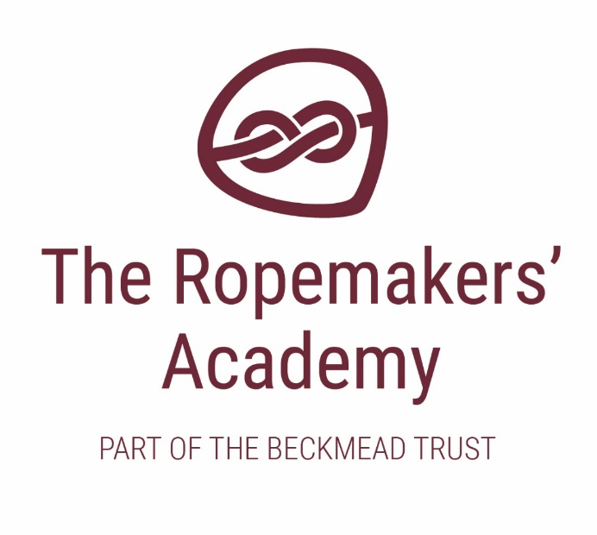

SEX AND RELATIONSHIP EDUCATION TRUST POLICY

Name of Policy | Sex and relationship education policy
Policy Level | Trust
Date of Issue | July 2018
Author | Board of Trustees
Date of Next Review | January 2020
Signature | Dr Jonty Clark
Date of Signature | September 2018

Table of Contents
- Aims 3
- Statutory requirements 3
- Policy development 3
- Definition 4
- Delivery of SRE 4
- Roles and responsibilities 4
- Parents/carers’ right to withdraw 5
- Training 5
- Monitoring arrangements 5

Aims
The aims of sex and relationship education (SRE) at our school are to:
  - Provide a framework in which sensitive discussions can take place
  - Where appropriate, prepare pupils for puberty, and give them an understanding of sexual development and the importance of health and hygiene
  - Help pupils develop feelings of self-respect, confidence and empathy
  - Create a positive culture around issues of sexuality and relationships
  - Teach pupils the correct vocabulary to describe themselves and their bodies.

SRE will always take full account of the ethos and values of the schools in the trust. In particular, SRE will take full account of our approach to teaching and learning which is focused on meeting individual pupils’ needs, given that our pupils have a range of special educational needs and disabilities and will present challenging behaviours.

Statutory requirements

The Relationships Education, Relationships and Sex Education and Health Education (England) Regulations 2019, made under sections 34 and 35 of the Children and Social Work Act 2017, make Relationships Education compulsory for all pupils receiving primary education and Relationships and Sex Education (RSE) compulsory for all pupils receiving secondary education.

Policy development
Our schools will consult parents/carers and stakeholders when creating an SRE policy.
Therefore, this policy has been developed in consultation with staff, pupils and parents/carers. The consultation and policy development process involved the following steps:
- Review – Members of staff have collated all relevant information including relevant national and local guidance
- Staff consultation – all school staff are given the opportunity to look at the policy and make recommendations
- Parents/carers and stakeholder consultation – parents/carers and any interested parties are invited to contribute to and comment on the policy
- Pupil consultation – we consult on what exactly pupils want from their SRE
- Ratification – this policy is shared with Trustees and ratified by the Board of Trustees. It is also circulated to LGB’s for input especially Teaching and Learning Committees.

Definition
SRE is about the emotional, social and cultural development of pupils, and involves learning about relationships, sexual health, sexuality, healthy lifestyles, diversity and personal identity.
SRE involves a combination of sharing information, and exploring issues and values. SRE is not about the promotion of sexual activity.

Delivery of SRE
SRE is taught within the personal, social, health and economic (PSHE) education curriculum. Biological aspects of SRE are taught within the science curriculum, and other aspects are included in religious education (RE).
The new Government guidance describes two components to SRE, namely:
- Relationships Education
- Sex Education

Our primary children will be taught Relationships education. Our secondary pupils are taught sex and relationships education.
Within this our secondary pupils will receive stand-alone sex education sessions delivered by a trained health professional where appropriate.
Individual discussion and teaching may take place with key members of staff such as teaching assistants and therapists especially if specific concerns or input is deemed appropriate.
Across all key stages, pupils will be supported with developing the following skills:
  - Communication, including how to manage changing relationships and emotions
  - Recognising and assessing potential risks
  - Assertiveness
  - Seeking help and support when required
  - Informed decision-making
  - Self-respect and empathy for others
  - Recognising and maximising a healthy lifestyle
  - Managing conflict
  - Discussion and group work.
These skills are taught within the context of family life or a care home. The approaches to the teaching and learning of these skills will be differentiated to meet the individual needs of pupils, taking full account of their special educational needs and disabilities, and social, emotional, and behavioural difficulties.

Pupils with special educational needs and disabilities (SEND)

Relationships Education, RSE and Health Education must be accessible for all pupils.
High quality teaching that is differentiated and personalised will be the starting point to ensure accessibility to our pupils. We are also required to be mindful of the preparing for adulthood outcomes, as set out in the SEND code of practice, when teaching these subjects to those with SEND.
We are aware that some pupils are more vulnerable to exploitation, bullying and other issues due to the nature of their SEND. Relationships Education and RSE can also be particularly important subjects for some pupils; for example those with Social, Emotional and Mental Health needs or learning disabilities.
Such factors will be taken into consideration when we are designing and teaching these subjects. Due to the nature of the needs of some of our pupils, there may be a need to tailor content and teaching to meet the specific needs of those pupils at different developmental stages. As with all teaching for these subjects, we will ensure that our teaching is sensitive, age-appropriate, developmentally appropriate and delivered with reference to the law.

Roles and responsibilities

The Board of Trustees
The Board of Trustees will approve the SRE policy, and hold each Head to account for its implementation.

The Headteacher
Each Head is responsible for ensuring that SRE is taught consistently across the school, and for managing requests to withdraw pupils from components of SRE (see section 7).

Staff
Staff are responsible for:
    - Delivering SRE in a sensitive way
    - Modelling positive attitudes to SRE
    - Monitoring progress
    - Responding to the needs of individual pupils
    - Responding appropriately to pupils whose parents/carers wish them to be withdrawn from the various components of SRE.
Staff do not have the right to opt out of teaching SRE. Staff who have concerns about teaching SRE are encouraged to discuss this with senior staff within their school.

Pupils
Pupils are expected to engage fully in SRE and, when discussing issues related to SRE, treat others with respect and sensitivity.

Parents/carers’ right to withdraw
Parents/carers continue to have the right to withdraw their children from the sex education component of SRE.
They do not have the right from September 2020 to withdraw their children from the relationships education element of the SRE curriculum.
Requests for withdrawal from sex education should be put in writing and addressed to the Headteacher. A copy of withdrawal requests will be placed in the pupil’s educational record. The Headteacher will discuss the request with parents/carers and take appropriate action.
Alternative work will be given to pupils who are withdrawn from sex education.

Training
Staff are trained on the delivery of SRE as part of their induction and it is included in our continuing professional development calendar.
The Head will also invite visitors from outside the school, such as school nurses or sexual health professionals, to provide support and training to staff teaching SRE.

Monitoring arrangements
The delivery of SRE is monitored by the nominated trustee through planned scrutiny such as lesson observations, learning walks, discussions with pupils, and any other appropriate means.
Pupils’ development in SRE is monitored by class teachers as part of our internal assessment systems.
This policy will be reviewed by the Board of Trustees.

Further Information

Further information can be found via:

https://www.gov.uk/government/news/relationships-education-relationships-and-sex-education-rse-and-health-education-faqs

