Teaching, Learning, Marking and Assessment Policy

Table of Contents

1. The Vision for Teaching and Learning 3
2. Planning at Roundwood School 5
3. Behaviours for Learning Checklist 7
4. Marking Principles 10
5. Learning Folders 14
6. Triangulation Meetings 16

1. The Vision for Teaching and Learning
At Roundwood School we believe in the concept of lifelong learning and the notion that learning should be a rewarding and enjoyable experience for everyone. It should be exciting, challenging and dynamic.
All teaching and learning, will be underpinned by our Core Values of -
- Love
- Flourishing
- Social Justice
- Community
These values must be evident in the learning that children complete and the teaching that adults prepare and deliver. Everything must be seen through this lens in order to create a coherent approach to teaching and learning.
Through our teaching we equip children with the skills, knowledge and understanding necessary to be able to make informed choices about the important things in their lives.
We believe that appropriate teaching and learning experiences help children to lead happy and rewarding lives.

We believe children learn best when:
- Learning activities are well planned, ensuring progress in the short, medium and long term
- Teaching and learning activities enthuse, engage and motivate children to learn, and foster their curiosity and enthusiasm for learning
- Assessment informs teaching so that there is provision for support, repetition and extension of learning for each child, at each level of attainment
- The learning environment is ordered, the atmosphere is purposeful and children feel safe
- There are strong links between home and school, and the importance of parental involvement in their children’s learning is recognised, valued and developed
At Roundwood School we have high expectations. We challenge both students and staff in order to achieve the highest standards. We know our students can find learning difficult, so we provide a high level of targeted support to ensure everyone is successful in achieving their individualised and bespoke targets and expectations. Our students face many different challenges and we look to help them develop resilience towards these. Our focus on the complete wellbeing of our students and nurturing approaches helps them feel safe and be safe.

Through our vision we aim to foster:
- A high level of literacy and numeracy and an enquiring mind which wants to learn more each day
- Independent young people who are confident, flexible and able to cooperate with others
- Imagination and creative expression through a wide range of media
- Conscientious young citizens of our multi-cultural society who are tolerant and respect others’ values
- Pride in achievement and a desire to succeed
- Effective links between the school, the child’s home and the community which promote aspiration and high expectations
- Equality of opportunity for all.

The characteristics of effective teaching and learning at Roundwood School:

- Teaching is planned effectively to promote students’ learning. Time in lessons is used productively. Students focus well on their learning because the teacher has consistently high expectations of student behaviour and sets clear tasks that challenge students.

- In lessons, the teacher develops, consolidates and deepens students’ knowledge, understanding and skills. Sufficient time is given for students to review what they are learning and to develop further. The teacher identifies and effectively supports those students who start to fall behind and intervenes quickly to help them to improve their learning.

- Secure subject knowledge is used to plan learning that sustains students’ interest and challenges their thinking. The teacher uses questioning skilfully to probe students’ responses, tackles misconceptions and builds on students’ strengths.

- The teacher gives students feedback, in line with our feedback and marking policies. Students use this feedback well and they know what they need to do to improve.

- The teacher develops and promotes students’ reading, writing and communication, and where appropriate mathematics, across the curriculum.

- The teacher expects and encourages all students to work with positive attitudes so that they can apply themselves and make strong progress.

- Students develop the capacity to learn from their mistakes and as a result demonstrate resilience and perseverance when faced with challenging tasks. They are keen learners who want to find out more.

- Students commit to improving their work. They are given time to apply their knowledge and understanding in new ways that stretches their thinking and to practise key skills.

- The teacher promotes equality of opportunity and diversity.

- Evidence of work is important for the children and their parents and carers. We use folders and books as evidence and to celebrate students’ learning.

- Teachers must follow the Marking Policy

2. Planning at Roundwood School

Planning must consist of:

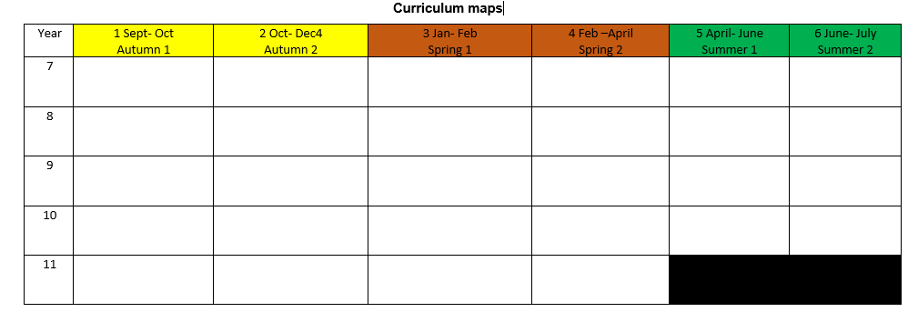
2.1 Curriculum maps
These outline the topic headings for the 6 half terms for all year groups
The specification provides the guidelines that define the structure and content of a course. It maps out clearly how resources, class activities and assessment strategies will be used to ensure that the learning aims and objectives of the course are met successfully.

2.2 Medium Term Plans
These map out clearly what is being done each half term. There must be clear progression and sequenced learning towards building knowledge and skills for future learning. Strategies that teachers may incorporate into their Medium term plans are outlined below.

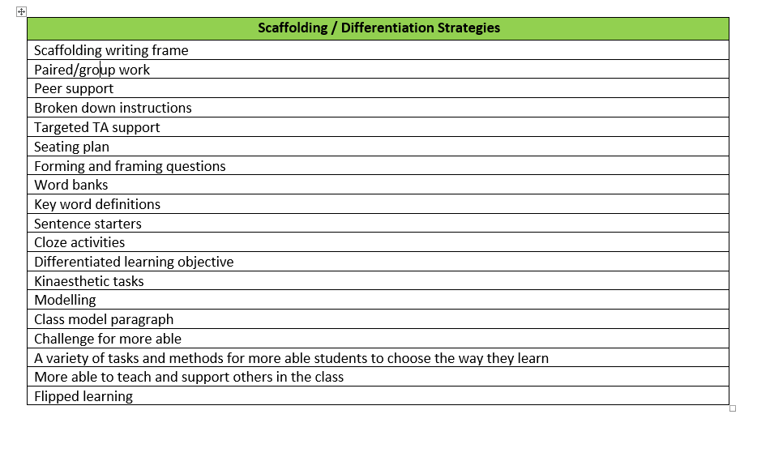
2.3 Planning scrutiny proforma
When looking at lessons and their planning and preparation, the following checklist will be used. This will be used to guide feedback to teachers and support coaching conversations in how best to support our learners. Feedback to staff will be regular and ongoing throughout the year. Due to the bespoke nature of our curriculum, observation and feedback will be regular and frequent, with the focus on development of staff for the betterment of students.
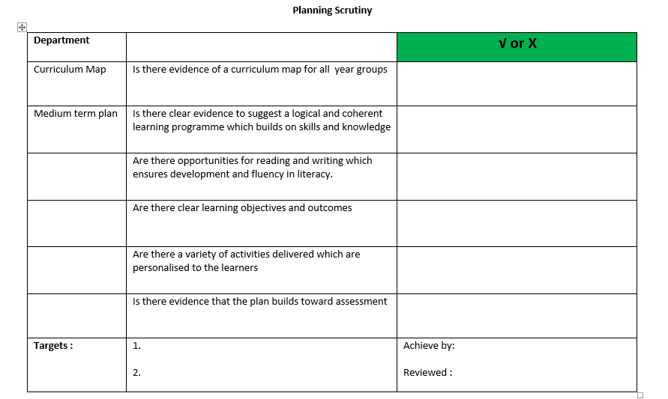

3. Behaviours for Learning Checklist

Lesson Planning
- Take ownership of the room. Ensure you have a seating plan.
- Make sure you know the names of your students.
- Always aim to have a ‘do now’ activity at the start of the lesson building on prior learning, so no time is wasted

At the start of the lesson
- Always meet and greet and correct at the door while standing outside your classroom. Use positive comments and non-verbal communication to enforce behaviour
- Acknowledge latecomers but don’t let it disrupt the lesson

During the lesson
- Establish clear routines by using simple instructions
- Use non-verbal skills e.g. ‘the stare’ to deal with off task or poor behaviour and ‘thumbs up’ when students respond to your instructions
- ‘Work the room’ by walking all around the room to take ownership of the space. Do not just sit or stand behind your desk
- Use lots of praise, positive reinforcement and the school’s Merit system
- When dealing with low level disruption move around to the individual and speak to them quietly
- Try to focus on good behaviour rather than off-task behaviour

After a lesson
- Make phone calls home about achievement and positive behaviour. Remember to structure the call to include Attainment, Behaviour and Commitment
- Try to engage with students outside lessons, talk to them and find out about them

Dealing with disruptive behaviour
- Use their name, keep eye contact, pause, body language, Action “Look this way”, thank you and then move on
- Ask them “What should you be doing now?” this helps to refocus them.
- Provide the power of choice “I have asked you to move seats. If you choose not to move, I will have to keep you behind at break. If you choose to move I won’t have to do this, you decide”
- Diversion- agree and refocus so it is not structured as an argument “Maybe you are going to the bin but can you sit down, thank you”
- Use non-confrontational techniques “Is everything alright there, how can I help you, do you have a question?”
- Avoid using please and try to use thank you instead “Can you stop talking, thank you”
- Appear reluctant to give a consequence “I would much rather you stopped talking and then I wouldn’t have to keep you behind”
- Provide students with every opportunity to back down and be explicit about this “You still have a chance to sort this out.
- After a consequence has been given, use praise at the first opportunity. Always wipe the slate clean and avoid referring back to historical previous behaviour.
Be the change you want to see and always model positive behaviour
Marking And Assessment
Learning Walk Checklist
Learning Walks will be regular and frequent. The aim of these is to reassure staff and to enable effective planning and support for students. There is no agenda of ‘trying to catch teachers out’. Our students will present challenges at times and regular learning walks will enable the school to identify good practice and re-model/re-purpose teaching and learning where it is less effective. The aim is to create a rich dialogue around teaching and learning.

Teacher:…………….Class:………Period:……Observer:……………Date:…………..
Evidence of | √ or X | Notes
Do NOW
Clear learning objectives and outcomes
Quick pace
Is there evidence the teacher knows the learners
Level of challenge suited to need of learner
Pair /group /independent activities
Activities engaging
Opportunities to deepen understanding by a range of questioning
Opportunities to write – extended writing activities
Constant reference to LOs- checking learning
Use of the TA
Plenary consists of what learned in the lesson
Students show respect for self, others and the environment- a nice positive calm learning environment
Students are able to demonstrate and take responsibility for their own self by having the correct uniform are punctual to lessons and engage positively in learning
Learners are positive to each other and are supportive of each other in becoming more resilient
Action(s)/Who/When: | 1.  2

4. Marking Principles
The purpose of our marking principles is:
- To establish a consistent and purposeful approach to the way the student’s work is marked, so that students feel valued.
- to enable students to have a clear understanding of how well they are doing and how to make progress.
- To ensure all students have their work marked regularly and precisely to help them reach or exceed their full potential.
- To inform teacher planning and monitoring.

Key Principles
This marking policy applies to all Key Stages.

- All work should be marked consistently with clear links to assessment objectives.
- All work should be marked for literacy.
- All work should be marked for factual accuracy.
- All marking should be completed in green ink.
- Where appropriate, work should be graded in line with school policy and GCSE guidelines; with an explanation of what has been achieved and what needs to be done to achieve the next grade. This should be done using WWW (What Went Well) and EBI (Even Better If).
- Where the teacher deems appropriate, poorly presented work should be commented upon by the teacher. This must be done sensitively.

The teacher should
- Indicate where some improvements can be made in relation to the learning outcomes/ success criteria.
- Mark for literacy – see below.
- Correct factual errors.

The student should
- Look carefully at the learning outcomes/success criteria to remind them of what they were learning.
- Read, act and respond to the teacher’s comments to make an improvement. This should be completed in pen, after the teacher’s comment.

Peer/Self-Assessment
Peer and self-assessment should be used in addition to teacher assessment where appropriate as indicated in schemes of learning. This may be verbal or written. This should also be completed in a GREEN pen (when written).

Make It Better! (MIB!)
After student work has been marked/assessed students should be given the opportunity to respond to teacher comments/questions and make improvements based on feedback.

Live Feedback
Teacher to offer live feedback during lessons as they circulate (e.g. verbal discussions, questions, verbal targets, coded targets).

Marking for Literacy

✔ | This is where you have achieved the learning outcomes/success criteria.
X | Factual inaccuracy
Sp | Incorrect spelling
// | New paragraph
WW | Wrong word
? | Confusing
C | Capital letter errors
G | Grammatical error
P | A problem with punctuation
Exp (expression) | Something doesn’t make sense
WO | Working out required
^ | Missing word

BTEC Marking

- Feedback given using the Exam Board Assessment record sheets
- Feedback must be in line with BTEC expectations and criteria. During assessment periods students will not receive formative feedback.
- Summative feedback will use the BTEC assessment sheet. It will state the criteria achieved, the criteria achieved will also be written on the work, e.g. ‘P1’ where the evidence is.
- Summative feedback will state the criteria not achieved, but will NOT state how to achieve this.
- Students may receive a 15 period window to resubmit work after making improvements without further support, providing they achieve the initial deadline. Summative feedback will again follow this.
- BTEC work will be marked for SPAG (spelling, punctuation and grammar).
- Students given time to re-draft and re-submit work as per the assessment plan.
- Correct documentation to be completed as per BTEC guidelines (Assessment Record Sheet, internal verification – assessment decisions, internal verification – assignment brief, learner assessment submission and declaration, observation / witness record where appropriate)
Roles and Responsibilities
Teacher
- Ensure work is marked in line with the policy
- Share good practice of book marking where necessary
- Implement MIB to support students’ progress

HLTA/TA
- Look at teacher’s comments/feedback in order to guide students they are working with

Senior Leadership Team
- Support staff to implement the policy
- Monitoring books when required to do so

Students
- Read comments and use MIB
- Respond positively to comments in GREEN pen
- Put their best effort into book work

Parents
- To support the school and encourage their child to use MIB positively

Governors
- To agree to the schools marking policy
- To listen to feedback on the implementation of the new policy
- On monitoring visit Governors are encouraged to sample students work

5. Learning Folders

There are regular opportunities to assess students' learning. This will be completed through regular work scrutinies/book looks.
This will result in 3 data collection points over the year.

Learning Folders
All students will have a green Learning Folder in which they will put their work and assessments. Their data and targets will be recorded on their Learning progress record sheet which is kept at the front of their green folder
Learning Folders are an important way of collating an overview of student progress. They are also the place that students can reflect upon and sum up their progress every term. Learning Folders should be kept in the teaching room for the class they relate to. They should always be up to date and well presented.
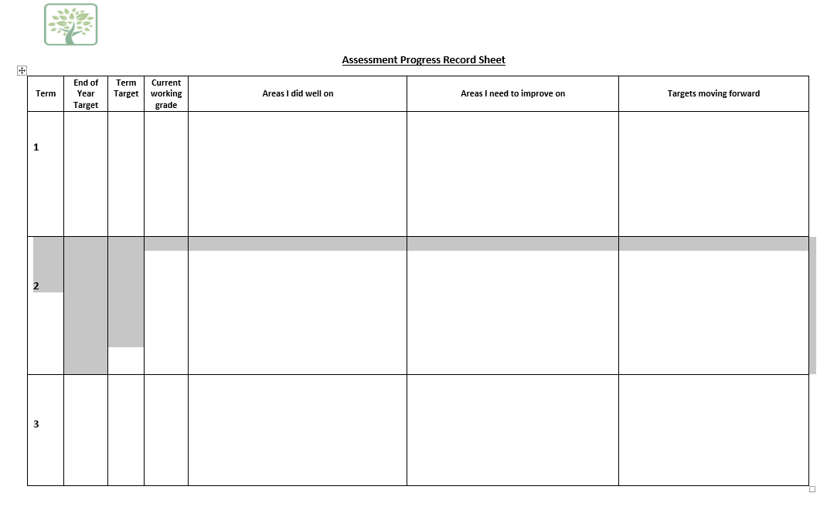
Book and Assessment checklist for Teachers
Book Looks/work scrutinies will be regular, frequent and informal.The aim of these is to reassure staff and to enable effective planning and support for students. There is no agenda of ‘trying to catch teachers out’. Our students will present challenges at times and regular book looks will enable the school to identify good practice and re-model/re-purpose teaching and learning where it is less effective. The aim is to create a rich dialogue around teaching and learning.

Subject:
Teacher/s:
 | √ or X | √ or X
Is there a Date and Title for the lesson
Is end of Year target grade written on front cover of the Learning Folder
Is Marking for Literacy evident inside the Folder
Progress – check against planning
Marked in green pen by the teacher
Learner response is evident
Targets identified and acted upon / MIB
Evidence of peer marking
Is marking Regular
Is the level of challenge appropriate
Is there evidence of extended writing tasks
Is the Learning Progress record evident in the Learning Folder
Is this record filled in with identified targets
Project Mark sheets present and filled in
Actions/Who/When | 1.
 | 2.

6. Triangulation Meetings
This process will occur 3 times per year, once per term.
It is a process by which teachers collect evidence about the students learning. The sources will come from Teaching and Learning, Assessment and Data, Student books and Student Voice. Teachers will meet with the Headteacher formally to discuss their class and are welcome to bring evidence of planning, observations and interventions to the meeting.
This process will feed into the formal Appraisal process. Staff will be given notice of when triangulation weeks are due, by the latest at the start of each term.

