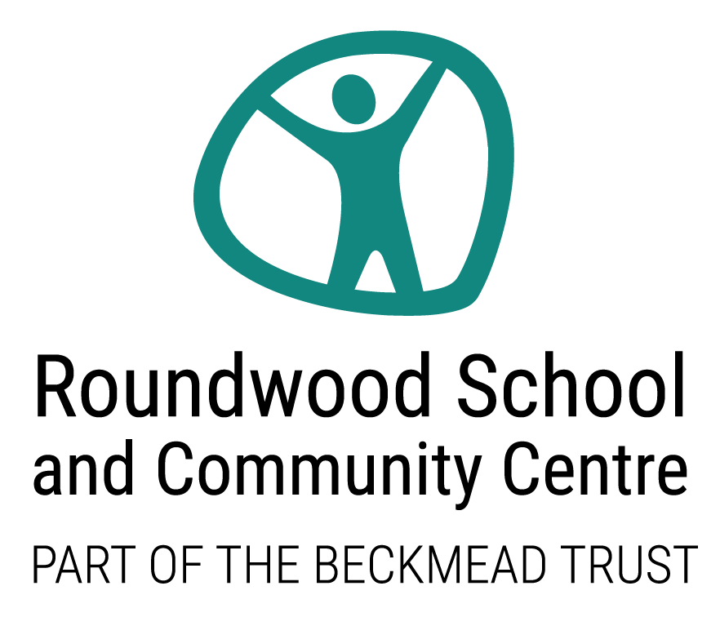

Risk Assessments Policy

ACADEMIC YEAR | AUTHOR | ROLE | DATE OF NEXT REVIEW
2021-2022 | Juan Fernandez | Headteacher | January 2022

1. Aims
Roundwood School and Community Centre aims to ensure that:
- All risks in our school that may cause injury or harm to staff, students and visitors are identified, and all control measures that are reasonably practicable are in place to avoid injury or harm
- Risk assessments are conducted and reviewed on a regular basis

2. Legislation and statutory requirements
This policy is based on the following legislation and Department for Education (DfE) guidance:
- Paragraph 16 of part 3 of The Education (Independent School Standards) Regulations 2014 which requires proprietors to have a written risk assessment policy
- Regulations 3 and 16 of The Management of Health and Safety at Work Regulations 1999 require employers to assess risks to the health and safety of their employees, including new and expectant mothers
- Regulation 4 of The Control of Asbestos Regulations 2012 requires that employers carry out an asbestos risk assessment
- Employers must assess the risk to workers from substances hazardous to health under regulation 6 of The Control of Substances Hazardous to Health Regulations 2002
- Under regulation 2 of The Health and Safety (Display Screen Equipment) Regulations 1992, employers must assess the health and safety risks that display screen equipment pose to staff
- Regulation 9 of The Regulatory Reform (Fire Safety) Order 2005 says that fire risks must be assessed
- Regulation 4 of The Manual Handling Operations Regulations 1992 requires employers to conduct a risk assessment for manual handling operations
- The Work at Height Regulations 2005 say that employers must conduct a risk assessment to help them identify the measures needed to ensure that work at height is carried out safely
- DfE guidance on first aid in schools says schools must carry out a risk assessment to determine what first aid provision is needed
- DfE guidance on the prevent duty states that schools are expected to assess the risk of students being drawn into terrorism
- The Health and Safety Executive (HSE) say schools that manage their own pools must conduct a risk assessment
A table of all the risk assessments schools are required to have in place can be found in Appendix 1 of this policy.
This policy complies with our funding agreement and articles of association.

3. Definitions

Risk assessment | A tool for examining the hazards linked to a particular activity or situation, and establishing whether enough precautions have been taken in order to prevent harm from them based on their likelihood and their potential to cause harm
Hazard | Something with the potential to cause harm to people, such as chemicals or working from height
Risk | The chance (high or low) that people could be harmed by hazards, together with an indication of how serious the harm could be
Control measure | Action taken to prevent people being harmed

4. Roles and responsibilities
4.1 The Beckmead Trust Board of Trustees/Local Governing Board (LGB)
The Beckmead Trust Board of Trustees/Roundwood’s School Local Governing Board (LGB) has ultimate responsibility for health and safety matters in the school, but will delegate day-to-day responsibility to the Headteacher, Juan Fernandez.
The governing board has a duty to take reasonable steps to ensure that staff and students are not exposed to risks to their health and safety. This applies to activities on or off the school premises.
The Beckmead Trust Board of Trustees/Roundwood’s School Local Governing Board, as the employer, also has a duty to:
- Assess the risks to staff and others affected by school activities in order to identify and introduce the health and safety measures necessary to manage the risks
- Inform employees about risks and the measures in place to manage them

4.2 The Headteacher
The Headteacher is responsible for ensuring that all risk assessments are completed and reviewed.

4.3 School staff and volunteers
School staff are responsible for:
- Assisting with, and participating in, risk assessment processes, as required
- Familiarising themselves with risk assessments
- Implementing control measures identified in risk assessments
- Alerting the headteacher to any risks they find which need assessing

4.4 Students and parents
Students and parents are responsible for following the school’s advice in relation to risks, on-site and off-site, and for reporting any hazards to a member of staff.

4.5 Contractors
Contractors are expected to provide evidence that they have adequately risk assessed all their planned work.

5. Risk assessment process
When assessing risks in the school, we will follow the process outlined below.
We will also involve staff, where appropriate, to ensure that all possible hazards have been identified and to discuss control measures, following a risk assessment.
Step 1: identify hazards – we will consider activities, processes and substances within the school and establish what associated-hazards could injure or harm the health of staff, students and visitors.
Step 2: decide who may be harmed and how – for each hazard, we will establish who might be harmed, listing groups rather than individuals. We will bear in mind that some people will have special requirements, for instance students with special educational needs (SEN) and expectant mothers. We will then establish how these groups might be harmed.
Step 3: evaluate the risks and decide on control measures (reviewing existing ones as well) – we will establish the level of risk posed by each hazard and review existing control measures. We will balance the level of risk against the measures needed to control them and do everything that is reasonably practicable to protect people from harm.
Step 4: record significant findings – the findings from steps 1-3 will be written up and recorded in order to produce the risk assessment. A risk assessment template can be found in appendix 2 of this policy.
Step 5: review the assessment and update, as needed – we will review our risk assessments, as needed, and the following questions will be asked when doing so:
- Have there been any significant changes?
- Are there improvements that still need to be made?
- Have staff or students spotted a problem?
- Have we learnt anything from accidents or near misses?
Step 6: retaining risk assessments – risk assessments are retained for the 3 years after the length of time they apply. Risk assessments are securely disposed of.

6. Monitoring arrangements
Risk assessments are written as needed and reviewed by the Headteacher, Juan Fernandez.
This policy will be reviewed by the Headteacher every year and approved by the Beckmead Board of Trustees/LGB.

7. Links with other policies
This risk assessment policy links to the following policies:
- Health and safety
- Education Visits Policy
- First aid
- Supporting students with medical conditions

8. Additional Information
At Roundwood School and Community Centre we have also contracted an outside support service to help us develop our Health and Safety and Risk Assessment processes, including quality assurance and compliance work

Appendix 1: Statutory risk assessments checklist
The following table lists the risk assessments that schools are required to have in place.

Statutory or mandatory risk assessment |  | Completed by | Date of review
Workers under the age of 18
Asbestos
Substances hazardous to health
Display screen equipment
Fire
First aid
Manual handling
Working at height
Children being drawn into terrorism
Swimming pools (if applicable)

Name of person completing the risk assessment |  |  |  |  | Date
What are the hazards? | Who might be harmed and how? | What control measures are already in place?  Are they sufficient? | What additional control measures are needed? | Action by who? | Action by when? | Completed?

Appendix 2: Generic Risk Assessment Template

