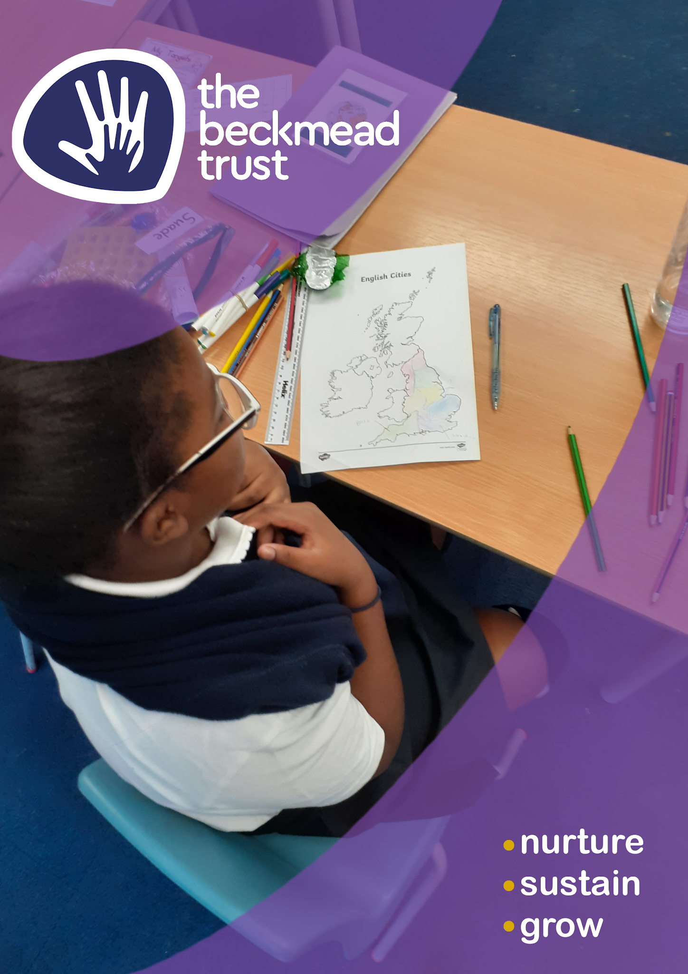
Food Policy
Food Policy

Policy Level | Trust
Date of Approval | June 2022
Author | Shared Services Committee
Date of Next Review | June 2024

Contents
- Summary
- Aims
- Objectives
- Monitoring & Evaluation
- National Guidance
- Nut Free Schools
- Food Waste
- Food Safety
- The Food and Eating Environments
- Water
- Packed Lunches
- Foods and Drinks we discourage include:
- Breakfast
- Food Allergy & Intolerances
- Special Dietary Requirements
- School Lunches
- Visits and Residentials
- Nurture or Reward activities around food
- Curriculum
- Events and Celebrations & Rewards
- Exemptions
- Appendix 1 - Food Standards - Eatwell Guide

1. Summary

This policy sets out the expectations of food provision provided and consumed in schools within The Beckmead Trust including before, during and after school and on school trips and during extracurricular events.

School name: The Beckmead Trust

Date of policy implementation: June 2022
Date of next Review: June 2024
This Beckmead Trust actively supports healthy eating and drinking throughout the school day. Each individual school has its own unique situation around the provision of food to its pupils and this is recognised, this policy is an overarching Trust guidance. Each individual school within The Beckmead Trust will be required to produce their own individual school policy based on this guidance.
The Beckmead Trust requires that every person who handles any food in our schools must be trained in accordance with current food hygiene and food safety guidelines so they know how to prepare food that is safe to eat.(This includes nurture, snacks, breakfast, lunches (packed or otherwise). They must follow the guidelines according to current food safety legislation and follow the Beckmead School Food Safety and Food Hygiene Policy as stated for the local school setting.
This policy must be read in conjunction with the Beckmead Trust Food Management Policy.
2. Aims
To ensure that all aspects of food and nutrition in school promotes the health and wellbeing of pupils, staff and visitors to our schools. Underpinning our provision for foods, in all areas will be the need to implement a healthy and sustainable food system, which is publicly accountable and socially and environmentally responsible.
The Beckmead Trust recognises the important part that a healthy diet plays in a child’s well-being and their ability to learn and achieve effectively. The Trust is dedicated to providing an environment that promotes healthy eating and enables pupils to make informed food choices.
We believe that the school, in partnership, can make a major contribution to improving children’s health by increasing their knowledge and understanding of food and helping them to make healthy food choices. This will be achieved by the whole Trust approach to food provision and food education documented in this policy.

Local School Food Policies will be coordinated by the Head teacher in consultation with the catering provider and school cooks alongside The Beckmead Trust Estates and Compliance Lead.

The main aims of this School Food Policy are:
- To provide a range of healthy food choices throughout the school day and in line with the mandatory School Food Standards.
- To support pupils to make healthy food choices and be better prepared to learn and achieve.
- To ensure a consistent approach to healthy eating across the Trust community including pupils, staff and parents/carers

3. Objectives

- Review the formal curriculum to ensure information relating to food and nutrition in different lesson areas is consistent and up to date.
- Work with the school caterers to review and trial healthier breakfast offerings and food around nurture, serving a range of items. To make changes to improve the offering as/when where necessary.
- Establish a Food Week in school to promote healthy eating and drinking messages.
- Ensure that teachers who are taking responsibility for food in the classroom have food hygiene training (Level2). Refresher training must be undertaken every 3 years.
- Ensure that those preparing foods in the main kitchens and teaching food tech have food safety and hygiene training (Level 2 minimum). Refresher training must be undertaken every 3 years. To participate in networking and training activities to improve knowledge and practice as required.
- All staff with food handling responsibilities, inside and outside the classroom, will be required to undertake additional allergy awareness and hazard control training. Refresher training will be required every 3 years or if there are any significant changes in the guidance.
- Ground to table food growing school activities encouraging children to lead healthier lives, through physical activity outdoors and inspiring children to eat the fruit and vegetables they have grown. https://www.sustainweb.org/publications/every_school_a_food_growing_sch ool/
- To incorporate the impact on the environment of what we eat and how we source it. To aim to educate on reducing our environmental impact, by showing how locally grown, seasonal food can enhance biodiversity and reduce waste.
- Raise educational standards and improve behaviour, particularly for those less comfortable in a classroom setting.

We will meet our objectives by:
- Discussions at school council.
- Formal curriculum: setting up a working group to audit food based topics across general learning areas.
- Healthier breakfast offerings: working with school caterers on a menu of breakfast options. Publicising this offering in school newsletters, plus through poster advertising in the corridors.
- Food week: running fruit and veg taster sessions. Having a food related competition.
- Linking with health promoting national events, such as Smile Week for Oral Health, World, Cancer Awareness etc.
- Continuing professional development for all staff involved in food handling.

4. Monitoring & Evaluation
We will monitor and evaluate progress through:

- Formal curriculum: teachers being able to identify food based topics through schemes of work.
- Healthier breakfast and nurture food options monitored
- Asking pupils, parents and teachers their thoughts about the food at school and the range of food provided.
- Food week: head teacher presenting certificates or prizes in school assembly. Displaying photographs at parents’ evening.
- Extra-curricular: producing a club recipe book, reports and photographs posted on the school website

5. National Guidance
This policy guidance has been written to reflect the School Food Standards that were revised in January 2015. It has also been written to reflect the Eatwell Plate Model of Healthy Eating and supports key outcomes of the School Food Plan. The policy supports Ofsted’s commitments to assess pupils’ knowledge of how to keep themselves healthy and our school’s ethos of healthy eating. The policy must be read in conjunction with the school’s Food Safety Policy which details safe storage and preparation of food within The Beckmead Trust schools.

6. Nut Free Schools
For the protection of pupils and staff with varying degrees of nut allergy The Beckmead Trust has a nut-free foods whole school approach. Parents are informed of the policy when their child starts school and are discouraged from bringing nuts or food containing nuts into school. Employees are advised of the policy as part of their induction. Any foods that contain nuts must be removed immediately.

This also applies to any food brought into school by staff or visitors for lunch/snacks.
7. Food Waste
The Beckmead Trust is committed to seeking to reduce food waste and to minimising the impact of wasted food on the environment through the use of food waste bins in kitchens.

8. Food Safety
Appropriate food safety precautions are taken when food is prepared or stored. These vary depending on the food on offer and include: ensuring that adequate storage and washing facilities are available; that food handlers undergo appropriate food hygiene training; and that suitable equipment and protective clothing are available. Any food safety hazards are identified and controlled. We consult our local Environmental Health Department about legal requirements.
Please read the Food Safety Policy alongside this document.

Although the Trust will have a corporate Food Safety Policy each school is required to have its own separate Food Safety Policy based on national and local guidelines and their own individual needs.

9. The Food and Eating Environments
Each school will set up its own specific eating environment(s) that meet the needs of the pupils in its care. These eating environments must be cleaned thoroughly each day. All food and general waste cleared away daily as part of hygiene and pest control measures.

10. Water
Clean drinking water will be available for all pupils throughout the day and pupils will be encouraged to drink water at frequent intervals. All packed lunch pupils have access to water at lunch time meaning there is no need for an additional drink to be brought as part of a packed lunch. Pupils are encouraged to bring a water bottle every day that they can refill as necessary. Bottles go home at the end of every day to be washed and returned. No drinks other than water will be brought into school by pupils unless recommended by a doctor for medical needs.

11. Packed lunches
If parents choose for their child not to have a meal prepared by the school, we ask them to provide children with packed lunches that complement the nutritional standards. This is achieved by promoting healthy packed lunch options using the principles of the ‘Eatwell Plate’. (Appendix 1)
This ensures that children having packed lunches have a healthy balanced meal. Food safety issues around packed lunches will be conveyed to parents.
Packed lunches provided (by the school) for school trips as part of our Free School Meal provision comply with National Food Standards.

12. Foods and drinks we discourage include:
- Foods with a high fat content e.g. chocolate
- Foods with a high sugar content e.g. sweets
- Foods with a high salt content
- Drinks containing high levels of sugar

13. Breakfast
This is an important meal that should provide 25% of a child’s energy requirement and contribute significantly to their vitamin and mineral requirements. This should be considered by staff in the provision of foods for breakfast.

14. Food Allergy & Intolerances
Food allergy and intolerance Individual care plans must be created for children with food allergies. These document symptoms and adverse reactions, actions to be taken in an emergency, and emergency contact details. Classroom staff, School caterers and relevant others must be made aware of any food allergies/food intolerance and requests for special diets are submitted according to an agreed process.
Staff must declare any food allergies and intolerances immediately they commence employment or asap if a change in the medical situation arises.

15. Special Dietary Requirements
The school provides food in accordance with pupils’ religious beliefs and cultural practices as required. School caterers offer a vegetarian option at lunch every day. Vegan options can be made available with notice.
Allergy information is provided with all school menus. The school cook is responsible for updating this information every time there is a change or amendment to the menu. Food Tech teachers are also responsible for ensuring this information is readily available for any foods used as part of their lessons
We recognise that some pupils may require special diets that do not allow for our food policy to be exactly met. In this case parents are asked to make us fully aware of this.
Individual care plans need to be created for pupils with special dietary needs/requirements. These should document symptoms and adverse reactions, actions to be taken in an emergency and emergency contact details, along with any particular food requirements e.g. for high-energy diets. School caterers are made aware of any food allergies/food intolerance/medical diets and requests for these diets are submitted according to an agreed process.

Details of food allergies are shared in a sensitive way and maintained by the local schools, information is kept on local staff and pupils files, with the kitchen manager and shared with all relevant catering staff. Teachers and Teaching Assistants should be aware of pupil allergies. Staff must ensure they also make their school aware of any allergies they may have.
Any sites where lunch is brought in by a 3rd party must follow the same guidelines.

All information relating to allergies and tolerances must be reviewed, updated and recorded annually. If changes occur between annual updates, the school must be informed immediately.

16. School Lunches
Food prepared by the school catering team must meet the School Food Standards (2015). Where possible, we will use organic and local ingredients.
As a school, we encourage pupils to have a school lunch provided by our catering service* and free school meals are provided to all those pupils who are entitled to them. We will advise on the process for obtaining a free meal where needed.
*some schools will have meals provided via a 3rd party.

Healthy options are promoted at lunchtime and the children should be consulted about food choices through local School Councils.
Staff will work with children to provide clean, safe, attractive and appropriate dining areas. Children are encouraged to be independent during the meal and clearing up after themselves at the end by tidying their plates and cutlery away. Pupils are provided with water with their school meal.

17. Visits and Residentials
Any meals taken off school site for day trips or as part of a residential trip will provide a balanced and healthy approach to meals and where possible we will look to use off site providers that comply with the National Food Standards.
Packed lunches provided (by the school) for school trips as part of our Free School Meal provision comply with National Food Standards.

18. Nurture or reward activities around food
This policy applies to all food within schools including food as part of nurture or reward activities. The provision of a healthy approach to food used in this aspect of school life must be considered at all times. This will ensure a healthy approach to food and its linked association to healthy eating is embedded with National Food Standards.

The Trust does not encourage food, especially unhealthy fast food, to be predominantly used as a reward for good behaviour or achievement.

19. Curriculum
Food, its production and preparation is an important part of the curriculum for all pupils at each key stage and is taught across the curriculum through Science, PHSE, PE and Design and Technology.
We reinforce our delivery of the national curriculum by holding a healthy schools week annually which enables us to focus on all aspects of healthy eating.
Food and nutrition is taught at an appropriate level throughout the school in Science, PSHE and Design Technology (cooking and nutrition).
The Eatwell Model is used throughout the school as a model of understanding a balanced diet. Occasional clubs also support the teaching of food and healthy eating (e.g. cooking or food growing) Staff delivering cooking sessions and clubs will have achieved Level 2 in Food Safety and Hygiene.

20. Events and Celebrations & Rewards
The Trust does not encourage the regular eating of sweets or other foods high in sugar or fat. Occasional fund-raising events may include the sale of treat food such as cakes, but the inclusion of other foods will also be encouraged. We generally request that parents do not bring in food from home as it is increasingly difficult to manage the associated allergy risks.

21. Exemptions
The School Food Regulations do not apply to food provided: At parties or celebration to mark religious or cultural occasions
  - At fundraising events
  - As rewards for achievement, good behaviour or effort
  - For use in teaching food preparation and cookery skills, including where the food is prepared to serve to pupils as part of a school lunch
The requirements in the School Food Regulations do not apply to confectionery, snacks, cakes or biscuits, served as part of an evening meal at maintained boarding schools before 6pm.

Appendix 1 - Food Standards Agency - Eatwell Guide
