Admission process
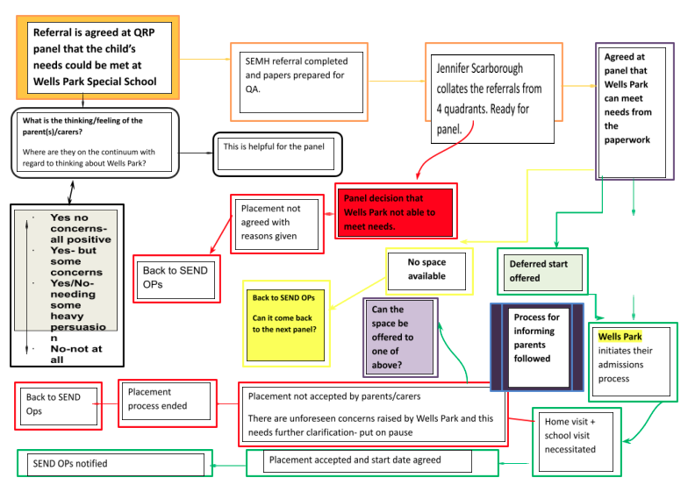

Assessment upon admission

Assessment systems in place
Subject | In- school summative assessment | When in the year the assessment occurs? | Who? | Where is assessment recorded?
Initial baseline | - Cambridge Primary Insight | Within 4 weeks of entry | All pupils who are able to access it | Online report in CEM
EYFS | - Early Learning Goals grid  - Early Learning Goals statements | Termly  Autumn, Spring, Summer | Pre- Band 1, 2 & 3 | EYFS assessment folder in each class
Phonics | - Little Wandle assessment | Half Termly | Phase 2,3,4,5 | EDart  Mid-term planning
Reading | - 2 Eskimos  - Teacher assessment- Reading statements  - Collins Reading comprehension progress tests | Termly  Autumn, Spring, Summer  At least termly or more often if required to confirm judgements | All pupils  (Pre Band 1- Band 6)  Bands 2-6 | EDart  Paper grid  Mid- term planning
Writing | - Writing assessment statements (using National Curriculum)  - Independent writing | Termly  Autumn, Spring, Summer | All pupils  (Pre Band 1- Band 6) | EDart  Paper grid  Mid- term planning
Maths | - Maths assessment statements (using National Curriculum)  - Whiterose assessment papers | Termly  Autumn, Spring, Summer | All pupils  (Pre Band 1- Band 6)  Band 1-6 | EDart  Paper grid  Mid- term planning
Science | - Science assessment statements (using National Curriculum)  - Plan Bee ½ termly assessment | Termly  Autumn, Spring, Summer | Band 1- Band 6 | EDart  Paper grid
ILPs | - National Curriculum Spelling Lists  - Assessment Statements | Weekly within class  ½ termly formal recording | All pupils  (Pre Band 1- Band 6) | EDart  In Books
24hr/Social Curriculum | - 6 Core Strengths | Termly Autumn, Spring, Summer | All Pupils | EDart
Summary of progress in Reading, Writing & Maths | - Forthcoming targets | Termly Autumn, Spring, Summer | All pupils | Termly report
EHCP review | - Review against EHCP outcomes identifying strengths and needs | Annual review | All pupils | Annual review
Planning placement | - Residential outcomes review in: Behaviour, Interacting & social language, Working with others, Emotional regulation and Self care & independence | Termly  Autumn, Spring, Summer | All pupils | Termly
Geography | - Annual assessment against curriculum coverage | Termly  Autumn, Spring, Summer | Band 1- Band 6 | Pupil reports
History | - Annual assessment against curriculum coverage | Termly  Autumn, Spring, Summer | Band 1- Band 6 | Pupil reports
Art | - Annual assessment against curriculum coverage | Termly  Autumn, Spring, Summer | Band 1- Band 6 | Pupil reports
DT | - Annual assessment against curriculum coverage | Termly  Autumn, Spring, Summer | Band 1- Band 6 | Pupil reports
RE | - Annual assessment against curriculum coverage | Termly  Autumn, Spring, Summer | Band 1- Band 6 | Pupil reports
Music | - Annual assessment against curriculum coverage | Termly  Autumn, Spring, Summer | Band 1- Band 6 | Pupil reports
PSHE | - Annual assessment against curriculum coverage | Termly  Autumn, Spring, Summer | Band 1- Band 6 | Pupil reports

Formative assessment
 | Formative assessment | When in the year the assessment occurs? | Who? | Where is assessment recorded?
Initial baseline | - Cambridge Primary Insight | Within 4 weeks of entry | All pupils who are able to access it | - Online report in CEM
Phonics | - Phonics screening | June | Yr 1 and Yr 2 if they did not meet the standard | - Annual reports
Times table | - Year 4 Times table checker | June | Year 4 | - Annual reports
Reading | - Year 6 SATS | May | Yr 6 pupils who are able to access it | - Annual reports  - WPS website
Maths | - Year 6 SATS | May | Yr 6 pupils who are able to access it | - Annual reports  - WPS website
SPaG  Spelling, Punctuation & Grammar | - Year 6 SATS | May | Yr 6 pupils who are able to access it | - Annual reports  - WPS website

