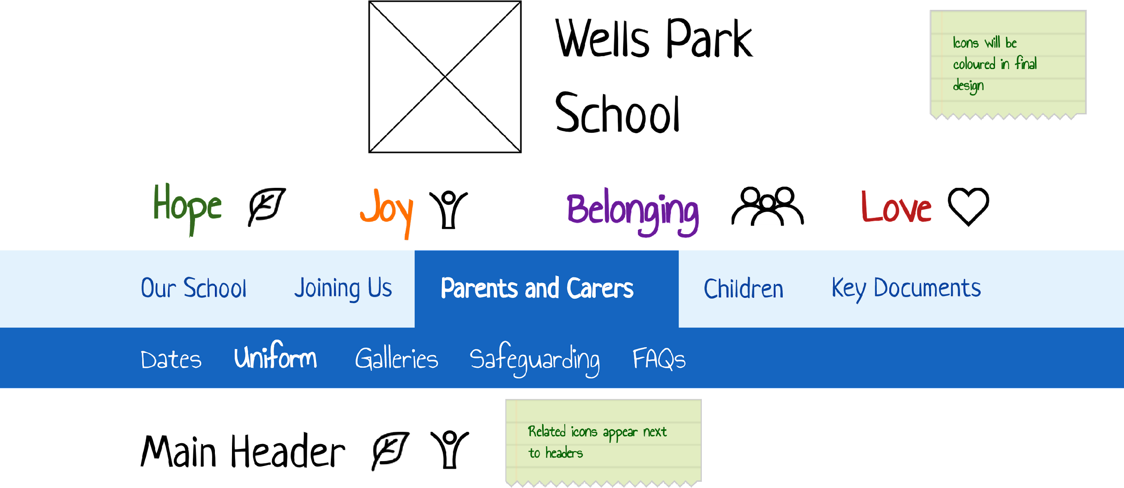
SCHOOL COUNCIL NEWSLETTER
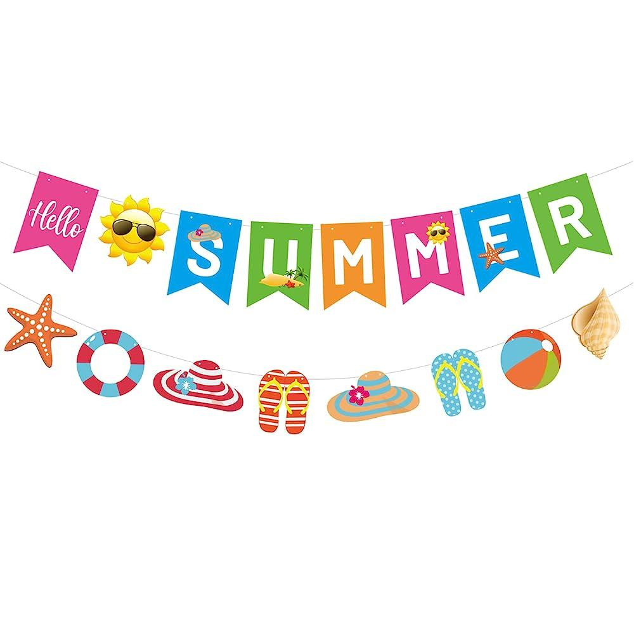
July 2024
Dear Wells Park Community,
The time has come again for us to enjoy the summer holidays, we hope the sun will be shining and we all get a well deserved break ready for action in September.
Lots has been going on since our last Newsletter, there have been many trips out with your class groups to London and not forgetting the yearly saver trips.
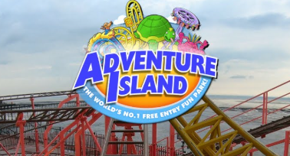
The choices this year were Gullivers land, Southend, Legoland, Chessington and Thorpe Park. Who was brave enough to face their fears and go on the fast and scariest rides?
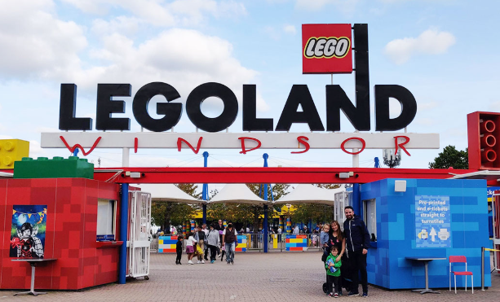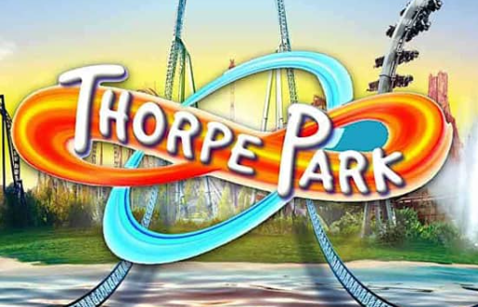

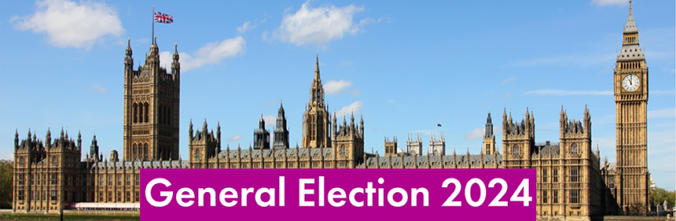
Purple class delivered an excellent assembly on the General Election. All votes have been counted and the winner is ; The Green Party!
Green party | 25 votes
Labour | 20 votes
Liberal democrats | 13 votes
Conservative | 7 votes
Total votes | 65 votes
Our new Prime Minister is Keir Starmer who is the leader of the Labour party. 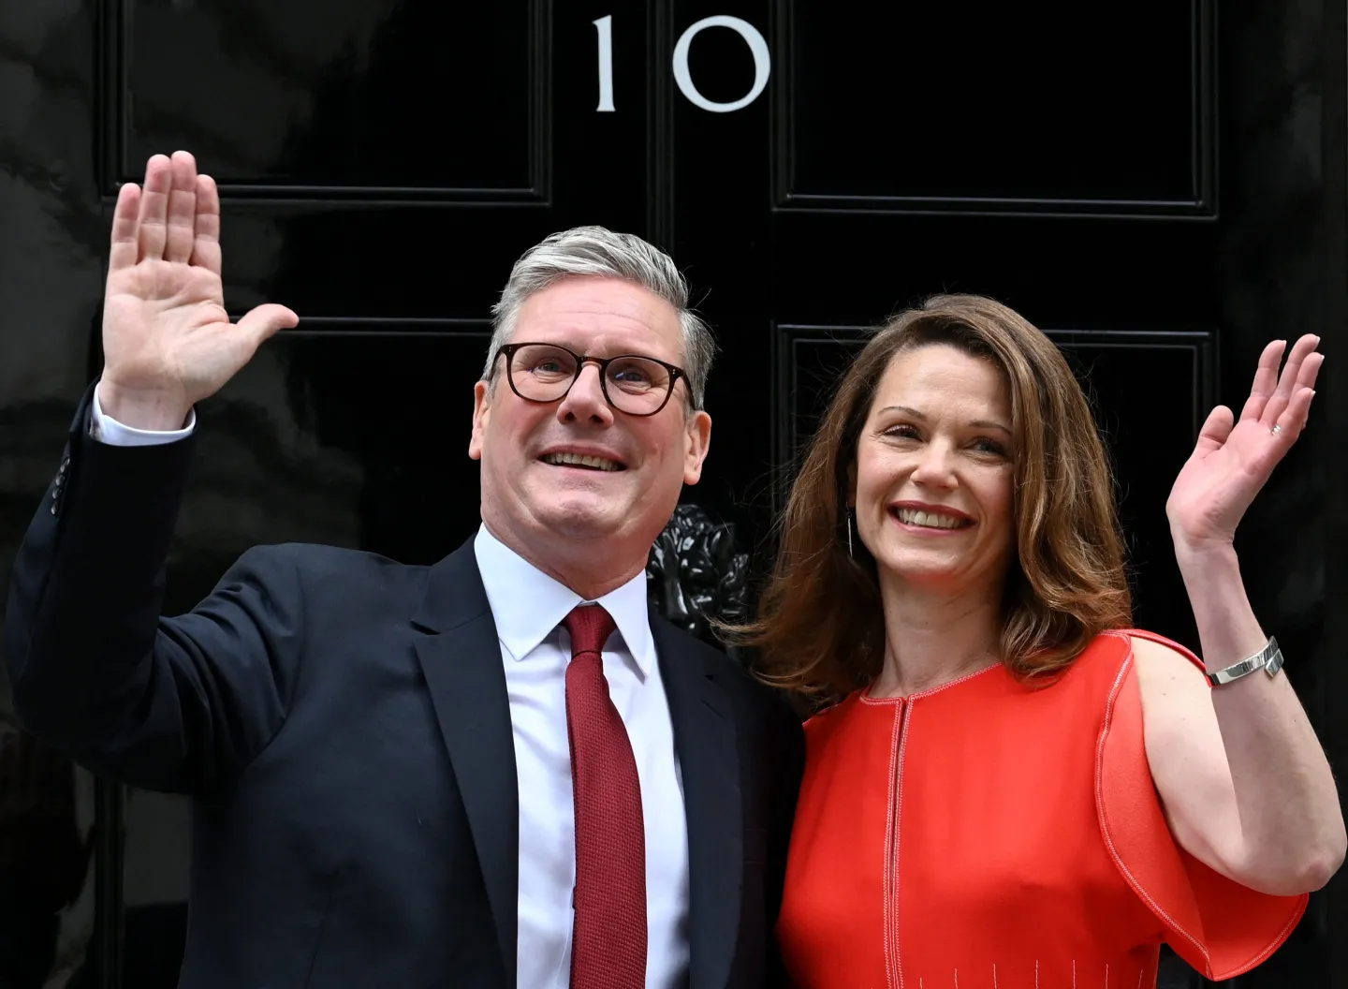

Facts about the Labour party;
- The Labour party has existed since 1900
- One of Labour’s most important achievements was setting up the National Health Service (NHS).
- Labour became the ruling political party in Britain in 1997.
- In the 2010 general election the party failed to win a majority of the seats in Parliament and The Conservative party took the lead until 2024.
Labour Prime Ministers
Name | Portrait | Country of birth | Time in Office
Ramsay MacDonald | 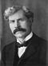 | Scotland | 1924; 1929–1931
Clement Attlee | 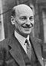 | England | 1945–1951
Harold Wilson | 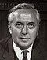 | England | 1964–1970; 1974–1976
James Callaghan |  | England | 1976–1979
Tony Blair |  | Scotland | 1997–2007
Gordon Brown |  | Scotland | 2007–2010


So England made it through to the finals but unfortunately, Spain were the winners with a 2- 1 score 🙁
England played well with C. Palmer scoring(Riley Hudson) 🎉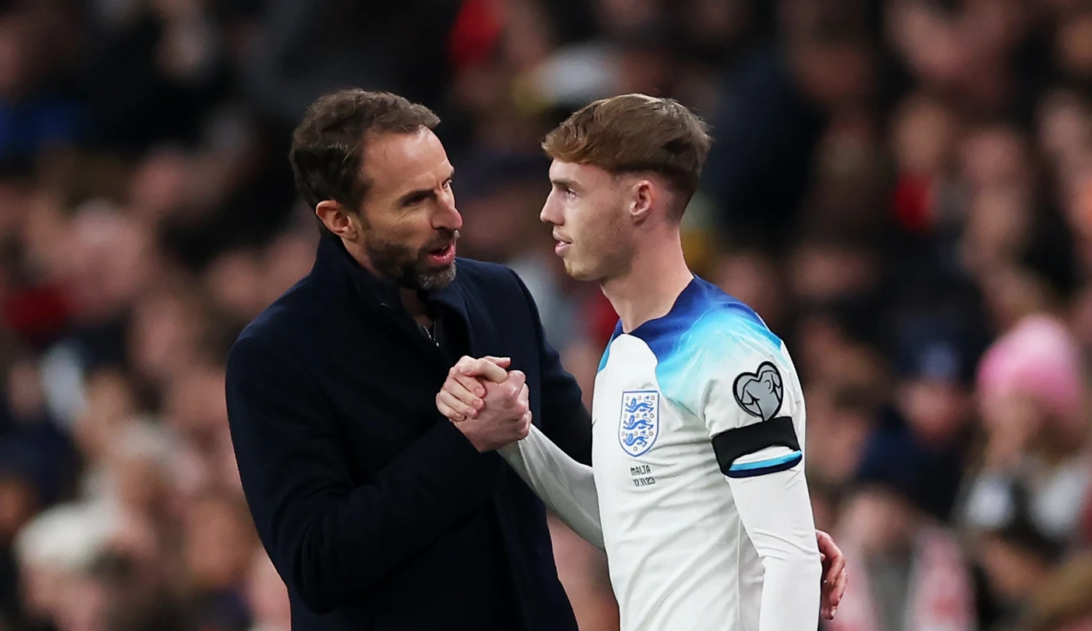

N. Williams and M. Oyarzabal scoring the goals for Spain 👏

Year 6 Leavers 2024
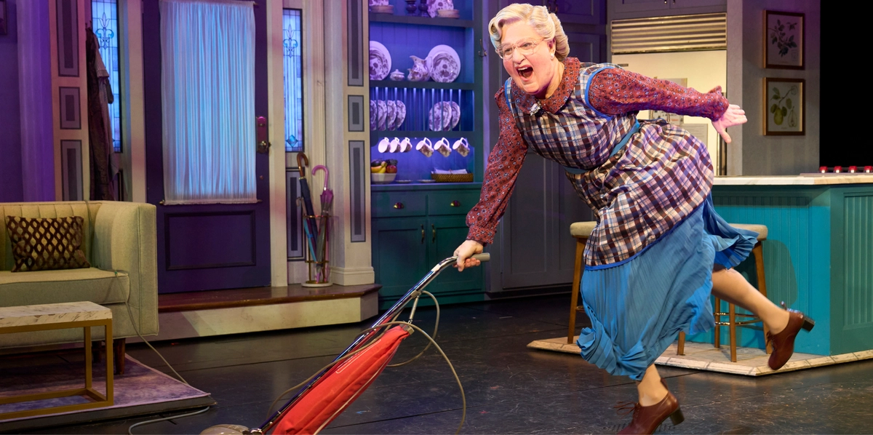
Our year 6 boys have been enjoying lots of activities before leaving such as biking, camping where PJ’s famous all night run outs took place and not forgetting the year 6 day out to watch Mrs Doubtfire the musical!
Summer and Year 6 Leavers
Another year has come to an end, and we say goodbye to our Year 6 leavers. We hope you have enjoyed your time here at Wells Park and will take some great memories with you. Good luck in your new schools, and remember to keep in touch!
We said an early goodbye to some pupils, but we are hoping to see them all back at the Summer festival 🙂
Year 6 Memories:
Joanna has asked all the Year 6 children about a special memory they may have of their time at Wells Park School. Here are some of their memorable moments:
- A: I’m going to miss my friend Cand miss everyone. (Too many to mention). I’ve loved it here!
- C: Meeting J and being best friends. I’m going to miss all the adults in my class and on the house and not forgetting Jasmine. I have enjoyed swimming at school and making a book before I leave.
- J: Mr Mcgregor and myself playing football and the score was 2-2. My first ever summer festival was really fun. Especially playing with my friends.
- J: The Christmas performance on 14th December (Mum's birthday) - The whole night was a really good night. Especially as my family came. Also my best friend(My Nan) really enjoyed it. The fireworks night as I got to meet all the care side people, meeting Georgia D's child and the fireworks were really good.
- K: Bringing in my dog Teddy Joe and bashing him up on Hornbeam. Becoming a day boy!
- M: Making friends and my first ever saver trip at Southend was Amazing!
- K: Making friends on Chestnut and Rowan and becoming good friends with Tony and spending time in the youth club.
- J: Always going onto Rowan house to get food that they forgot to order or ran out of.
- M: My favourite memory was having my first ever s'more at camping. I also loved Max joining my Purple Class family because he tells the best jokes. I'll never forget when I moved into Purple class because I've had such a fun time and I wasn't expecting to move here.
- T: Ted remembers having a movie in Blue class.
- T: My favourite highlight was the Food & Farming trip because we learnt about how food is grown (and obviously I loved the free food samples). I also loved visiting the beach and going on Zaine's shoulders in the sea. Also, camping was so much fun. Especially playing hide and seek at midnight. I tripped over the tent 4 times- whoops.
- T: My favourite memory is from 2021 and we made chocolate poo because we were learning about the human body and digestion. It was weirdly nice. My second best memory was our trip to Frinton on Sea because I used an almighty spade to make the biggest hole ever!

WHAT’S NEW IN SEPTEMBER?

Nuthatches (old Blue)
Starlings (old green)
Ospreys(old Yellow)
Kingfishers(old Purple)
Robins (old Orange)
Goldfinches (old Butterfly)
New Class Names:
Don’t forget, your class names will
change from a colour to a bird! Here’s
the list of new class names and their
old colour.
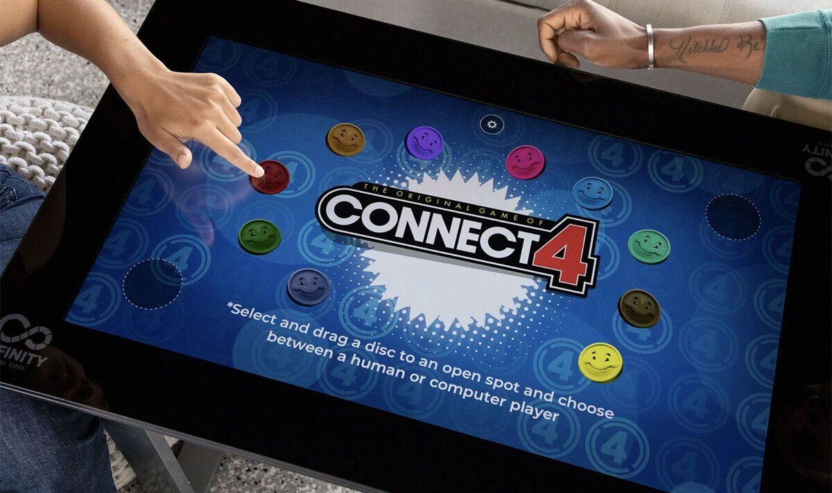
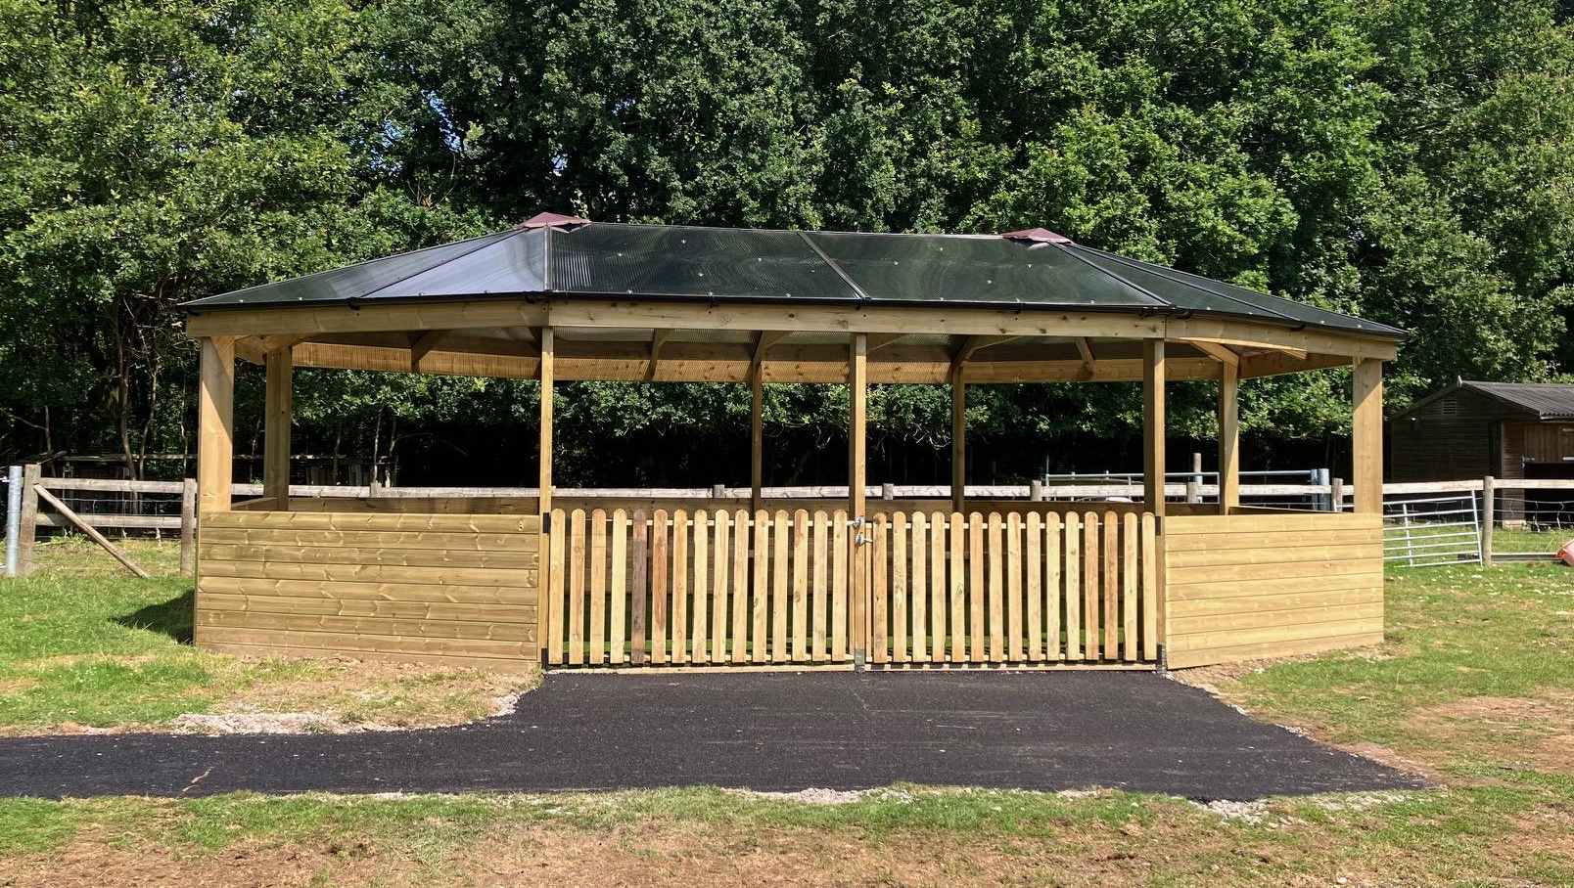
New Facilities
The grand opening of our new community classroom will take place on Friday. We will all be able to say a big thank you to all the builders and generous people who made this possible for us.
In the Youth Club, we will be adding a table top interactive gaming console where you will be able to play some classic board games and arcade games with your friends.

