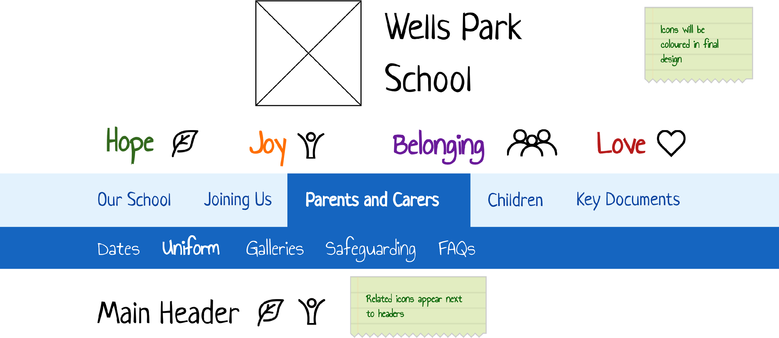




Wells Park School
Newsletter
Easter 2024

Wow! We are in March already, the sun has been shining (a little bit), the flowers are beginning to blossom and so much has happened since we last spoke.

We have celebrated Chinese New Year, pancake day and lots more.

It’s a Leap Year in 2024
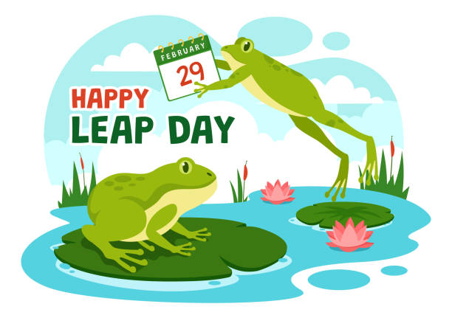
Leap day is an extra day that gets added to the calendar. During a leap year, which occurs every four years. This leap year’s leap day fell on Feb 29th , giving the shortest month of the year one added day.

So does that mean if you are lucky or unlucky enough to be born on 29th February, do you only celebrate your birthday every 4 years? Do you know anyone that was born on this day?



World Book Day 2024

We celebrated World book day on Thursday 7th March. The theme this year is;
“Read your way calls on everyone to let go of pressure and expectations, giving children a choice - and a chance - to enjoy reading.”
Each class has chosen a book to read and dress up in the characters from their book.

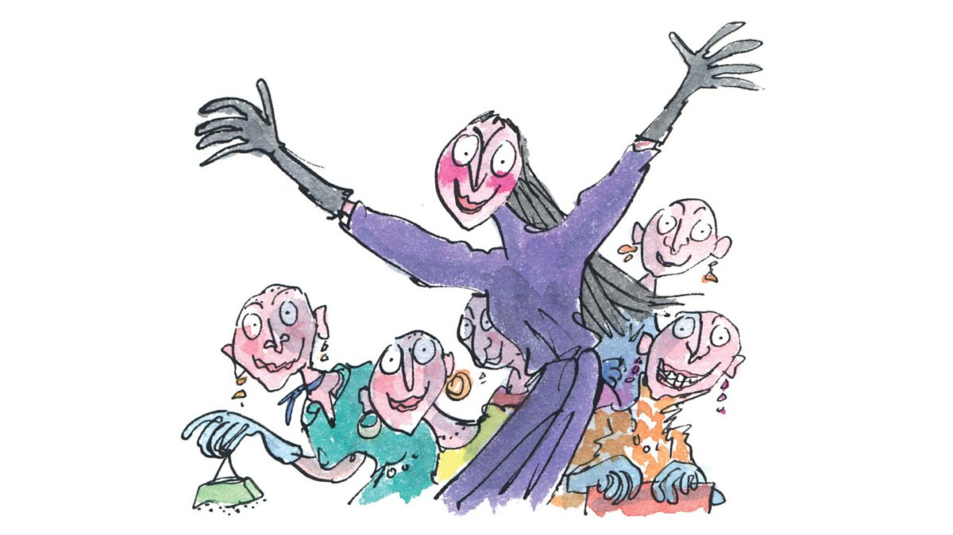
Roald Dahl was the theme in Purple and they dressed up as The Witches. They have been learning about Matilda to link with the theatre visit, where they used the 5 senses to describe Bruce Bogtrotters cake, created a persuasive poster about Bruce's cake, redesigned Matilda's book cover, experienced a PE lesson by Miss Trunchbull and wrote a book review of the new books for class.

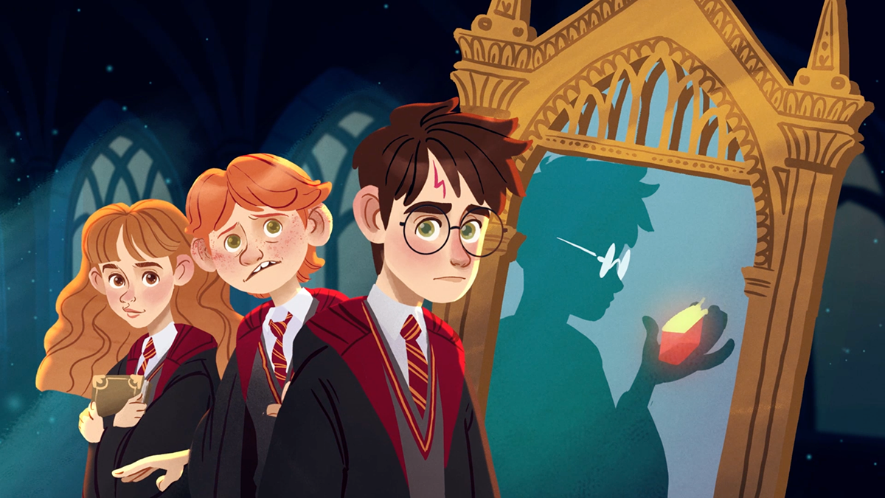
Harry Potter was the theme in Yellow class, the class have been watching Harry Potter films and made their own costumes. Yellow class started reading the first book and even got to watch the movie!

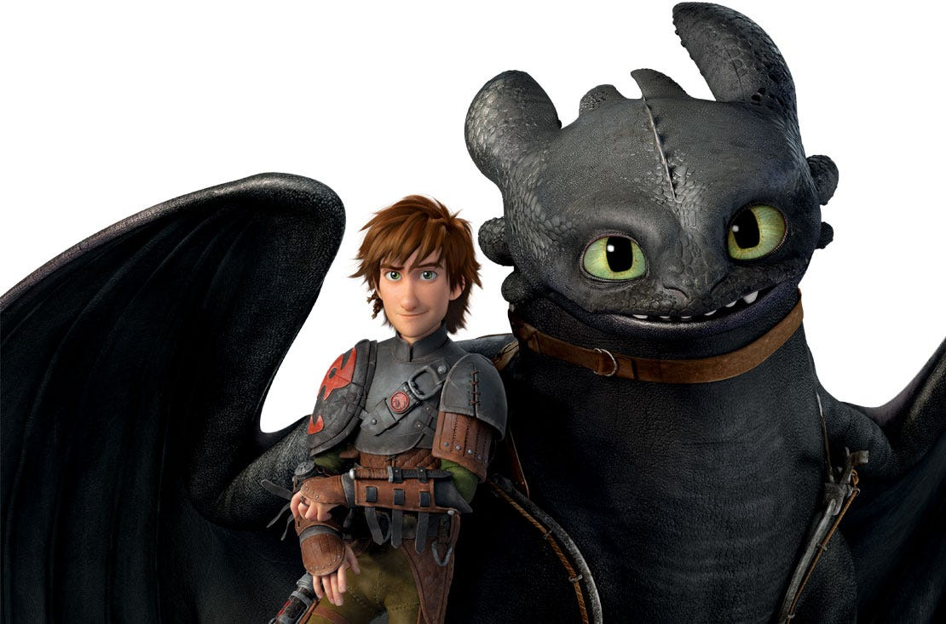
How to train a dragon was the theme in Green class. They took part in a range of activities. Green class spent a lot of time creating their own armour out of cardboard boxes and recycling. All were very exciting to see!



Diary of The Wimpy Kid was the theme for Orange class and made masks and props during the week.

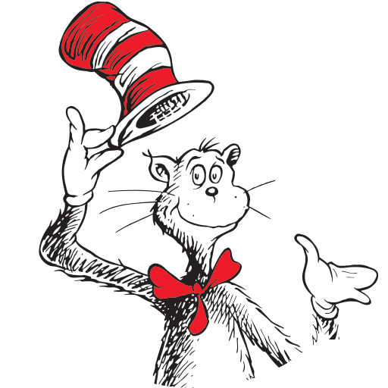

Dr Suess was the theme for Butterfly Net throughout the week and they dressed up as the Cat in the Hat. Butterfly created their own hats and wore them to assembly. They were very impressive!

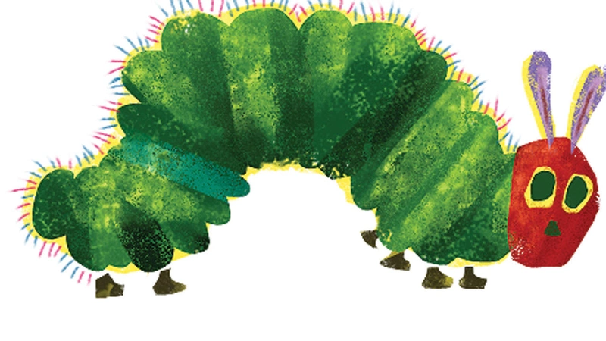

The Very Hungry Caterpillar was the theme for Blue class where the class took part in caterpillar themed activities relating to the book in the afternoon.

Did you all enjoy making your own costumes this year?

Mental Health Week - Express yourself

This month Hollie has kick started our 'Wellness Wednesdays' and what a hit they have been!
In the sessions taught so far the groups have learnt to use breathing techniques, find the feeling of calm and begin to talk and recognise their own feelings. Maybe those that have attended could share some of the techniques they have already learnt with their friends. We always love to hear what caring friends you have been and remember it's really important to share and show kindness!

We also had a great week expressing ourselves. Learning the importance of who we are, our talents and what makes us unique as an individual. We all created our own t-shirts expressing all the things we like, using colours to show our personalities. We express ourselves through music, dance and drama and some children showcased these in our 'dress to express' assembly. What a lovely week it was. Thank you to all of the adults and children for embracing this week and joining in.

School Council News

School council members have been meeting regularly and bringing your views to the meeting. Your ideas and views are typed up and a copy is sent to Mr Surman.

We discussed how School counsellors can be involved in Mental Health week and how they can support you all. We had suggestions of giving someone a hug if they need one, looking out for someone, listening to others and allowing others to share their thoughts and sharing toys and using teddies to help re focus in class and regulate themselves.
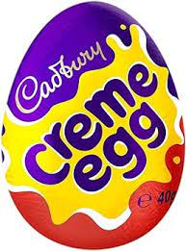
Easter
Do you know what the most popular type of Easter egg is?
It is a Cadbury’s Creme Egg which has been a staple for Easter for over 50 years as it has a unique creamy filling which is loved by many - including Zoe!




On the following page, you will find some lesser known facts about Easter. How many did you already know?

1. The Easter Bunny legend began in Germany

The origin of the Easter Bunny dates back hundreds of years, beginning in pre-Christian Germany. Here, the hare was said to be the symbol of the Pagan Goddess of Spring and Fertility.

As Christianity spread across Europe, Pagan traditions were blended with Christian holidays, which saw the Easter Bunny lay a nest of colourful (today, chocolate) eggs for children who were well-behaved on Easter Sunday.

2. The holiday was named after the Anglo-Saxon Goddess, Eostre
According to scholars, this Christian holiday was named after the Anglo-Saxon goddess, Eostre, who was depicted as a Fertility Goddess and a Goddess of Dawn and Light.

3. More than 1.5 million Cadbury Creme Eggs are produced every day
Another fascinating Easter fact for you, Cadbury’s makes 500 million Creme Eggs every year! If you piled them on top of each other, it would be 10 x higher than Mount Everest.

4. The act of painting eggs originates from a Ukrainian tradition
For countless generations, Ukrainians have been decorating eggs as a calling out to the Gods and Goddesses of health and fertility.

5. The world’s largest Easter egg weighs in at 2.3 tonnes, that’s heavier than a family car
Standing 31 ft tall and 18ft wide is the world’s largest Easter egg. Found in Vegreville, Alberta, Canada, the egg weighs a hefty 2.3 tonnes and taking12,000 hours to complete.

6. Easter is celebrated on the Sunday after the full moon following March 21st

Easter in fact falls on the first Sunday after the full moon that takes place on or after March 21st, which is said to signal the start of spring.
7. In 2007, an Easter egg sold for £9 million
Possibly the world’s most expensive egg was sold at Christie’s in London for £9 million, breaking Faberge records. The egg was made by Karl Fabergé in St Petersburg in 1902 and is the second-largest egg ever made by Fabergé.

What do you do to prepare for all the Easter treats?
Eggs-ercise!

What kind of jewellery is the best Easter gift?
A 14 Carat gold necklace!

How does the Easter bunny leave?
He makes an eggs-it!

What do you call a rabbit with fleas?
Bugs bunny!

What is an Easter bunny's favourite music?
Hip hop!


We hope you all have a great Easter break and look forward to seeing you back in April!



