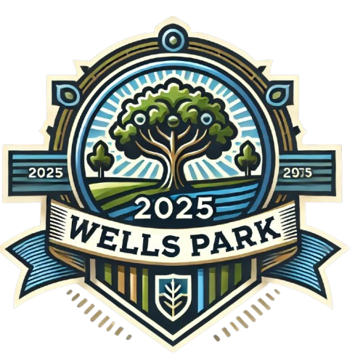
School Newsletter

January 2025

We hope you have settled back into school and the usual routines after the christmas break, January seems such a long month especially with all the dreary weather! But with spring just around the corner, there’s lots to look forward to. Activities and school trips will once again include more outdoor venues so make sure you keep track of where you’ve been as these trips and visits all count towards your Explorer Bade.

What was the toy trend in 2024?
From bouncy plush collectibles to Interactive early education toys. The list of toy trends in 2024 has everything from DIY robotics toys to puzzle cubes, which promise to shape how kids learn, play and grow. Remote control cars still seemed to be a firm favourite at Wells park in 2024 with Father Christmas delivering quite a few when he came to visit us.

What were the most popular toys when Mr Surman was born and can anyone guess what year this was?
Just in time to hit the shelves for christmas, Pet Rocks became a phenomenon selling over 1.5 million rocks in mere months. I wonder if Mr Surman ever got one as a gift?
Here’s what Mr Surman said when we asked him:
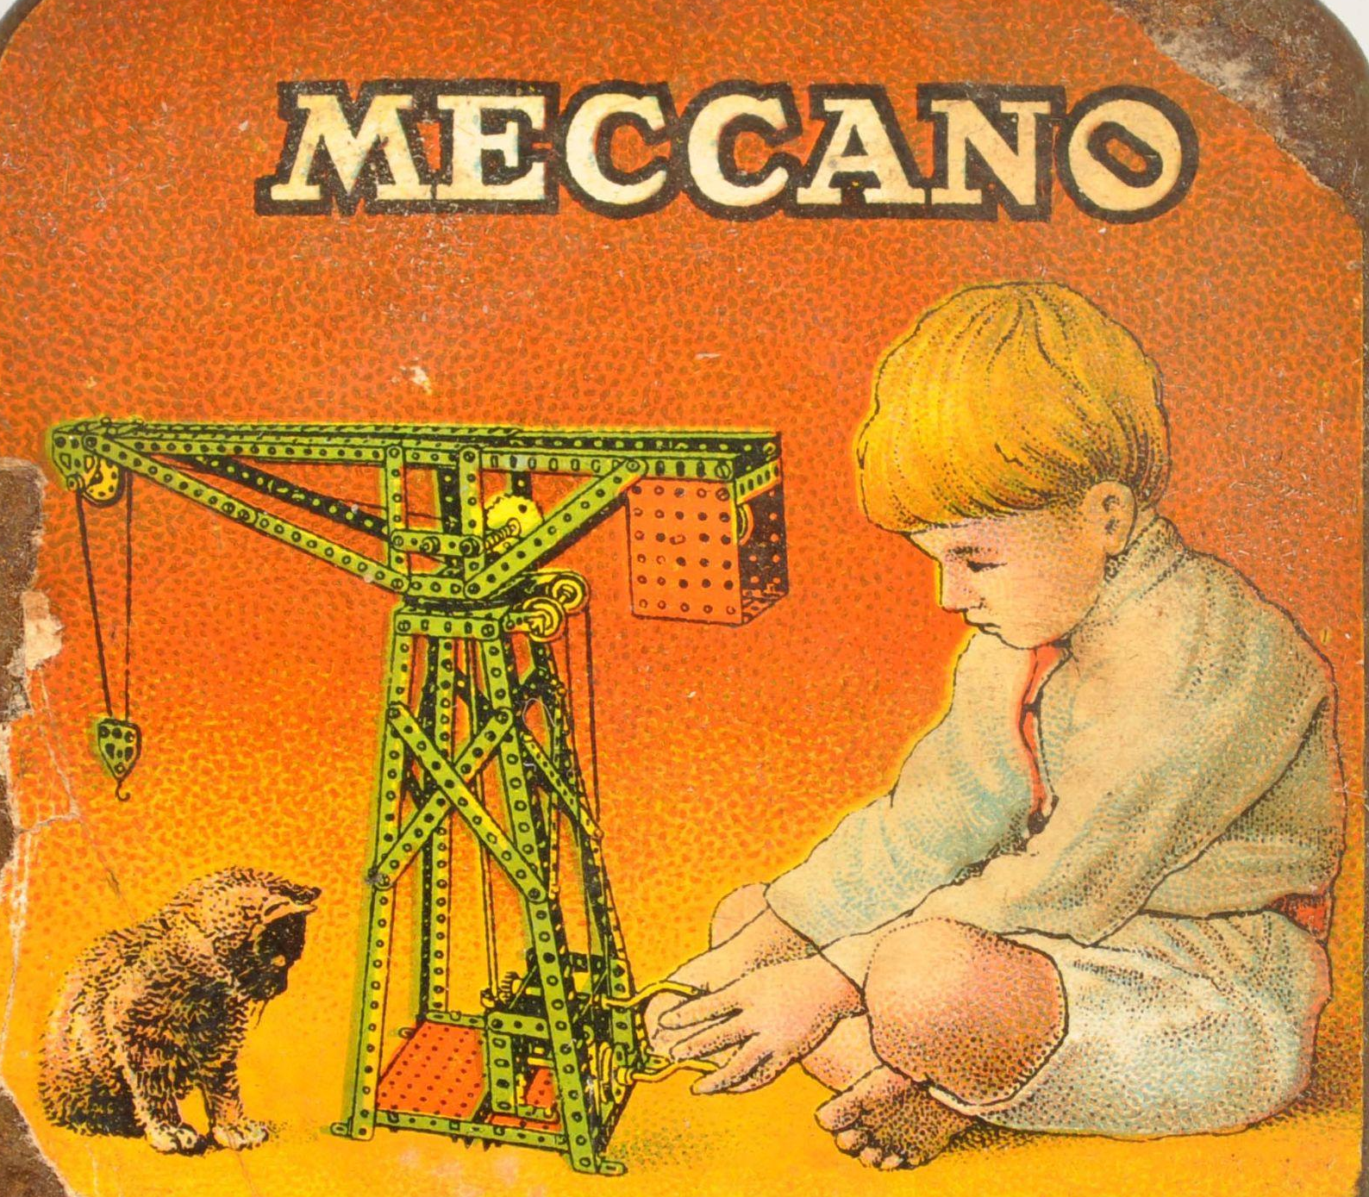
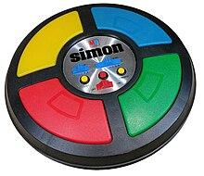
“When I was born, there were two really popular Christmas presents; Meccano and Simon Says. Meccano was a bit like lego but made of metal and you could build cranes, trains and tanks. It had little nuts and bolts that if you left out on the carpet would get sucked up by the hoover and make a nasty rattling noise as they disappeared amongst the fluff, never to be seen again! Simon Says was an electronic game that, believe it or not, is still for sale today. They used to have a Simon Says on Rowan house but I haven’t seen it in a long time.”

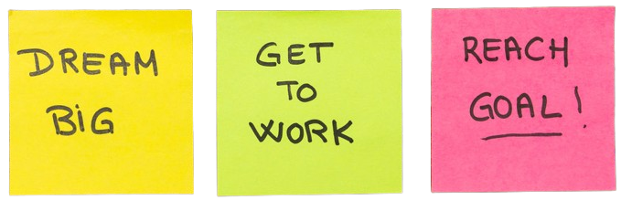
New Year’s Resolutions
As with every new year, people from around the world make new resolutions, have you made any yet?

The most popular resolutions are:
- To save more money
- Eat healthier
- Exercise more
- To spend more time with family and friends

Chinese New Year 2025

The Chinese horoscope for 2025 is the year of the snake. The wood snake is a charming, intelligent and creative sign, but also secretive, cunning and sometimes ruthless.

The last wood snake year was in 1965 and we welcome the year of the wood snake in 2025. It is also known as the Year of the Green snake because according to the Chinese Five Elements theory, wood is associated with green.

Year of the snake 1905,1917,1929,1941,1953,1965,1977,1989,2001,2013,2025

Here are a few famous people that were born in the year of the snake. Do you know what they are famous for and can you guess the year they were born from the above dates?

John F Kennedy
Audrey Hepburn
Taylor Swift
Anne Frank
Charlie Sheen
Robert Downey Jr
Muhammad Ali
Joanna Millar



Recent School Council News

The School Council met back in December and several points were discussed. The main point of discussion was the school post box which L is now in charge of, a school council post box and the possibility of a post box outside Mr Surman’s office as we know how busy he can be!

Other discussions took place around play times. If you have any more ideas to improve play times then please let your school council rep know.

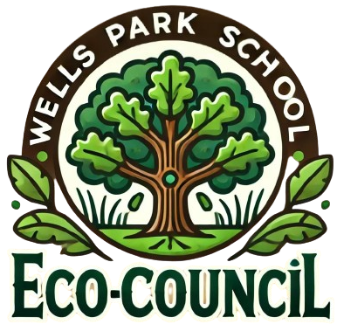
Recent Eco-Council News
We have noticed more litter around the school site and would appreciate everyone’s help to put rubbish in bins. We also noticed that we do not have a bin on the playground so have asked Mr Surman to order us one so we have somewhere to throw rubbish away that we find on the Playdale or Playground.

With Spring just around the corner, the birds will be looking for places to nest so the Eco Council have decided to improve the available nesting sites by adding bird boxes.

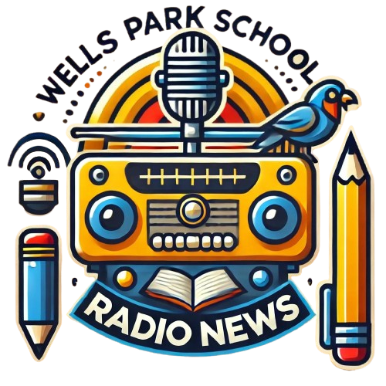
School Radio
Friday School Council News broadcasts are going really well and very informative, well done to those who have made a broadcast so far. If you want to have a go at reading the news or would like to add your own headline for us all to hear, let Wendy in the office know.
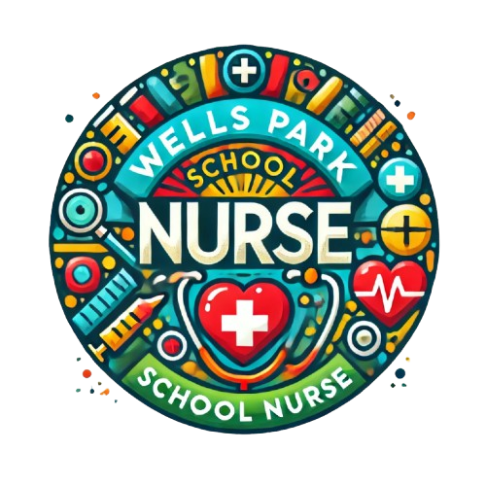

School Nurse
A big congratulations to everyone who took part in the dental check, Maria is delighted to say that you are brushing your teeth well. Sadly, Maria will be leaving us on the 13th of February. She’s loved working at Wells Park and promises to keep in touch. She will introduce our new School Nurse very soon.



