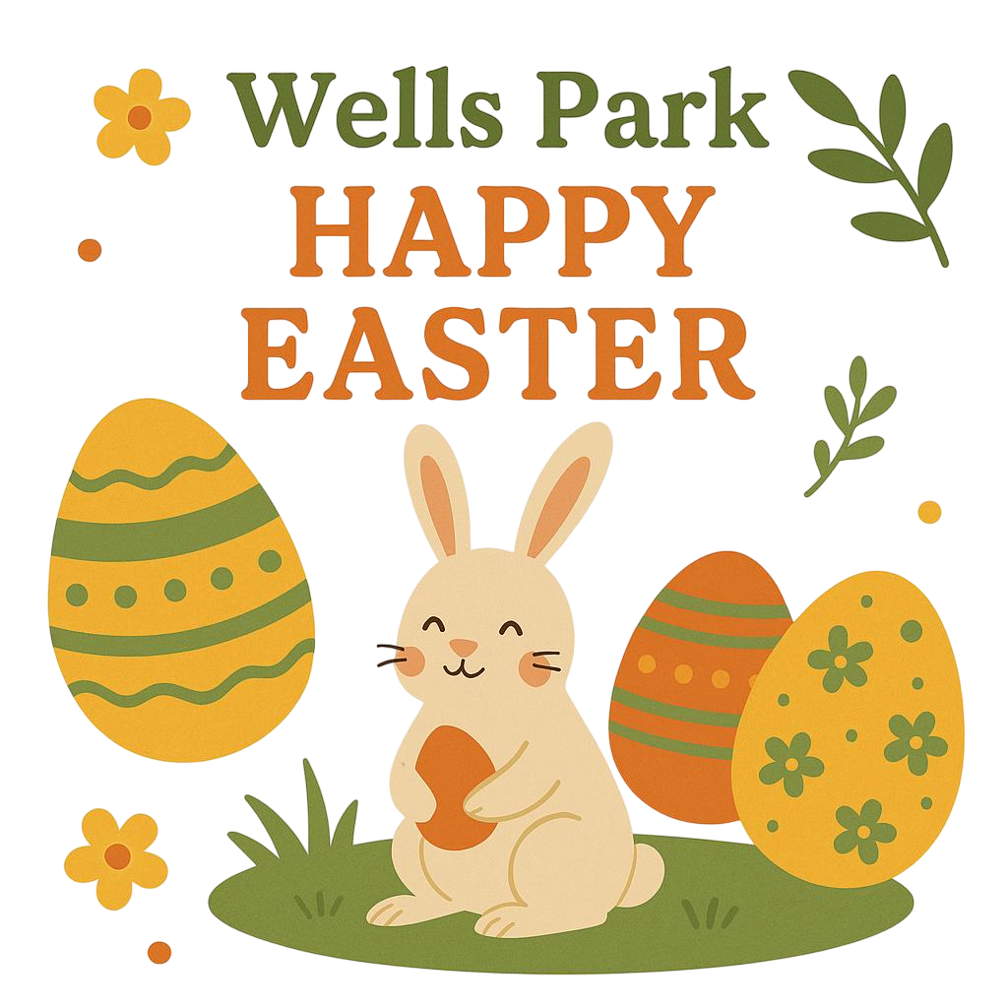
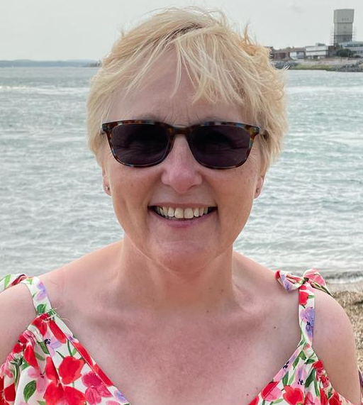
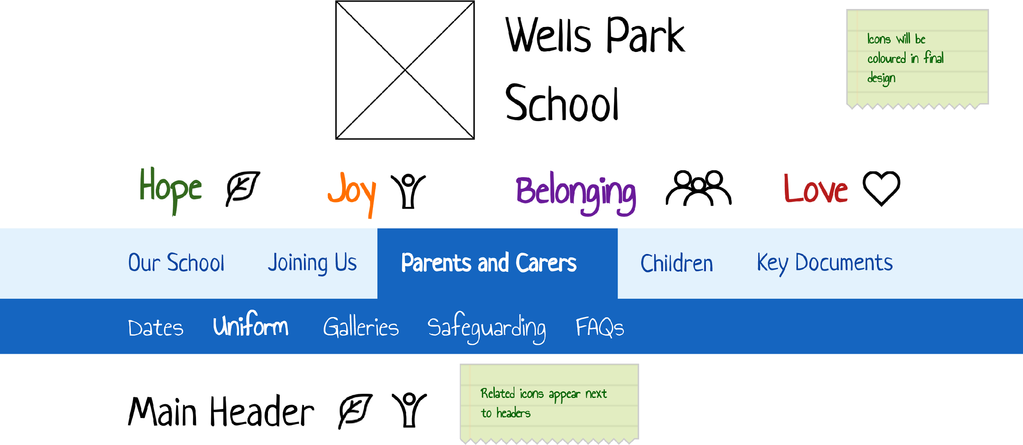

HOLD THE FRONT PAGE!
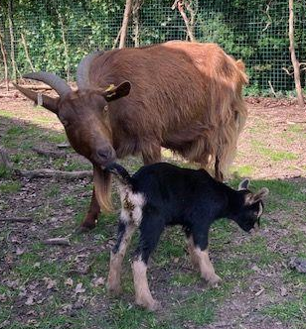
Surprise Arrival on the School Farm!
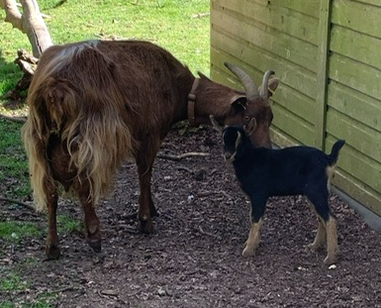
There was an unexpected – and very adorable – addition to the school farm this weekend! On Saturday afternoon, staff were delighted to discover a tiny, wobbly-legged kid exploring the paddock, with its proud mum keeping a close eye.
The surprise? No one knew the mother goat was in kid!
Despite showing no clear signs, she delivered a healthy baby with no fuss, delighting everyone with the sudden expansion to our goat family.
Farm staff have confirmed that both mum and baby are doing well, enjoying the sunshine and a bit of extra attention from visitors.
We’ll be holding a "Name the Kid" competition this week—so get your thinking caps on!

Newsletter – Easter 2025
Spring has sprung and the warm weather is creeping in. The flowers are starting to bloom and the hayfever is setting in! I’m sure everyone is looking forward to the hot summer days after a cold and frosty winter.

So what’s happened since our last newsletter?
Christmas has come and gone, we celebrated Chinese New Year, Pancake Day, Eggs Factor and Comic Relief to name just a few of the things that have been going on around school since our last newsletter.

World Book Day 2025
We celebrated World Book Day on Wednesday 5th March.

Facts about World Book Day:
- The first official World Book Day was on 23rd April 1995.
- The date was chosen because England's greatest wordsmith, William Shakespeare, died on that date in 1616.
- Over 100 countries celebrate this special day.
- The UK and Ireland celebrate World Book Day in March, so it doesn’t clash with Easter.
- Popular stories for World Book Day include:
Alice in Wonderland, Goldilocks, One Hundred and One Dalmatians, Mary Poppins, Peter Pan, Red Riding Hood, Robin Hoodand The Wizard of Oz.

Robin Class
We read Harry Potter and the Philosopher's Stone. We designed a house flag and a magical wand, took part in a potions lesson where we made lava lamps and role-played living like Harry Potter — even experiencing life in a cupboard under the stairs!

Osprey Class
Our focus was Charlie and the Chocolate Factory and it was a VERY chocolatey day! We made our own costumes, designed our own chocolate bars with catchy names and slogans and created chocolate slabs using a range of ingredients — including ready salted crisps! We also wrote diary entries from a character’s perspective and listened to the story throughout the day.

Kingfisher Class
We celebrated WBD with Roald Dahl's hilarious book, The Twits. We wrote diaries as Mr Twit, made Mr Twit's beard and even created Mrs Twit's glass eyes out of cake!

Nuthatch Class
We focused on Snow White and the Seven Dwarfs. We watched the movie, read the story, completed comprehension tasks and ended the day with a lovely tea party in the outdoor classroom. The dwarfs were so worn out after their day of work, they went up for an early night!

Goldfinch Class
We read The Hungry Caterpillar and tried all the food he ate on Saturday! We opened our own Hungry Caterpillar Café and had a picnic, then made beautiful butterflies.

Starling Class
We went all out for We’re Going on a Bear Hunt by Michael Rosen, illustrated by Helen Oxenbury. We dressed up, joined in with the story and even went on our very own Bear Hunt in Hainault Forest! In English, we created freeze frames of different scenes and recreated them on our forest adventure.

School Council News

The School Council has been meeting and sharing your ideas. We’ve had lots of discussions around playtimes and new equipment, as well as extra clubs and activities.
H in Osprey is interested in starting a farming club and already has a plan in place!
Do you have a club in mind? Let us know!

Goodbye, Maggie!
Maggie has been with us for an incredible 23 years!
Her journey started at Catering College, then took her through working in a hotel, NatWest Bank, BHS and Superdrug before joining us here at Wells Park School. Maggie began in the kitchen alongside her bestie Alison, before becoming Assistant Catering Manager, creating all those amazing desserts.
Her favourites? Lemon tart and Berry Drizzle sponge cake.
What’s your favourite dessert?
Mine has to be Lemon and Ginger Fool — and O agrees! But word on the street is that the Magic Chocolate Pudding is a firm favourite.
What’s the magic in the pudding?

🌱 Eco-Council Update
Our Eco-Council has been hard at work thinking of ways to improve the natural habitats around our school site to support local wildlife.
This term, we’ve started planning the installation of bird boxes in quiet areas around the grounds to encourage nesting and provide safe spaces for birds during the spring and summer months.
We’re also working on building beetle banks — raised mounds of earth and plants that give insects, especially beetles and other helpful bugs, a place to live and thrive. These will help increase biodiversity and give our pupils more chances to spot interesting minibeasts while learning outside.
If you’re interested in getting involved, speak to a member of the Eco-Council or your class rep — everyone is welcome to help us create a greener, wilder Wells Park!

🐥 Did You Know?

Bird boxes provide a safe place to nest, especially for birds like blue tits, great tits, robins, wrens and sparrows.

Natural nesting sites are becoming harder to find because of urban development and fewer old trees, so putting up bird boxes helps support bird populations.

The best time to put up a bird box is before spring, so birds have time to find them ready for nesting season.

Boxes should be placed around 2–4 metres high on a wall, tree or fence — out of reach of predators like cats!

Once birds move in, they can lay up to 12 eggs and chicks will hatch in just a couple of weeks.

It's important not to disturb the box once it’s in use — birds can abandon their nests if they feel unsafe.

🛡️ Online Safety – Be Kind Online
We know that spending time online is a big part of life for many of our pupils — gaming, chatting and sharing things with friends. But how we treat each other online matters just as much as how we treat each other in school.

🗨️ We’ve recently had concerns about some pupils being unkind to each other online at weekends.
This includes group chats where people have felt left out, or where hurtful comments were made.

🌟 Here’s how you can help make Wells Park a safe and kind community online:
- Think Before You Type
Would you say it to their face? If not, don’t type it. Your words have power — use them to lift others up, not bring them down.
- Use the Report Button
If someone is being unkind in a group chat or game, report it. You won’t get in trouble for doing the right thing.
- Take a Break
If something is upsetting you online, step away. Go outside, talk to someone, or do something else for a while.
- Talk to Someone You Trust
If someone is unkind or if you see something that doesn’t feel right, talk to an adult at home or at school. You can also contact Childline at 0800 1111.

💬 Kindness online isn’t just important — it’s essential.
Let’s make sure that Wells Park values of Love, Joy, Hope and Belonging shine through in every message we send.

🏅 Skills 4 Life – Badge Spotlight
Have you been checking in on your Skills 4 Life targets lately?
Every pupil at Wells Park School is working towards earning Skills Badges that help build confidence, independence and wellbeing. Whether you’re aiming for your Leadership, Belonging, Health, or Safety badge — remember, each small step counts!

🌼 Spring into Explorer Mode!
Now that the days are brighter and the weather is warmer, it’s the perfect time to focus on your Explorer Badge.
Here are some great ways to earn steps toward your Explorer Badge this term:
- Take part in an outdoor learning session
- Try something new on a school trip
- Explore a new area of the school grounds
- Help in Forest School or on the farm
- Go on a nature walk and spot new signs of spring

Your targets are in your Badge Book — take a look, set yourself a goal and talk to your teacher about how to get there.
Let’s see how many badges we can achieve together before the end of the year!
Easter quiz

- Why do christians celebrate Easter Sunday?
1. Because Jesus was resurrected
2. Because everyone loves a Sunday
3. Because we needed a date to eat lots of chocolate

- What dried fruit is in hot cross buns?
1. Raisins
2. Cranberries
3. Blackcurrants

- What is the nation's favourite chocolate bar?
1. Mars bar
2.Snickers
3.Milky way

- What is the nation’s favourite way to eat eggs?
1. Hard-boiled
2.Omlette
3.Scrambled

- What type of bun do we traditionally eat at easter?
1.Hot cross bun
2.Hot upset bun
3.Hot angry bun

- What is the main ingredient in chocolate?
1.Sugar
2. Cocoa
3.Milk

- What meat is traditionally eaten at Easter?
1.Lamb
2.Chicken
3.Pork

- What is the darkest chocolate you can buy?
1.75%
2.95%
3.100%

