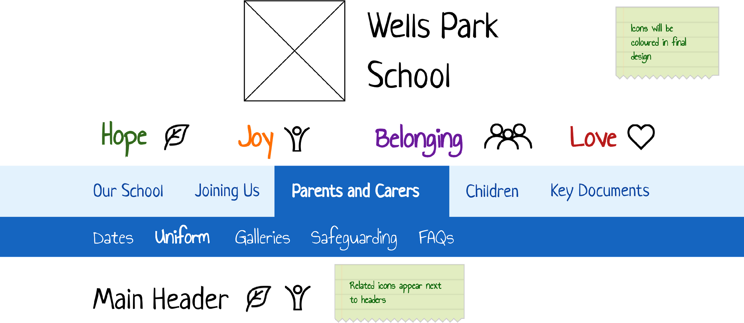
SCHOOL COUNCIL NEWSLETTER

July 2025

Dear Wells Park Readers,

The summer holidays are nearly here and we have enjoyed lots of trips out, saver trips, the year 6 day out, biking and camping. What has been your favourite trip out this year?


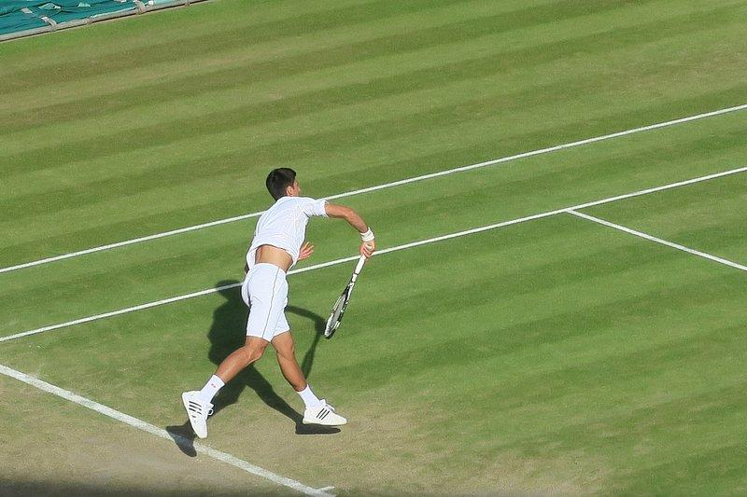

We all had an amazing time on our saver trips this year and some of us were lucky enough to experience Wimbledon and watch a live tennis match!

Some of you may have conquered your fears on the big and scary rides and some of you just love them anyway. Not me though!
Year 6 Leavers 2024
Our year 6 boys have been enjoying lots of activities before leaving us in July such as biking, camping where PJ’s famous all night run outs took place - I don't know where he gets his energy from! And not forgetting the year 6 paintballing day out.
Another year has come to an end, and we say goodbye to our Year 6 leavers. We hope you have enjoyed your time here at Wells Park and you will take some great memories with you. Good luck in your new schools, and remember to keep in touch!
Year 6 Memories:
Joanna has asked all the Year 6 children about a special memory they may have of their time at Wells Park School. Here are some of their memorable moments:
We said an early goodbye to C and F. We hope they have settled in and are enjoying their new schools. It was good to see them both at camping.
- O remembers playing Fifa with H and C and them being silly and joining in with the silliness.
- H remembers organising a Farm club with some help from Phoebe although it was only help with the planning and that she wanted to be mentioned.
- T remembers when he was playing on my own and C came up to me and asked to play with him. We played a game of it and managed it well.
- K remembers Phoebe helping me and joining Rowan house.
- J remembers when K and some other boys were playing a monster game and it was really fun when he first came to Wells Park School.
- T remembers being with Joanna on Rowan house and going trampolining.
- H remembers playing the Taco Bell game with J and having a lot of fun.
- M remembers going camping and L pushing him in the water twice.
- L remembers D being his best friend and the Kitty kingdom and also being best friends with K.
- K remembers his first summer festival and having face painted and going to Thorpe park for the first time and passing out on the Colossus.
- L remembers annoying Zaine so much that his head blew up and going to Chessington.
- R remembers playing football and hitting the top bins. His football skills have improved since being here. Jack Palmer watch this space!
- O remembers going camping and making friends with K and having lots of fun.
- F remembers when he was in Butterfly net and it was fun.
- A remembers playing games on the playdale.
- B remembers going camping, it was really good.
- T remembers being on Rowan with Jo, although we called her bossy lady Jo!
- J remembers being in Miss Chapman's class and being with T, F and M.
- K remembers when he was in yellow class and being on Rowan house.
Wall of Fame
It looks like we have a record number of boys on this year's Wall of Fame, I hope we have enough space for you all!
Well done to all the boys that have made it to the Wall of Fame. You have achieved great things and we wish you all the luck in the future.

Freedom of the school
Well done to H, L, K AND B for achieving freedom of the school in their last week at Wells park. Enjoy freedom and Independence!

Summer Fun

What will you be doing in the summer holidays? Let's hope it's going to be a warm one! Don't forget to put your sun cream on and a hat! Here are some great ideas to help keep you occupied over the six weeks of holidays. How many will you try?

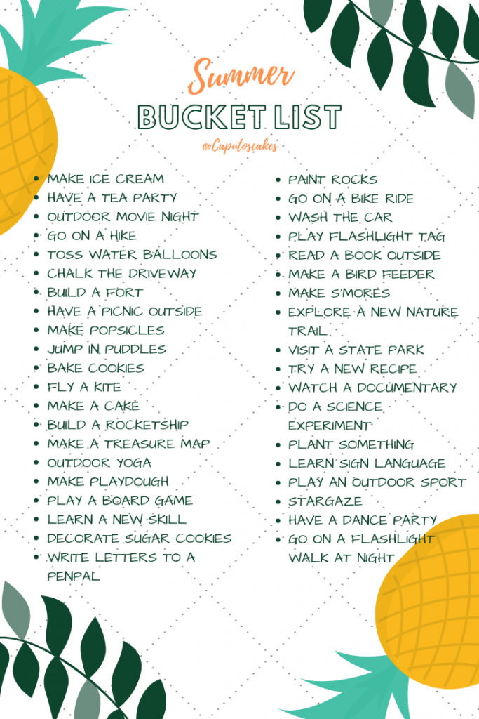

Summer Quiz

- What are the three months of summer?

- What is the name of the icy treat that is popular during summer and comes in various flavours?

- What is the name of the small, sweet fruit that is often picked in the summer used to make pies and jams?

- What is the name of the popular outdoor activity that involves setting up a tent and sleeping under the stars?

- What is the name of the event that happens every four years where people gather to participate in various athletic competitions?

- What is the fastest land animal?

- What does SPF on sunscreen stand for?

- What is the name of the event where people gather to listen to live music outdoors?


