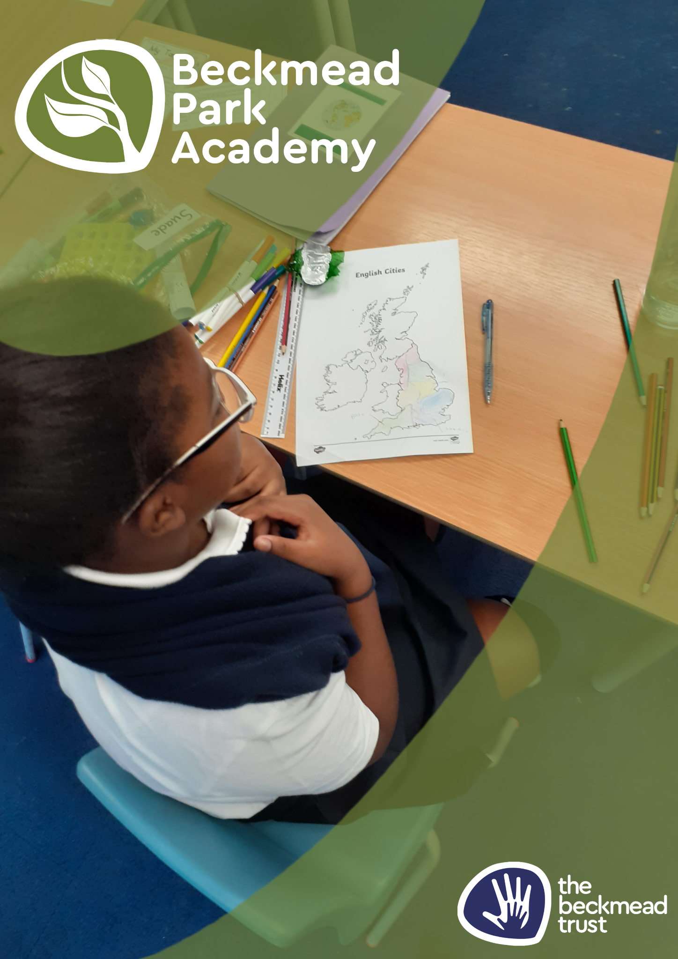
Weapons Policy

Name of Policy | Weapons Policy
Policy Level | School
Date of Issue | September 2025
Author | Samantha Hoyer
Date of Next Review | September 2026
Signature | Samantha Hoyer
Date of Signature | September 2025

BECKMEAD PARK ACADEMY
WEAPONS POLICY

Under no circumstances should a weapon be brought into school. If a pupil is discovered to have brought a weapon into school the police will be informed and the permanent exclusion of that pupil will be discussed by the Chair of Governors and the Headteacher.

This discussion will focus on the following issues:

- How the weapon was found, discovered or reported.
- The nature of the weapon.
- The location and storage of the weapon on the school site.
- Knowledge of third parties as to the weapon being in school.
- What the perceived purpose was of having the weapon in school.
- Preceding behaviour and attitude of the pupil whilst attending The Beckmead Trust School.
- It is usual for permanent exclusion to be recommended if the pupil is in Key Stages 3, 4 or 5 unless it is judged that there are very exceptional circumstances to be considered. The contextual information will be evaluated in a differentiated way for pupils in Key Stages 1 and 2 and it will not always be the case that permanent exclusion will be recommended for this age group although this still remains an option.

Following this discussion, the Headteacher or Head of School will either:

- Recommend permanent exclusion to the governors or:
- Following discussion with the parents / carers, place the pupil on a fixed term exclusion and organise a disciplinary hearing to include the pupil and representatives of the governing body, the school and the family or carers.

Outcomes from this meeting will include:

- Extension of fixed term exclusion
- An agreement that the pupil will spend an agreed period of time working with key staff on specific targets that when met, will facilitate reintegration back onto the school site.

Weapons include…guns, pellet guns, BB guns, air guns, replica guns, knives, num-chukkas, death stars and other martial arts objects; screwdrivers, hammers, chisels, bradles and any tool that could be used offensively; razors, razor blades, aerosols, chains, scissors, etc. This list is not exhaustive but it should be noted that weapons also describe ‘home made’ implements manufactured to injure, threaten or intimidate.

If an item such as a pair of scissors is picked up in school and used or threatened to be used as a weapon then any sanction referred to in the behaviour management policy may be recommended to the governing body.

If a pupil hands in a weapon to a member of staff before they have been challenged about it being in their possession the outcome of this incident will be negotiated with the Chair of the governing body and the Headteacher.

Members of staff can use reasonable force to protect themselves against a weapon or when retrieving a weapon from an individual or group. In the circumstances of a pupil being unwilling to hand over a weapon to a member of staff the police will be called using 999. In this instance staff may use whatever proportional physical intervention is necessary to retrieve the weapon and / or to protect the safety of all.

Dr Jonty Clark, CEO, The Beckmead Trust.
Reviewed September 2024
Samantha Hoyer, Headteacher, Beckmead Park Academy

