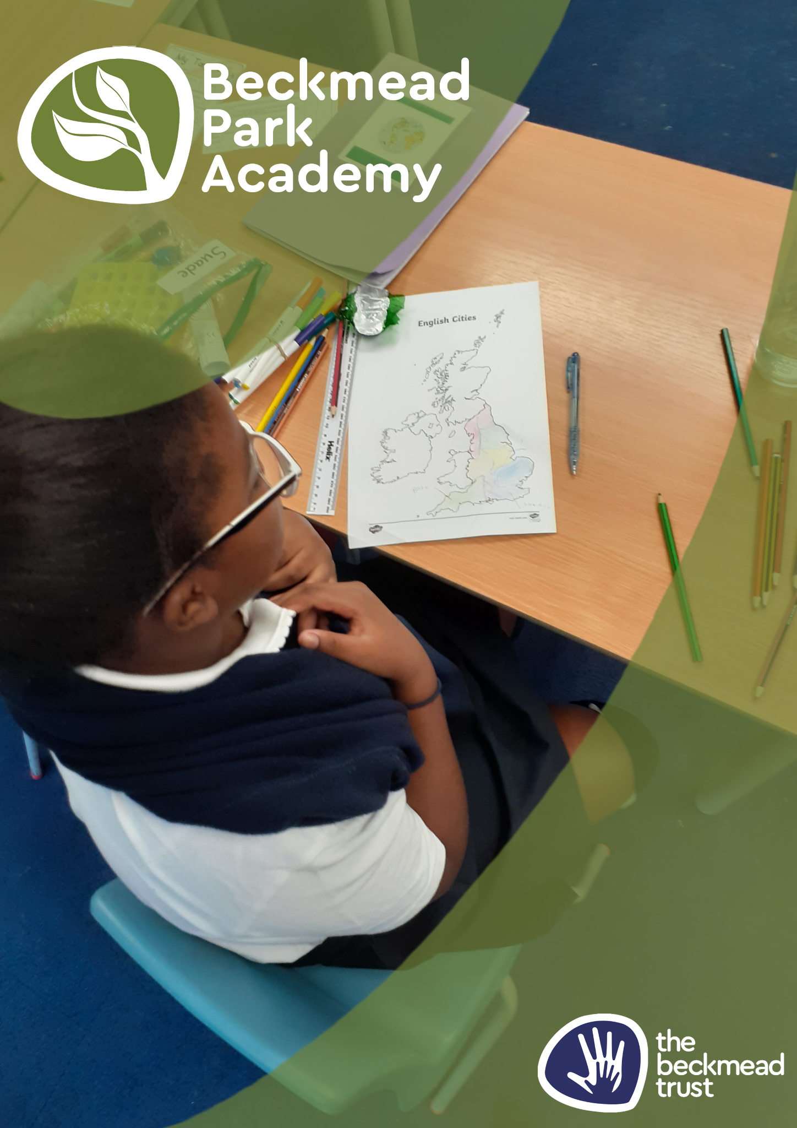
Special Educational Needs Policy

Name of Policy | Special Educational Needs Policy
Policy Level | School
Date of Issue | September 2025
Author | Samantha Hoyer
Date of Next Review | September 2026
Signature | Samantha Hoyer
Date of Signature | September 2025

Table of Contents
1. Aims
3 2. Legislation and guidance
.3 3. Definitions
3 4. Roles and responsibilities
3 5. SEN information report
5 6. Monitoring arrangements
7 7. Links with other policies and documents

1.Aims
- Set out how our School will support and make provision for pupils with special educational needs (SEN)
- Explain the roles and responsibilities of everyone involved in providing for pupils with SEN.
- Develop the aims and vision of a specific SEN Trust which embraces children with a variety of impairments.
- Promote equality, tolerance and sustainable outcomes for children in receipt of additional support during their schooling.
2. Legislation and guidance
This policy and information report is based on the statutory Special Educational Needs and Disability (SEND) Code of Practice and the following legislation:
- Part 3 of the Children and Families Act 2014, which sets out Schools’ responsibilities for pupils with SEN and disabilities
- The Special Educational Needs and Disability Regulations 2014, which set out Schools’ responsibilities for education, health and care (EHC) plans, SEN coordinators (SENCOs) and the SEN information report .
This policy also complies with our funding agreement and articles of association.
3. Definitions
A pupil has SEN if they have a learning difficulty or disability which calls for special educational provision to be made for them.
They have a learning difficulty or disability if they have:
- A significantly greater difficulty in learning than the majority of others of the same age, or
- A disability which prevents or hinders them from making use of facilities of a kind generally provided for others of the same age in mainstream Schools.
Special educational provision is educational or training provision that is additional to, or different from, that made generally for other children or young people of the same age who are placed in mainstream Schools.
4. Roles and responsibilities
4.1 The SENCO
Not all of the schools in the Trust will have a specific or standalone SENCO. The nurture model of education and care frequently means that classroom staff or school leaders will undertake the duties of a SENCO due to the resourcing of the
special school and the detailed relationships this funding enables.
3

Irrespective of school structure, those fulfilling SENCO duties will:
- Work with the SLT and SEN governor to determine the strategic development of the SEN policy and provision in the School
- Have day-to-day responsibility for the operation of this SEN policy and the co ordination of specific provision made to support individual pupils with SEN, including those who have EHC plans (the majority of children attending Beckmead Trust schools).
- Provide professional guidance to colleagues and work with staff, parents/carers, and other agencies to ensure that pupils with SEN receive appropriate support and high quality teaching.
- Advise on the graduated approach to providing SEN support.
- Advise on the deployment of the School’s delegated budget and other resources to meet pupils’ needs effectively.
- Be the point of contact for external agencies, especially the local authority and its support services.
- Liaise with potential next providers of education to ensure pupils and their parents/carers are informed about options and a smooth transition is planned.
- Work with the Head and Board of Trustees to ensure that the School meets its responsibilities under the Equality Act 2010 with regard to reasonable adjustments and access arrangements.
- Ensure the School keeps the records of all pupils with SEN up to date.
4.2 The SEN governor / Trustee
This colleague will:
- Help to raise awareness of SEN issues at Board of Trustees meetings
- Monitor the quality and effectiveness of SEN and disability provision within the School and update the Board of Trustees on this
- Work with the Heads and SENCO’s to determine the strategic development of the SEN policy and provision in the School.
4.3 The Head
The Head will:
- Work with the SENCO and SEN governor to determine the strategic development of the SEN policy and provision in the School
- Have overall responsibility for the provision and progress of learners with SEN and/or a disability.
4.4 Class teachers
Each class teacher is responsible for:
- The progress and development of every pupil in their class.
- Working closely with any teaching assistants or specialist staff to plan and assess the impact of support and interventions and how they can be linked to classroom teaching.
- Working with the SENCO to review each pupil’s progress and development and decide on any changes to provision.
- Ensuring they follow this SEN policy.
5. SEN information report
5.1 The kinds of SEN that are provided for
Our School currently provides additional and/or different provision for a range of needs, including:
- Communication and interaction, for example, autistic spectrum disorder, Asperger’s Syndrome, speech and language difficulties,
- Cognition and learning, for example, dyslexia, dyspraxia,
- Social, emotional and mental health difficulties, for example, attention deficit hyperactivity disorder (ADHD),
- Sensory and/or physical needs, for example, visual impairments, hearing impairments, processing difficulties, epilepsy,
- Moderate learning difficulties.
5.2 Identifying pupils with SEN and assessing their needs
We will assess each pupil’s current skills and levels of attainment on entry, which will build on previous settings, professional diagnosis and Key Stages, where appropriate. Class teachers will make regular assessments of progress for all pupils and identify those whose progress:
- Is significantly slower than that of their peers starting from the same baseline
- Fails to match or better the child’s previous rate of progress
- Fails to close the attainment gap between the child and their peers
- Widens the attainment gap
This may include progress in areas other than attainment, for example, social needs and behaviour.

5.3 Consulting and involving pupils and parents/carers
We will discuss, on admission and induction, with the pupil and their parents/carers how we can best meet their special educational needs. These conversations will make sure that:
- Everyone develops a good understanding of the pupil’s areas of strength and difficulty.
- We take into account the parents/carers’ concerns and expertise. Everyone understands the agreed outcomes sought for the child
- Everyone is clear on what the next steps are.

5.4 Assessing and reviewing pupils' progress towards outcomes
We will follow the graduated approach and the four-part cycle of assess, plan, do, review.
The class or subject teacher will work with other professionals to carry out a clear analysis of the pupil’s needs. This will draw on:
- The teacher’s assessment and experience of the pupil.
- Their previous progress and attainment and behaviour
- Other teachers’ assessments, where relevant
- The individual’s development in comparison to their peers and national data
- The views and experience of parents/carers
- The pupil’s own views
- Advice from external support services.
The assessment will be reviewed regularly as well as being scrutinised and adapted through the Annual Review and IEP cycles.
All teachers and support staff who work with the pupil will be made aware of their needs, the outcomes sought, the support provided, and any teaching strategies or approaches that are required. We will regularly review the effectiveness of the support and interventions and their impact on the pupil’s progress.

5.5 Supporting pupils moving between phases and preparing for adulthood
We will share information with the School, college, or other setting the pupil is moving to. We will agree with parents/carers and pupils which information will be shared as part of this.

5.6 Our approach to teaching pupils with SEN
High quality teaching is our first step in responding to pupils who have SEN. This will be differentiated for individual pupils.
We will also provide a raft of interventions that include the following: nurture, behaviourism, therapeutic interventions, small group and individualised learning, differentiated pedagogy and curriculum, sensory specific environments, social and physical care.

5.7 Adaptations to the curriculum and learning environment
We make the following adaptations to ensure all pupils’ needs are met:
- Differentiating our curriculum to ensure all pupils are able to access it, for example, by grouping, 1:1 work, teaching style, content of the lesson, etc.
- Adapting our resources and staffing
- Using recommended aids, such as laptops, coloured overlays, visual timetables, larger fonts, etc.
- Differentiating our teaching, for example, giving longer processing times, pre teaching of key vocabulary, reading instructions aloud.
5.8 Additional support for learning
We have many staff who are trained to deliver interventions in areas including
literacy, numeracy, behaviour, OT, S and L, play and self-care.
5.9 Evaluating the effectiveness of SEN provision
We evaluate the effectiveness of provision for pupils with SEN by:
- Reviewing pupils’ individual progress towards their goals constantly
- Ongoing review of the impact of interventions
- Pupil questionnaires, informal feedback and pupil Councils.
- Using a range of methods to map and measure progress
- Holding annual reviews for pupils with EHC plans.
5.10 Working with other agencies.
The schools and provisions within the Beckmead Trust are committed to working with external agencies to enhance the welfare of pupils and maximise the effectiveness of the work of the school. These agencies will include social care, CAMHS, YOS, EP service, Police.
5.11 Complaints about SEN provision
Complaints about SEN provision in our Schools should be made to the Headteacher in the first instance. They will then be referred to the School’s complaints policy.
The parents/carers of pupils with disabilities have the right to make disability discrimination claims to the first-tier SEND tribunal if they believe that our School has discriminated against their children. They can make a claim about alleged discrimination regarding:
- Suspensions
- Exclusions
- Provision of education and associated services
- Making reasonable adjustments, including the provision of auxiliary aids and services
6. Monitoring arrangements
This policy and information report will be reviewed by the Board of Trustees every year. It will also be updated if any changes to the information are made during the year.
It will be approved by the Board of Trustees.
7. Links with other policies and documents
This policy links to our policies on:
- Accessibility plan
- Behaviour
- Equality information and objectives
- Supporting pupils with medical conditions.

