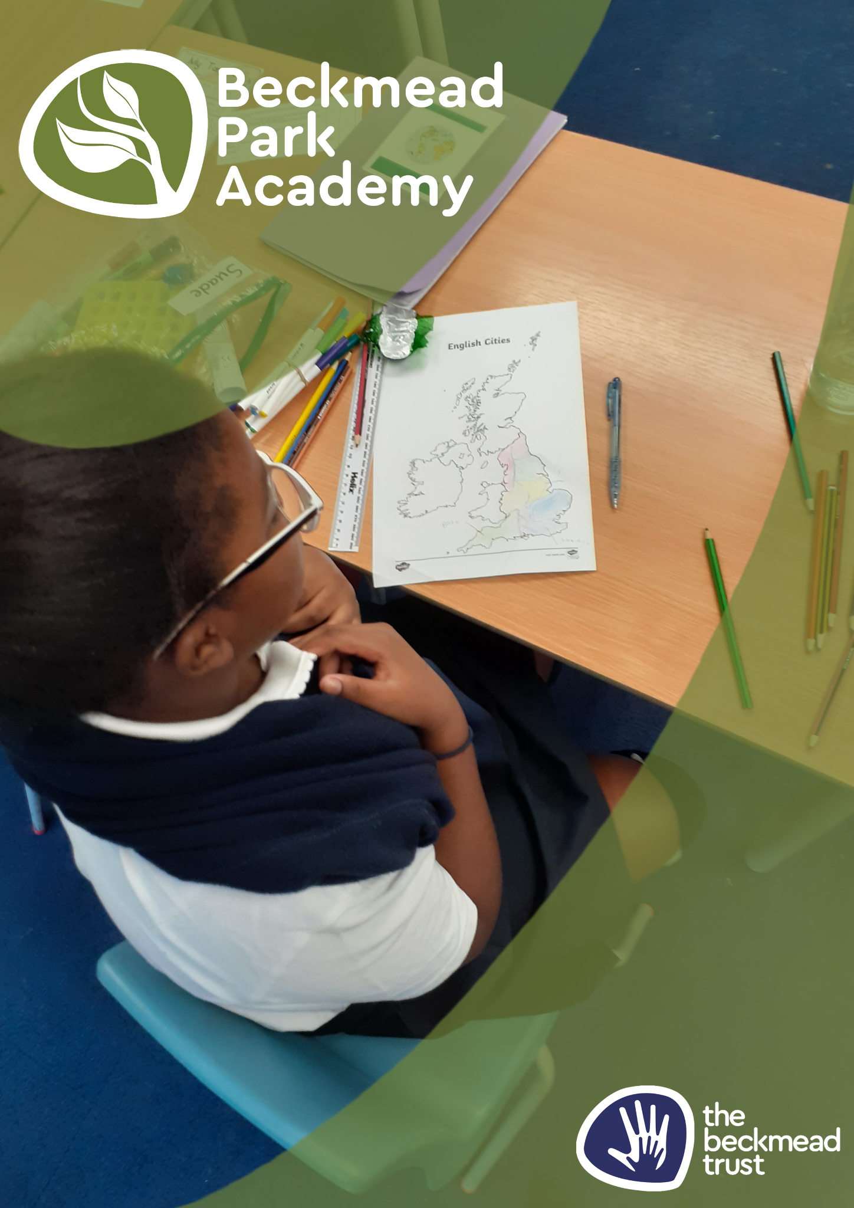
Physical Intervention Policy

Name of Policy | Physical Intervention Policy
Policy Level | Trust
Date of Issue | September 2025
Author | Samantha Hoyer
Date of Next Review | September 2026
Signature | Samantha Hoyer
Date of Signature | September 2025

AIMS & PRINCIPLES

The aim of this policy is to safeguard the wellbeing of pupils and staff when an incident requires the use of physical intervention. This policy refers to restrictive interventions including guiding and environmental change. It should be stressed that physical intervention will only be used as a last resort and whenever possible will only be used by members of staff that have had appropriate training. We will provide all of our staff training with an accredited provider.
The provider currently selected for The Beckmead Trust is ‘PRICE.’ (Protecting Rights in a Caring Environment)
The intention of this training is to develop and encourage consistent and safe practices in the use of physical intervention. Staff should not hesitate to act in an emergency provided they follow this guidance; however, they should always satisfy themselves that the action they take would be considered justifiable by a wider audience of their professional colleagues.
Our procedures take account of the guidance published by the Department for Education in their document “Use of Reasonable Force in Schools.”

DEFINITION

Physical Intervention is the positive application of force in order to protect/prevent a child from causing injury to him/herself or others or seriously damaging property.
Injury means ‘significant injury’; this would include: actual or grievous bodily harm, physical or sexual abuse, risking the lives of, or injury to, themselves or others by willful or reckless behaviour, and self-poisoning.

GUIDANCE

In any application of physical intervention, the minimum reasonable force should be used to calm down the situation. Help should be summoned from colleagues; other pupils should never be involved.
The pupil should be approached calmly but firmly. Where possible, explain the consequences of refusing to stop the behaviour and continue to communicate with the pupil throughout the incident; it should be made clear that any physical contact or intervention will stop as soon as it ceases to be necessary. A calm and measured approach is needed and a member of staff must never give the impression that she/he has lost his/her temper, or is acting out of anger or frustration - or to punish the pupil.
The method of intervention employed must use the minimum force for the minimum time and must observe the following requirements:

Intervention must NOT:
- involve hitting the pupil;
- involve deliberately inflicting pain on the pupil;
- restrict the pupil’s breathing;
- involve contact with sexually sensitive areas.
- go on for any longer than absolutely necessary
- be implemented whilst the pupils/young person is on the ground

During any incident the person(s) involved in the restraint should:
• provide constant and calm verbal reassurance to the pupil.
• cause the minimum level of restriction of movement;
• reduce the danger of any accidental injury.
• ensure that all other pupils are safely away wherever possible; e.g evacuate the class if necessary

Physical intervention can take several forms. It might involve staff:
• physically interposing between pupils;
• blocking a pupil’s path;
• holding;
• leading a pupil by the hand or arm;
• shepherding a pupil away by placing a hand in the centre of the back; or
• (in extreme circumstances) using more restrictive holds in line with physical restraint training practices.

Do’s and Don’ts:
DO | DON’T
- be aware of any feelings of anger  - summon help if required  - continue to talk to the pupil in a calm way  - provide a soft surface if possible  - be aware of any accessories worn by you or the pupil  - hold the pupil’s arms by his/her sides | - try to manage on your own  - stop talking even if the pupil does not reply  - straddle the pupil  - push arms up the back  - touch the pupil near the throat or head  - put pressure on joints

Further support will be provided through your PRICE training sessions.

Recording Incidents
It is important that any incident that requires physical intervention must be recorded on Arbor (depending on your site); the member of staff concerned should provide a written report as soon as possible afterwards and advise the Senior leadership team (SLT) immediately following the incident. This is important not only to ensure that the pupil is safe and all procedures are being correctly followed, but also to ensure that the member of staff is also suitably supported and their needs attended to.
The incident report must include:

• the name/initial(s) of the pupil(s) involved;
• the name/initial/initial(s) of the staff involved;
• when and where the incident took place;
• the name/initial(s) of any other staff or pupils who witnessed the incident;
• the length of time the child was restrained
• the reason that force was necessary;
• how the incident began and progressed;
• the pupil’s response, and the outcome of the incident;
• details of any injury suffered by the pupil/another pupil/member of staff, and any damage to property.

Parents must be informed that their child has been involved in a situation that required the use of physical intervention by a senior member of staff.
After an incident where a child has been exposed to the use of physical interventions, where possible the most appropriate support should be sought to enable the child to talk about their views and experiences. As a result of the physical intervention the child should be involved in any review of a risk assessment or a behaviour support plan.

Any injury to either pupils or staff, during physical intervention, must be reported to the schools first aider/s and recorded following the school’s accident and injury procedures and be brought to the attention of SLT. These incidents should then be investigated by the head of the provision, following the school’s investigations policies and procedures and outcomes recorded.

