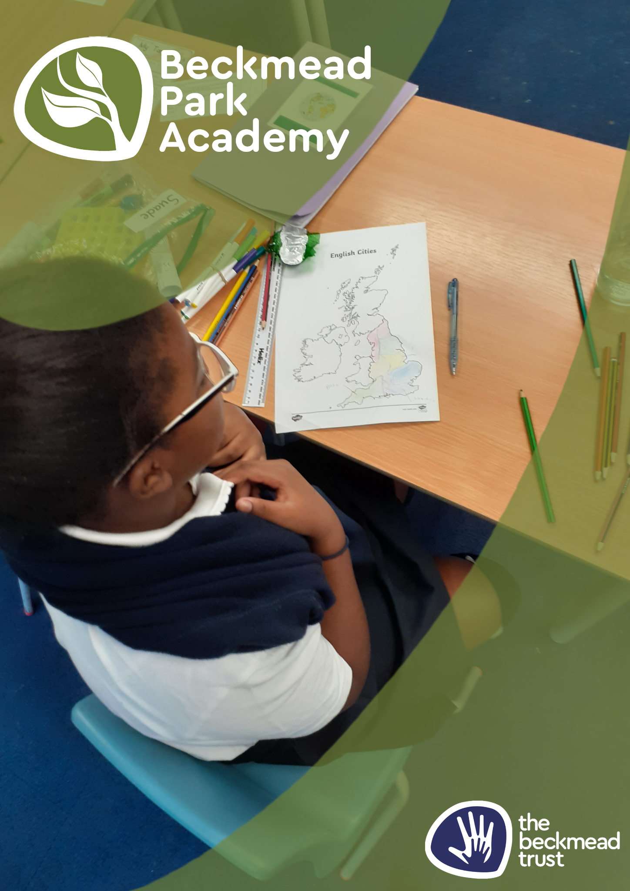
PSHE Policy

ACADEMIC YEAR | AUTHOR | ROLE | DATE OF NEXT REVIEW
2025-26 | Samantha Hoyer | Headteacher | September 2026

1. Aims
PSHE at Beckmead Park Academy will enable students to feel positive about who they are and to enjoy healthy, safe, responsible and fulfilled lives. Through active learning opportunities pupils will learn to recognise and manage risk, take increasing responsibility for themselves, their choices and behaviours and make positive contributions to their families, schools and communities.
Students will learn to recognise, develop and communicate their qualities, skills and attitudes. They build knowledge, confidence and self-esteem and make the most of their abilities. Students will learn to identify and articulate feelings and emotions, learn to manage new or difficult situations positively and form and maintain effective relationships with a wide range of people.
Our aim therefore for PSHE is to provide pupils with:
- accurate and relevant knowledge
- opportunities to turn that knowledge into personal understanding
- opportunities to explore, clarify and if necessary challenge, their own and others’ values, attitudes, beliefs, rights and responsibilities
- The skills and strategies they need in order to live healthy, safe, fulfilling, responsible and balanced lives.
At Beckmead Park Academy we know that learning and undertaking activities in PSHE education contribute to achievement of the curriculum aims for all young people to become:
- successful learners who enjoy learning, make progress and achieve
- confident individuals who are able to live safe, healthy and fulfilling lives
- responsible citizens who make a positive contribution to society.

2. Statutory requirements
PSHE is a non-statutory subject. However, there are aspects of it we are required to teach.
Our primary pupils will be taught relationships education under the Children and Social Work Act 2017, in line with the terms set out in statutory guidance
We must teach health education under the same statutory guidance
Our secondary pupils will be taught relationships and sex education (RSE) under the Children and Social Work Act 2017, in line with the terms set out in statutory guidance
We must teach health education under the same statutory guidance. Further details of our sex and relationships education is found within the Beckmead Trust’s SRE Policy.
3. Content and delivery
3.1 What we teach
As stated above, we are required to cover the content for relationships and sex education, and health education, as set out in the statutory guidance (linked to above).
All other aspects of what we teach in terms of PSHE, including health education, are contained within the PSHE curriculum map which provides the details about what we teach in each year/Key Stage. However, broadly speaking we will deliver a curriculum that educates our pupils across the following themes:

PSHE Concept | What students will learn about:
Identity | Their personal qualities, attitudes, skills, attributes and achievements and what influences these
Relationships | Including different types and in different settings
A healthy balanced lifestyle | Including physically, emotionally and socially (including within relationships, work-life, exercise and rest, spending and saving and diet)
Risk | To be managed rather than responsibilities simply avoided, and safety (including behaviour and strategies in different settings)
Diversity and equality | In all its forms
Rights, responsibilities | Including fairness and justics, and consent (in different contexts)
Change and resilience | The skills, strategies and 'inner resources' we can draw on when faced with challenging change or circumstances something to be managed
Power | How it is used and encountered in a variety of contexts including persuasion, bullying and negotiation
Career | Including enterprise and economic understanding

3.2 How we teach it
Our pupils will receive a weekly lesson explicitly focused on PSHE. This is typically delivered through a teaching programme, such as PSHE Association.
In addition to explicit lessons, we will deliver teaching around a range of aspect of PSHE through a range of other activities, such as:
- School trips
- Guest speakers
- Class and whole school assemblies
- Tutor sessions with teachers and support staff
The curriculum will primarily be delivered by our own teaching staff, supported where appropriate and/or necessary by specialist outside speakers, such as representatives from the health sector or emergency services for example.
In order to ensure that all of our pupils feel included and are able to access the learning, we will:
- Create a comfortable classroom climate where students are confident and discuss their hopes, fears and sensitive issues
- Develop a set of ground rules for the PSHE classroom
- Model good practice in the way we talk to students
- Provide enrichment opportunities that support and develop our students emotional and physical well being
- Work with external providers to provide the best possible experience and expertise for our students
- Remain flexible with our Curriculum and respond to issues as and when they arise.

4. Roles and responsibilities

4.1 The governing board
The governing board will hold the headteacher to account for the implementation of this policy.

4.2 The headteacher
The headteacher is responsible for ensuring that PSHE is taught consistently across the school. They will also arrange for monitoring to take place to ensure that the PSHE curriculum is being delivered in a broad and balanced way, ensuring that any views or beliefs held by any member of staff are not influencing the scope or quality of delivery.

4.3 Staff
All school teaching staff are responsible for:
Delivering PSHE in a sensitive way
Modelling positive attitudes to PSHE
Monitoring progress
Responding to the needs of individual pupils
As the school cohort expands we will appoint a suitable PSHE lead as required.

4.4 Pupils
Pupils are expected to engage fully in PSHE and, when discussing issues related to PSHE, treat others with respect and sensitivity.

5. Monitoring arrangements
The delivery of PSHE is monitored by the Headteacher, Dean Monfries, through:
- Planning checks
- Book scrutinies
- Learning walk
This policy will be reviewed by the Headteacher annually.

6. Links with other policies
This policy links to the following policies and procedures:

- SMSC Policy
- SRE Policy

