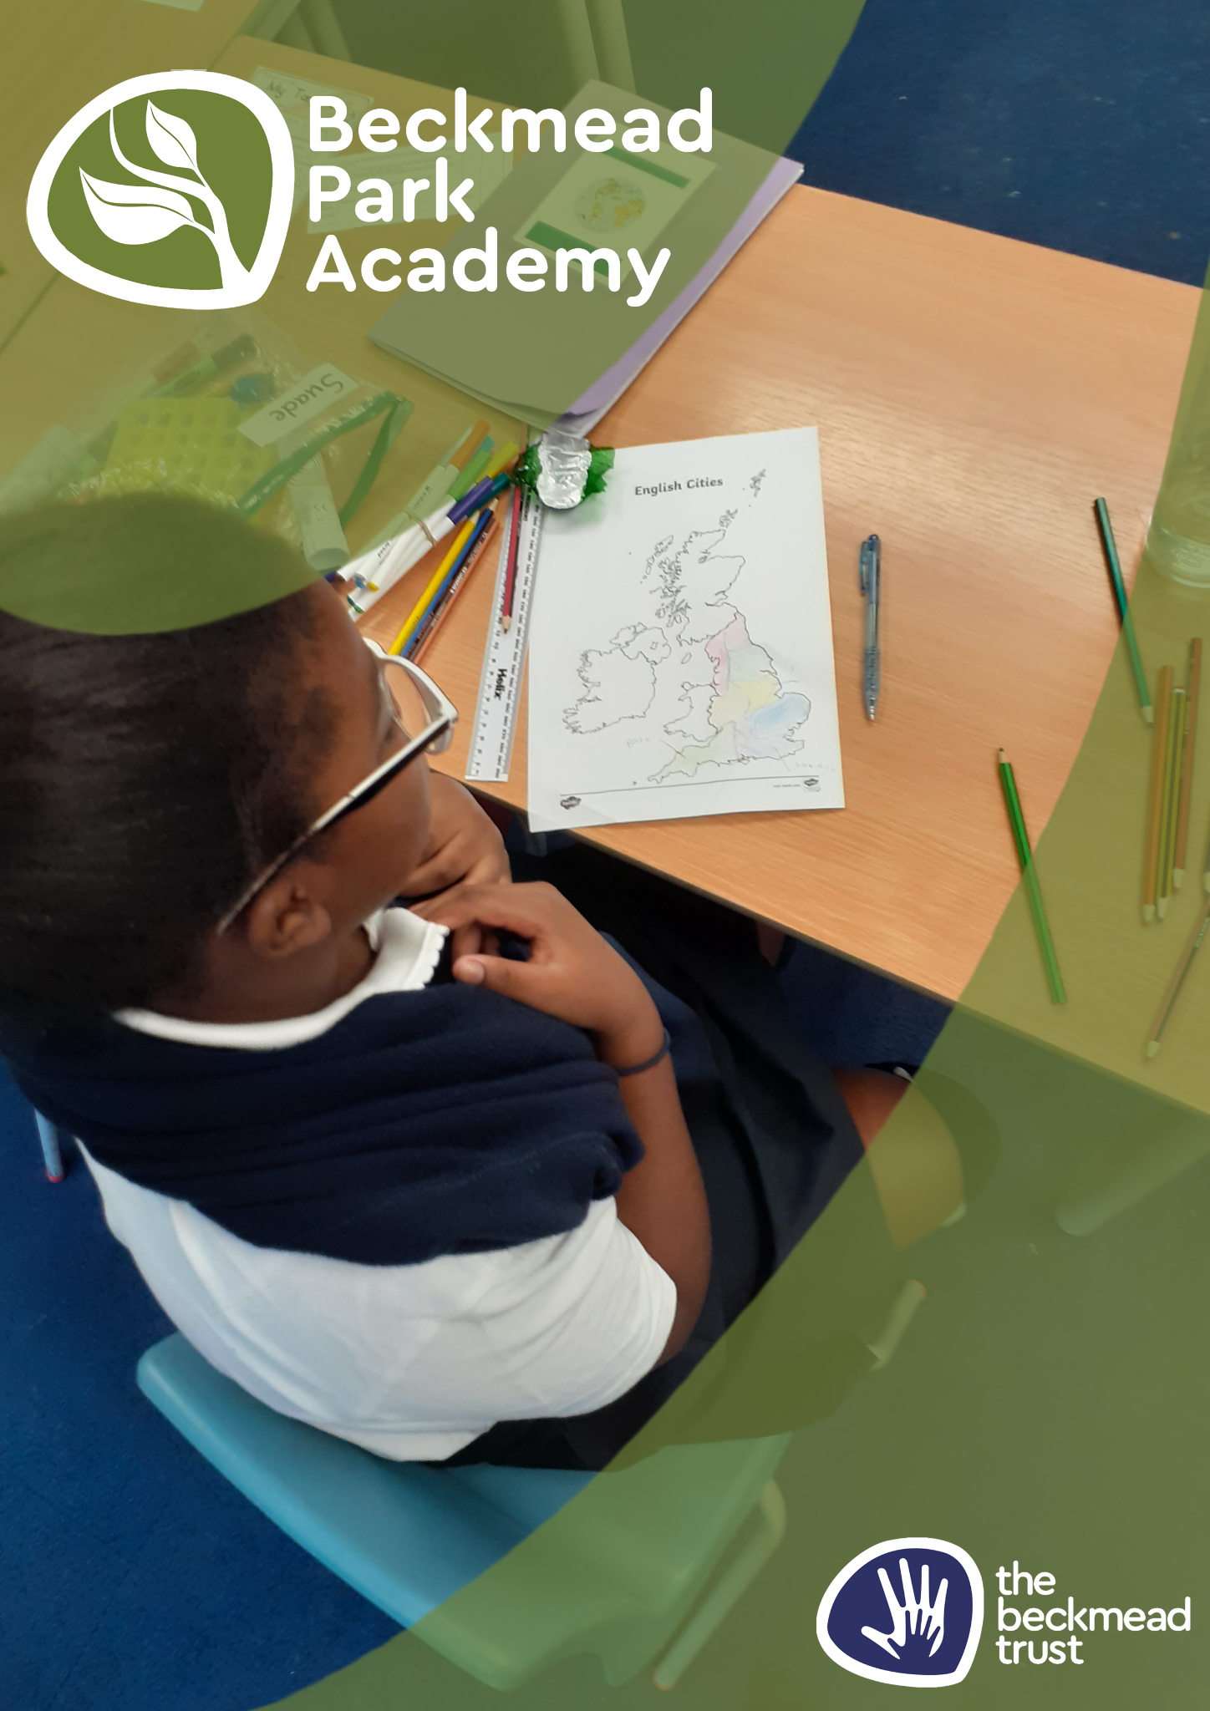
Educational Visits Policy

Name of Policy | Education Visits Policy
Policy Level | School
Date of Issue | September 2025
Author | Samantha Hoyer
Date of Next Review | September 2026
Signature | Samantha Hoyer
Date of Signature | September 2025

Introduction
Pupils at The Beckmead Trust can derive a good deal of educational benefit from taking part in visits with the school. In particular, they have the opportunity to undergo experiences not available in the classroom. Visits help develop a pupil’s investigative skills and longer visits, in particular, encourage greater independence.

This guide is designed to help ensure that the pupils and staff stay safe and healthy on school visits.

IF THE PROCEDURES ARE NOT FOLLOWED THEN THE VISIT WILL NOT BE AUTHORISED AND WILL NOT BE ALLOWED TO TAKE PLACE.

Failure to follow procedures could also lead to disciplinary procedures.

Educational Visits Policy
This policy is written to help complete the process so that we can identify hazards and minimise risks. It is important to identify which of the following visits/activities it is and ensure the appropriate planning and preparation is undertaken. This should be followed in conjunction with local authority guidance.

- Off-site educational visit led by the school
- Off-site educational visit where an external provider and facilities are used
- Off-site educational residential visit

Planning and Preparation
This is crucial to safety and educational effectiveness. On the few occasions when things do go wrong the cause can almost always be traced back, to at least some extent, to faults in planning.

It is essential that formal planning takes place before setting off on ANY visit. This involves considering the dangers and difficulties that may arise and making plans to reduce them.

The Headteacher – whose agreement must be obtained and who is responsible for planning visits – will often delegate the detailed planning to the organiser of the visit or the group leader.

Off-site educational visits led by the school or when an external provider and facilities are used, require approval by the Headteacher. Visit organisers should complete an Educational Visit Form four weeks before the intended trip and an Educational Visits Risk Assessment at least two weeks before the intended trip. Once the Educational Visit Form has been completed and signed-off by all relevant people, it should be passed to the office. The office staff will then send a text message, email or a letter (and any other documentation) to send to all applicable pupils.

Off-site educational residential visits require the approval of the Headteacher, governors and Trustees and therefore at least a terms notice is required.

The LA must be notified of all residential off-site educational visits at least two working weeks before the departure date.

The aims of all visits should be clearly established from the outset –

- Why are we doing this?
- What will it achieve?
- Who will benefit from it?
- Will it be worth doing – do the expected outcomes justify the means?

You should discuss the outlines of proposed trips with one or more colleagues and with the senior leader. This will enable ideas to be shared and supplemented.

Risk Assessment

The language of risk assessment requires an understanding and use of two essential definitions:

- “Hazard” means anything that can cause harm.

- “Risk” is the possibility that someone will be harmed by the hazard.

- “Control” is how to manage the risk and/or hazard.

Risk assessments are carried out by the Visit leader. Assessments should be completed well before the visit and should be approved by the Headteacher and Education Visits Co-ordinator. A formal assessment of the risks that might be met on a visit should have the aim of preventing the risks or reducing them. Pupils and staff must not be placed in situations which expose them to an unacceptable level of risk. Safety must always be the prime consideration.
Note: If the risks cannot be contained then the visit must not take place.
The risk assessment should be based on the following considerations:

- What are the hazards?
- Who might be affected by them?
- What safety measures need to be in place to reduce risks to an acceptable level?
- Can the group leader put the safety measures in place?
- What steps will be taken in an emergency?

At The Beckmead Trust, the risk assessment findings are recorded in written form using the risk assessment pro-formas. All staff who may be group leaders of off-site visits MUST be familiar with the forms.

The Visit Leader MUST share copies of the Risk Assessment to all staff going and get them to read and sign a copy stating that they have read and understood them.

PRE-VISIT

A pre-visit must be made by the Visit Leader who is to lead a group on a visit, (including residentials) to the location even if the location is familiar to them.

The Visit Lead must:

- Ensure at first hand that the venue is suitable to meet the aims and objectives of the school visit.
- Ascertain if it has suitable quality marks which might suggest the venue is appropriate
- Obtain advice from the venue manager regarding evacuation policy/first aid, etc.
- Assess potential areas and levels of risk and have a copy if parents wish to scrutinise.
- Ensure that the venue can cater for the needs of the staff and pupils in the group and ensure they are fully aware of the levels of need of our pupils.
- Become familiar with the area before taking a group of pupils there.

If using a provider, research them appropriately:

- Do the values and ethos of the provider match your expectations?
- Is there a clear understanding about the responsibility for supervision at all times during the visit?
- What are the respective roles of provider staff and your staff?
- What provision will be made for our pupils’ special needs?
- How flexible is the programme to meet changing circumstances?

YOU HAVE A DUTY OF CARE TO ENSURE THAT ANY PROVIDER YOU USE MEETS ACCEPTABLE STANDARDS.

When using external providers and facilities ensure you have read National Guidance from OEAP (https://oeapng.info).

First Aid/Medical Needs

First Aid should form part of the risk assessment. Before undertaking any off-site activities, the Visit Leader should assess what level of first aid might be needed.
On any kind of visit there must be one member of school staff or place of visits staff with an up to date first aid qualification or if within walking distance from school a designated member of school staff.

For residential visits at least one of the group’s staff to be a fully-trained first- aider. The person given designated responsibility for administering any regular medication will hold a copy of medication details for all pupils involved with the visit.

All adults in the group should know how to contact the emergency services. The minimum first aid provision for a visit is:
- A suitably stocked first aid box or pack.
- A person appointed to be in charge of first aid arrangements.

Other considerations when considering first aid should include:

- The number in the group and the nature of the activity.
- The likely injuries and how effective first aid would be.
- The distance of the nearest hospital.
- First aid should be available and accessible at all times.

Ratios

It is important to have a high enough ratio of adults to pupils for any visit. The factors to take into consideration include:

- Sex, age and ability of the group.
- Pupils with special educational or medical needs.
- Nature of activities.
- Experience of adults in off-site supervision.
- Duration and nature of the journey.
- Type of any accommodation.
- Competence of staff, both general and on specific activities.
- Requirements of the organisation/location to be visited.
- Competence and behaviour of the students.
- First aid cover.

At our school, due to the complex special needs, it is vital that the Visit Leader speaks to the students’ class staff and finds out potential risks when going off-site in order to appropriately staff the visit.

Residential Visits

Other issues for the Visit Leader to consider include the following:

- The leader should obtain a floor plan of the rooms reserved for the group’s use in advance.
- There must be separate male and female sleeping/bathroom facilities for pupils and adults.
- The immediate accommodation area should be exclusively for the group’s use.
- Ensure there is appropriate and safe heating and ventilation.
- Ensure the whole group are aware of the lay-out of the accommodation, its fire precautions/exits, its regulations and routine, and that everyone can identify key personnel.
- Security arrangements – where the reception is not staffed 24 hours a day, security arrangements should be in force to stop unauthorised visitors.
- The manager of the accommodation should be asked for assurances that all staff, including temporary workers, have been checked as suitable for work with students.
- Locks on doors should work in the group’s rooms but appropriate access should be available to teachers at all times.
- There should be drying facilities.
- There should be adequate space for storing clothes, luggage, equipment, etc., and for the safekeeping of valuables.
- Adequate lighting – it is advisable to bring a torch.
- There should be provision for students with special needs and those who fall sick.
- Balconies should be stable, windows secure and electrical connections safe.
- The fire alarm must be audible throughout the accommodation.
- There should be recreational accommodation/facilities for the group.
- The place of residence should be able to meet any particular cultural or religious needs of the group.
- There should be an appropriate number of group supervisors on standby during the night.

Farm Visits

Farms can be dangerous even for the people who work on them. Taking students to a farm should be carefully planned. The risks to be assessed should include those arising from the misuse of farm machinery and the hazards associated with E coli 0157 food poisoning and other infections.

Check that the farm is well-managed; that it has a good reputation for safety standards and animal welfare; and that it maintains good washing facilities and clean grounds and public areas. Always undertake a pre-visit.

There are some basic safety rules. Never let pupils:

- Place their faces against the animals or put their hands in their own mouths after feeding the animals.
- Eat until they have washed their hands.
- Sample any animal foodstuffs.
- Drink from farm taps (other than in designated public facilities).
- Ride on tractors or other machines.
- Play in the farm area.

Further advice is contained on the Health and Safety Executive’s website – Preventing or Controlling Ill Health from Animal Contact at Visitor Attractions or Open Farm.

Clothing

Specific clothing will be determined by:

- Weather.
- The nature of the activity.
- Where and when the activity takes place.

When using providers, it is important to know what clothing/equipment is required and that it is suitable.

Communicating with Parents

Parents should be informed in writing of any off-site activity unless it is a regular part of the school curriculum which parents have already been informed about.

Before residential visits parents should be encouraged to attend a briefing meeting where written details of the proposed visit should be provided. There should be alternative arrangements for parents who cannot attend or who have difficulty with communication in English. This is a legal requirement. Parents need to be aware that the teachers and other staff on the visit will have a ‘duty of care’.

The following information on matters that might affect pupil health and safety should be imparted to parents:

- Dates of the visit.
- Visit objectives.
- Times of departure and return – parents must have agreed to meet their child on return.
- The location where the pupils will be collected and returned.
- Mode(s) of travel including the name of any travel company.
- The size of the group and the level of supervision at all times
- Details of accommodation with security and supervisory arrangements on site.
- Details of provision for educational or medical needs.
- Procedures for pupils who become ill.
- Names of leader, of other staff and of other accompanying adults.
- Details of the activities planned and of how the assessed risks will be managed.
- Standards of behaviour expected and general group discipline, including prohibited items. This information may take the form of a code of conduct which parents should sign.
- What pupils should not take on the visit or bring back.
- Details of insurance taken out for the group as a whole in respect of luggage, accident, cancellation, medical cover, any exceptions in the policy and whether parents need to arrange additional cover
- Clothing and equipment to be taken.

A parental consent form will need to be completed and returned for each pupil in the group.

Medical Consent Forms part of the parental consent form. Parents are asked to agree to the pupil’s receiving emergency treatment, including the administration of a general anaesthetic and to surgical operations in the case of an emergency (in accordance with the recommendation of a qualified medical practitioner).

If parents do not agree to this, the Headteacher may decide to withdraw the child from the visit – given the additional responsibility this would entail for the Visit leader.

Contact with Parents/Carers during a Residential Visit

The Visit Lead should ensure that parents/carers can contact their child via the school contact and the group leader in the event of a home emergency, and that they have a number to ring for information. In the event of an incident during the visit or a late arrival home. Parents should therefore:

- Know the destination details.
- Be aware of the emergency contact arrangements at home and at all the venues the group will visit.
- Provide contact numbers for day and night use in an emergency.
- Group leaders should arrange for parents/carers to be told by the school of the group’s safe arrival using SMS or a similarly suitable service.

Use of Mobile Telephones

Pupils will not be permitted to take their mobile phones on visits, including residential visits.

Students with complex educational or medical Needs

Every effort should be made to include pupils with complex educational or medical needs in school visits, whilst maintaining the safety of everyone in the group.

If a venue or trip is unsuitable for some pupils as a result of their needs, then an alternative must be sought.

Special attention should be given to appropriate supervision ratios and additional safety measures may need to be addressed at the planning stage.
Additional safety measures to those already in place in school may be necessary to support pupils with medical needs during visits. Arrangements for taking medication and ensuring sufficient supplies for residential visits may be required.
All teachers supervising visits should be aware of a pupil’s medical needs and any medical emergency procedures.

Summary sheets held by all teachers, containing details of each student’s needs (within their assigned responsibility group), and any other relevant information provided by parents/carers, is one way of achieving this.

The Visit leader should discuss the pupil’s individual needs with the parents.

The Visit leader should check that the insurance policy covers staff and pupils with pre-existing medical needs.

Any limitations or problems that a pupil with special educational needs may have, should be taken into account at the planning stage and when carrying out the risk assessment.

Off-site visits may pose additional difficulties for a pupil with certain SEND, and the behaviour of some of our pupils may prove challenging. The following factors should be taken into consideration:

- Is the pupil capable of taking part in and benefiting from the activity?
- Can the activity be adapted to enable the pupil to participate at a suitable level?
- Will additional/different resources be necessary?
- Is the pupil able to understand and follow instructions?

It may be helpful to the pupil if one of the staff already knows them well and appreciates their needs fully. The group leader should discuss the visit with the parents of pupils with particularly complex SEN to ensure that suitable arrangements have been put in place to ensure their safety.

Scope of Educational Visits

Visits should be arranged that will support and enhance the planned curriculum. This may also be used as either a springboard to learning or as a summing up of learning. As an open-minded special school, we will likely include visits to all places of worship. These visits will both underpin the differing values and beliefs of other cultures and faiths and allow the students opportunities to explore different cultures and beliefs.

OUT OF SCHOOL EDUCATIONAL VISITS FORM
CLASS |  | YEAR |  |  |  | DATE AND TIME
GROUP LEADER |  |  |  |  |  | DRIVER (IF REQUIRED)
TRANSPORT ARRANGEMENTS

COST |  | LUNCH/DINING ARRANGEMENTS |  |  |  | Mobile number of group leader and 1 other
CURRICULUM LINK

NUMBER OF PUPILS | NAMES |  | NUMBER OF STAFF |  | NAMES
Medical Concerns & Requirements (Name pupils and needs, and attach supporting documents as required – e.g. IHP)
Additional Information:
Eg. Staff cover
Authorised:
Date:
Checklist:
Letter to parent:
Trip authorised:
Cover arranged:
Permission form signed:
Booster seats:
Risk assessment checked:
Mobiles and school numbers taken:
Lunch arrangements made:
Penpics taken:
Medication:
First aid bag:

Health and Safety Risk Assessment – Educational Visit

Name of Location: |  |  |  |  | Address:
Subject of Assessment

Assessed by |  |  |  | Date |  |  |  |  | Review date
Details of workplace/activity |  |  |  |  |  |  |  | Persons Affected  (Who may be harmed)
Hazards and Risks |  |  | Existing Control Measures |  |  |  |  |  |  | Risk Level  (Very High, High, Medium, Low) |  | Further Actions  √/X  (If √ See Actions)
1.
2.
3.
4.
6.
7.
8.
9.
10.

ACTION PLAN
(Additional Control Measures Required/Recommended Actions)

Hazards and Risks |  | Recommended Actions
1.
2.
3.
4.
5.
6.

Please note:
The hazards and controls noted above are an example of that which may be present when completing such a task. This assessment template is an example only and should either be used as reference only or amended to reflect the actual hazards and controls identified on site by the assessor.
Following assessment if no further actions are assessed to be required please mark an X in the “Further Actions” box. If however, additional controls or actions are assessed to be required please place a √ in the box and note the action in the action plan.
Any further actions identified should be completed before the assessed task is carried out.
All individual pupil risk assessments in place should also be attached to this document and taken on the visits

