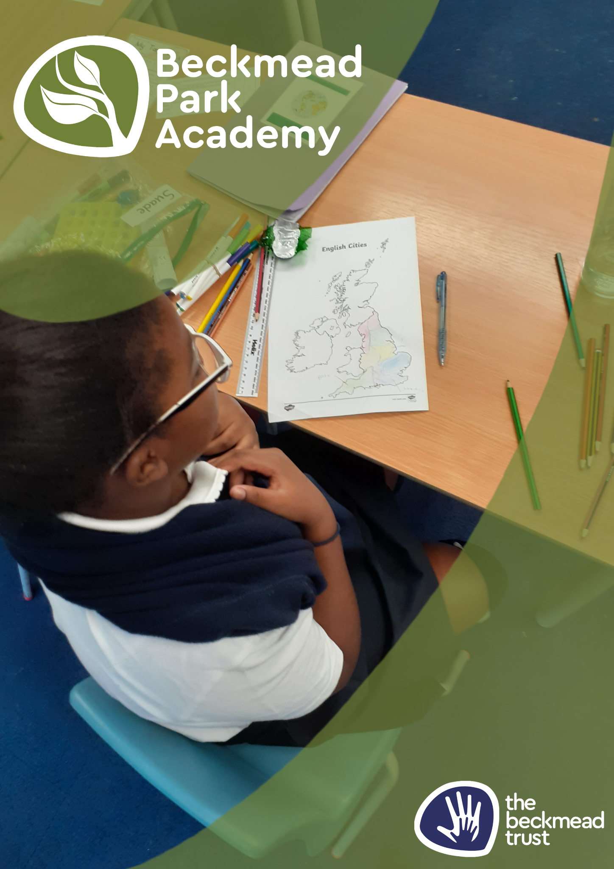
Nurture Policy

Name of Policy | Nurture Policy
Policy Level | School
Date of Issue | September 2025
Author | Samantha Hoyer
Date of Next Review | September 2026
Signature | Samantha Hoyer
Date of Signature | September 2025

NURTURE POLICY

Introduction.
Children’s difficulties when they are referred to a Beckmead Trust school are always complex and can seem unusual or even bizarre. Behaviour can range from withdrawn, avoidance-based behaviour linked to communication difficulties through to violent, disruptive behaviour targeting other children and adults emanating from deeply traumatic childhood experiences.
Although it may not be immediately apparent, many of our children will not have reached their developmental age both cognitively and academically and the wrong pedagogical and relational approaches can cause immense stress and even terror. Many of the Beckmead Trust children have very disorganised attachment experiences, feel little coherence on a day to day basis, have imperfect concepts and are frequently thoroughly confused.
Many of the Beckmead Trust parents are difficult to engage with and live with debilitating levels of stress and anxiety: they frequently find interventions and services unsympathetic or impenetrable and this is frequently their experience of schooling – both themselves and as parents. Our carers and parents can find our work of little relevance and are submerged beneath a struggle to exist which can manifest in a torrent of anger or a well of depression.
Our children and families all need to be nurtured and be able to experience adults who are genuine, harmonious, who offer a starting position of unconditional positive regard and communicate a deep empathic understanding of people and contexts.
The Beckmead Trust offers schools that are ‘safe spaces’ where children feel empathy, warmth and encouragement to help them explore and improve their emotional and physical wellbeing….
‘If we can provide a certain type of relationship, children will discover within themselves the capacity to use that relationship for growth and change and… personal development will occur’.
(Carl Jung).

Experiences.
Many pupils with SEMH and /or autism cannot see beyond the classroom, the moment or the last sentence they heard and thus struggle to contextualise the point of education or coming to school.
Supporting pupils to embrace different learning opportunities, whether that be gardening, creating a sculpture or visiting a local place of employment, helps pupils to see that there is a life beyond their school. It builds the cultural capital of pupils, but also encourages them to develop the belief that there are things “out there” that they can access, have relevance and that there is a reason to come to school and behave today.
Many of our pupils have previously lost out on these opportunities because their behaviour is a barrier, but for these pupils, for whom school historically has been a place which lowers their self-esteem, engaging with things outside of school can be a turning point. Furthermore, this encourages pupils to consider future life choices and careers. Trips and a broad curriculum build resilience, trust and self-belief – key skills to school life, learning and the world after school.

Celebrate the small stuff
There can be, at times, little to celebrate for our most disaffected pupils, so noticing the small things is key – for instance noticing and praising the first time a child did not swear when they wanted to or even the first time a child spits on the carpet rather than in an adults face. Celebrate with the child as this shows that they can get better attention for positive behaviour rather than negative attention for negative behaviour.
Many of our pupils find accepting praise very challenging, so finding quiet ways to praise can be important. For example, a simple pat on the shoulder or quiet whisper can be very effective in slowly building a pupil’s self-esteem as can praising through a third party conversation with another adult. When times get tough, reflecting back on these moments can be significant in reminding a pupil of a time when they did get it right.
Giving our children jobs and responsibilities to do can be a useful strategy so that you have a way to notice when they get it right. We often say to pupils, “be good” but many of them do not know what being good looks like and we need to explicitly make them aware when they are behaving in ways which are positive and indicate why.

Flexibility
Beckmead Park Academy pupils present with a vast spectrum of need and our children and the cohorts we work with and care for may be very different. We need to understand our pupils and then meet their needs in a responsive, reflective and flexible way. The provision we offer pupils often frequently has to change on a daily basis to meet the needs of the children in our care, but this happens within SEMH and Autism friendly structures that the students are familiar with. Students learn how it is not always possible to stick to a plan and that learning coping strategies is essential for the pupil or the staff involved. Many of the pupils we work with have rigidity of thought, so modelling a flexible approach teaches pupils that there are other ways to be. By using strategies like social stories, modelling, practicing before the event, having a key person to talk to, flexibility becomes possible for children with ASD and other comorbidities.
Finding a balance between boundaries and flexibility is one of the most significant and difficult challenges of working with youngsters identified as having additional needs, but one we need to work hard to achieve. It is useful to remind yourself and colleagues you are working with to step back and think about what you want to achieve out of any given situation and avoid getting into a mindset where you feel you ‘have to win’.

Wellbeing
Much of the work in The Beckmead Trust schools is about mental health and emotional wellbeing. For pupils who have coped with challenging life experiences, it is important for them to understand that their feelings and emotions are normal and valid. Improving pupils’ understanding of themselves is key to developing their intrinsic desire to be the best they can be and to make positive life choices.
Pupils can be taught to understand that mental health is as changeable as physical health and need to be encouraged to talk about ways this can be achieved. At Beckmead Park Academy we organise activities and focus weeks on Autism where children can explore this condition and learn how they may relate to the different aspects of their diagnosis.
Visitors, trips and events can focus on positive wellbeing. Parents and carers are also greatly encouraged to be involved in school life and The Beckmead Trust schools nurture and support these groups and individuals in the same way a wider family does. School-leavers often come back to share successes or to seek support in one way or another; frequently many years after leaving school. This demonstrates how valuable a nurturing approach can be and reinforces the concept of ‘hidden work’. The Beckmead Trust children never forget the love, compassion and guidance they receive whilst at school and even though they may not demonstrate acceptance of this during their schooling, the way of living they experience at our schools is often life-changing.

How our staff nurture our children and our families.
- Physical proximity facilitates emotional and physical attachment.
- Select straightforward experiences, model and control them.
- The school day is marked with slow, predictable interludes and routines.
- Routine and repetition underpin most of the school day.
- Toys, activities, language and interaction are appropriate for the developmental level of the children.
- Food, warmth and comfort demonstrate care and support.
- Sensory touching and experiences are very relevant.
- Eye contact and facial expressions can be deliberately exaggerated for clarity.
- Positive verbal encouragement demonstrates the child’s love and value.
- Adults give purposeful direction, clear boundaries and manageable constraints and alternatives.
- Groups are gathered together frequently with calm and reassurance.
- Transition planning, routines and objects of reference are critical.
- Opportunities for play are frequent and developmentally appropriate.
- Adults anticipate unmanageable situations and divert and distract.
- Adults and children share experiences and learn together with frequent praise being given.
- Communication is personalised and incremental with complex instructions broken down into stages.
- Share and choose activities are structured and directed.
- Expectations are clear, repeated frequently and accompanied by instant approval / disapproval often with visual support and a verbal commentary and reinforcement.

Conclusion
Working with the pupils who attend The Beckmead Trust schools is a challenging but immensely rewarding job. It is hard not to take some of the things our pupils can say or do personally, but it is important to remember that hardly any of their behaviour is about us; it is about them, their experiences and their journey.
The Beckmead Trust staff are enablers who encourage traumatised, disadvantaged children to explore, express and be listened to as they seek to find their way in the world.
It takes a team approach to support our children as well as a sense of humour and a great deal of resilience. It is important to remember that working at Beckmead can be stressful so taking time to nurture yourself and those around you away from school is also vital.

Dr Jonty Clark OBE: CEO The Beckmead Trust.
Samantha Hoyer

