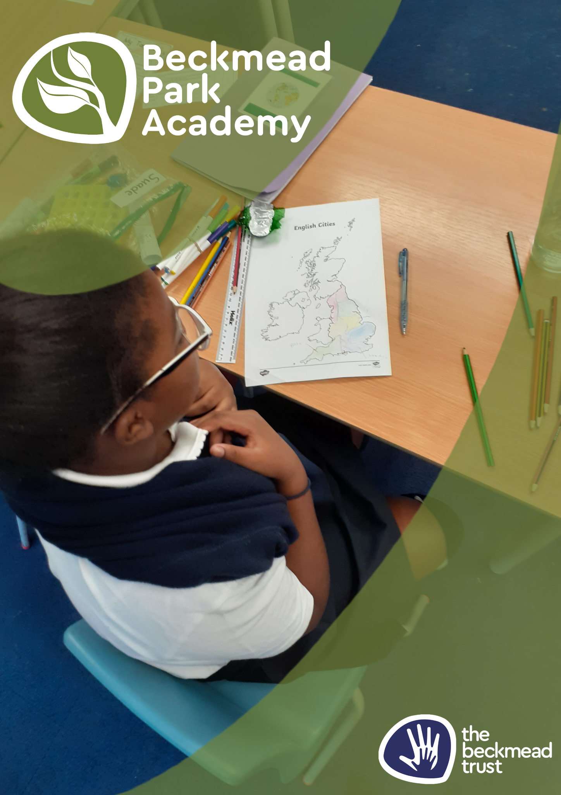
Anti Bullying Policy

Name of Policy | Anti Bullying Policy
Policy Level | Trust
Date of Issue | September 2025
Author | Samantha Hoyer
Date of Next Review | September 2026
Signature | Samantha Hoyer
Date of Signature | September 2025

Aims

At The Beckmead Trust, we aim to provide a safe, welcoming and empathetic environment for all members of the school. This is dependent upon maintaining high standards of behaviour, care, and control so that all students within The Beckmead Trust have the right to enjoy learning, free from intimidation, both inside and outside the classroom and within the surrounding community. Bullying deprives people of the right to make progress and to achieve their potential. Specifically, it deprives students of the right to an education within a safe, secure and positive environment. Our community will not tolerate bullying of any kind. We say NO to bullying – Reject it – Report it – Remove it.

Here at Beckmead Trust, we regard bullying as very serious and always take firm action against it. We encourage children to work against it and to report any incidents of bullying.

The purpose of this policy is:

• To prevent bullying from happening between children and young people who are a part of our organisation or take part in our activities
• To make sure bullying is stopped as soon as possible if it does happen and that
those involved receive the support they need
• To provide information to all staff, volunteers, children and their families about
what we should all do to prevent and deal with bullying.

This policy statement applies to anyone working on behalf of The Beckmead Trust, including senior managers and the board of trustees, paid staff,
volunteers, sessional workers, agency staff and students.

What is bullying?

Bullying can be physical, verbal or emotional by a single person or a gang.

Incidents of bullying can include:

- Name calling
- Malicious gossip
- Damaging or stealing property
- Coercion into acts they do not wish to do
- Violence and assault
- Punching/kicking
- Jostling
- Teasing
- Intimidation
- Extortion
- Ostracising
- Damaging school work and equipment

The term ‘bullying’ has changed over time. The Department for Children, Schools and Families defines bullying as:

- Repetitive, wilful or persistent behaviour intended to cause harm, although one-off incidents can in some cases also be defined as bullying
- Intentionally harmful behaviour, carried out by an individual or a group
- An imbalance of power leaving the person bullied feeling defenceless.

The Anti-Bullying Alliance defines bullying as:

- Intentional, repetitive or persistent
- Hurting of one person by another, where the relationship involves an imbalance of power

Forms of Bullying

Bullying can take many forms and can be short-term or continuing over a longer period of time. It can take the form of physical, verbal or psychological harm which is more subtle.

Research has suggested that a gender difference is present in the way in which boys and girls bully their peers. This trend develops the older the pupils become. Boys are twice as likely as girls to use physical violence, whereas girls are three times more likely to use gossip and name-calling.

Reasons for being a victim of bullying may include:

- Any difference including those on the grounds of Race, Religion or Belief, Gender or Gender Identity, Disability, Sexual Orientation or class.
- Family composition / living arrangements
- New child in school
- Child with family crisis
- They are likely to be children who are not assertive (timid), unlikely to fight back, loners with few friends, anxious or fearful children, younger children and those outside a group.

Reasons for being a bully may include:

- Victim of violence
- Enjoyment of power / creating fear
- Copying behaviour seen at home or on TV
- It occurs in children from all backgrounds, cultures, races, sexes, from Nursery through to 6th Form / adult.

Early Signs of Distress

- Withdrawn
- Deterioration of work
- Spurious illness
- Isolation
- Desire to remain with adults
- Erratic attendance
- General unhappiness/anxiety/fear
- Late arrivals
- Bed wetting and other signs noted in our Special Educational Needs Policy

Strategies for Reducing and Eliminating Bullying

We firmly believe that prevention is better than cure, so we:

- Encourage the caring and nurturing side of children through positive behaviour management strategies
- Work for a caring, co-operative ethos (such as through paired and group work, assemblies, Personal Social, Health & Citizenship Education curriculum)
- Discuss friendships and positive relationships on a regular basis
- Actively celebrate differences of all kinds regardless of Race, Religion or Belief, Gender or Gender Identity, Disability, Sexual Orientation or class.
- Ensure adequate supervision in playground and training of all school staff on behaviour management (including the prevention of bullying)
- Positively encourage caring and actively discourage bullying
- Buy in specialist support in the form of social skills groups, anger management and individual therapy for pupils.
- Regular class circle time which is used to address bullying and explore issues of feelings / friendship / asking for help when needed.
- All staff are ready to deal with bullying incidents in a sensitive and responsive manner.
- Pupils are regularly reminded of our referral systems for bullying: self referral (this is when a child is directly involved in an incident); peer referral (when a child has witnessed an incident but is not directly involved); parent/carer referral (when a parent raises a concern about bullying). We have clear referral routes for all pupils if they feel victimised.
- We actively follow-up incidents as this is crucial to pupils feeling confident that the school has taken the incident seriously and that action will be taken.

Constructing and maintaining an Anti-Bullying Ethos

The Beckmead Trust will endeavour to set positive role models in all relationships within the trust’s community.

All staff will regularly reiterate the message that bullying is unacceptable.
Bullying will feature in the PSHE programme on a regular basis.

Staff will refer to the unacceptable, negative impact of bullying during informal interactions with the pupils.

How to Recognise the Difference Between Bullying
& Bossy / Boisterous Behaviour
BULLYING

Focussed on younger, smaller and timid children increasingly relying on threat and force.

Wilful, conscious desire to hurt, threaten and frighten.

Play spoiling other children's activities, showing violence and hostility.

Rough intimidating behaviour

BOSSINESS / BOISTEROUS

Bossing whoever is around at the time.

Usually grows out of it as they mature and learn social skills.

More natural and uncontrolled (not vindictive), high spirits, not unfriendly

Advice for Parents / Carers:

Don’t give permission for bullying by saying:

- You must have done something to deserve it
- Go and hit him / her back
- Don’t be a wimp
- Boys will be boys
- It will sort itself out
- It is part of growing up
- Got to take it like a man
- Must learn to look after themselves
- Don’t tell tales

Procedure for Dealing with Bullying

- All complaints go to the Class Teacher before reporting it to the SLT. Class teachers are best placed to have a deeper understanding of the situation and to investigate.
- Record all incidents and discussions with all children involved.
- Involve parents and explain action taken, why and what they can do to reinforce and support. Communicate reports to parents.
- Stress that watching and doing nothing is supporting (some children prefer this as an option).
- Be aware and directly tackle any language that is racist, sexist, anti religious, homophobic or offensive on the grounds of disability.
- Give support to both the victim and the bully. Victim needs self-esteem and self-value. Bully needs to work with others (co-operation rather than competition). Do not bully the bully and instead find out why they are bullying.
- Reward non-aggressive behaviour.
- Follow up, to support the victim and prevent reoccurrence (monitor closely).
- Make clear to parent unacceptability of bullying, eg. no ‘hit him back’ attitude.
- Use peer group pressure and approbation and disapproval.
- Help children to see other points of view: “How would you feel if …?”

Investigating and Monitoring

All allegations of bullying will be investigated thoroughly and sensitively. If a teacher is unsure of how to deal with an incident of bullying s/he will seek advice from more experienced staff or the SLT. Students will always receive feedback if they have made allegations of bullying. If allegations are made about a teacher bullying a student, the Headteacher must be informed and will then decide the most appropriate course of action. All parties involved in any incident, including parents, will be kept informed at all stages in the investigation. SLT are to monitor to ensure the bullying has not resumed. Persistent or violent bullying will lead to tougher disciplinary measures including exclusion or possible permanent exclusion.

Desired Outcome

Incidents of bullying will be pursued until the situation is resolved and all parties can return to the safe and caring environment that best supports effective teaching and learning.

Evaluation and Review

This policy will be reviewed regularly and will reflect national advice and guidance.

