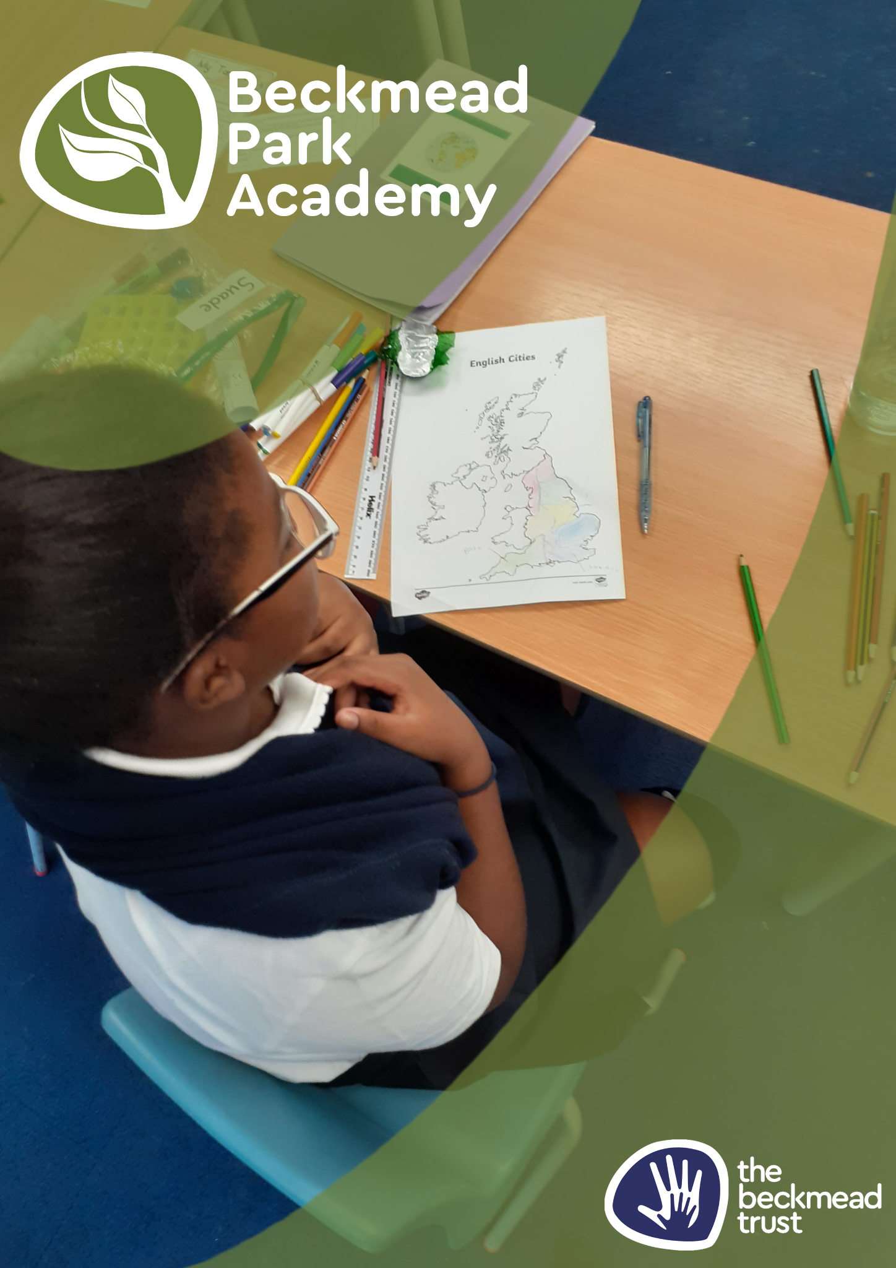
Admissions Policy
Name of Policy | Admissions Arrangements
Policy Level | School
Date of Issue | September 2025
Author | Samantha Hoyer
Date of Next Review | September 2026
Signature | Samantha Hoyer

Table of Contents
1. Aims 4
2. Legislation and statutory requirements 4
3. Definitions 4
4. How to apply 5
5. Requests for admission outside the normal age group 5
6. Allocation of places 5
7. In-year admissions 6
8. Appeals 6
9. Monitoring arrangements 6
10. Local Arrangements 6

1. Aims
This policy aims to:
- Explain how to apply for a place at Beckmead Park Academy
- Set out the school’s arrangements for allocating places to the pupils who apply
- Explain how to appeal against a decision not to offer your child a place.

2. Legislation and statutory requirements
This policy is based on the following advice from the Department for Education (DfE):
- School Admissions Code
- School Admission Appeals Code.
As an academy, the School is required by its funding agreement to comply with these codes, and with the law relating to admissions as set out in the School Standards and Framework Act 1998.
This policy complies with our funding agreement and articles of association.
The member schools of The Beckmead Trust will have a designated number of pupils on roll. These pupil numbers may be made up with a number of children from other local authorities who may have needed a school place when one was available at a Trust School. Member schools of the Trust in partnership with LA’s will recoup monies directly for these placements. It is important that all the schools are as near to capacity as possible at all times to mitigate any possible reduction in funding.
Beckmead Park Academy has 127 places for students from the ages of 5 – 16, and is co-educational, accepting both male and female students.

3. Definitions
The normal admissions round is the period during which parents/carers would apply for state-funded School places at the School’s normal point of entry, using the common application form provided by their home local authority.
Looked after children are children who, at the time of making an application to a School, are:
- In the care of a local authority, or
- Being provided with accommodation by a local authority in exercise of its social services functions.
Previously looked after children are children who were looked after, but ceased to be so because they:
- Were adopted under the Adoption Act 1976 or the Adoption and Children Act 2002, or
- Became subject to a child arrangements order, or
- Became subject to a special guardianship order.
A child reaches compulsory School age on the prescribed day following his or her fifth birthday (or on his or her fifth birthday if it falls on a prescribed day). The prescribed days are 31 December, 31 March and 31 August.

4. How to apply
For applications in the normal admissions round you should use the application form provided by Croydon local authority school admissions team. For our special school sites (Monks Orchard Road and Tharreo House), we can only accept pupils who are in receipt of an Education Health and Care Plan (EHCP), Special Educational Needs and Disabilities (ISEND) team are responsible for allocating pupils to us. For our Alternative Provision (Bramley Bank and The Beck), referrals are made through the local authorities Learning Access Team who will request places via the Fair Access Panel. These pupils do not have to be in receipt of an Educational Health Care Plan (EHCP).
You can work with the support of the SEN team within your Local Authority if your child is in receipt of an Education, Health and Care Plan (EHCP) or is in the process of receiving a plan.
You will receive an offer for a School place directly from your local authority. They will consult with us as a school to ensure that we are able to meet your child’s needs.

5. Requests for admission outside the normal age group
Parents/carers are entitled to request a place for their child outside of their normal age group.
Decisions on requests for admission outside the normal age group will be made on the basis of the circumstances of each case and in the best interests of the child concerned. In accordance with the School Admissions Code, this will include taking account of:
- Parents/carers’ views
- Information about the child’s academic, social and emotional development
- Where relevant, their medical history and the views of a medical professional
- Whether they have previously been educated out of their normal age group
- Whether they may naturally have fallen into a lower age group if it were not for being born prematurely
- The Headteacher’s views

Wherever possible, requests for admission outside a child’s normal age group will be processed as part of the main admissions round. They will be considered on the basis of the admission arrangements laid out in this policy. Applications will not be treated as a lower priority if parents/carers have made a request for a child to be admitted outside the normal age group.
Parents/carers will always be informed of the reasons for any decision on the year group a child should be admitted to. Parents/carers do not have a right to appeal if they are offered a place at the School but it is not in their preferred age group.

6. Allocation of places
Admission number
The School has an agreed admission number of pupils which is determined by the agreed number on roll. (127) The school will occasionally exceed this number if it is possible to do so whilst maintaining an outstanding level of education and care for all children and staff.

7. In-year admissions
You can apply for a place for your child at any time outside the normal admissions round. As is the case in the normal admissions round, all children whose EHCP names the school will be admitted as long as an appropriate vacancy exists.
Likewise, if there are spaces available in the year group you are applying for, your child will always be offered a place.
If there are no spaces available at the time of your application, your child’s name could be added to a waiting list for the relevant year group. Priority will not be given to children on the basis that they have been on the waiting list the longest and will be decided by the school and the Croydon SEND team.
Applications for in-year admissions should be sent to the SEND team at Croydon Council.

8. Appeals
If your child’s application for a place at Beckmead Park Academy is unsuccessful, you will be informed why admission was refused and given information about the process for hearing appeals. If you wish to appeal, you must set out the grounds for your appeal in writing and send it to the SEND team at Croydon Council.

9. Monitoring arrangements
This policy will be reviewed and approved by the Board of Trustees every year.
Whenever changes to admission arrangements are proposed (except where the change is an increase to the agreed admission number), the Board of Trustees will publicly consult on these changes.

10. Local Arrangements for admissions to Beckmead Park Academy.
Criteria for admissions to Beckmead Park Academy:
- The child will have an Education, Health and Care Plan issued by their Local Authority and the Local Authority will assume financial responsibility for the placement.
- The primary needs of the child will arise from Social Emotional Mental Health (SEMH) and will include behaviour that challenges
- The school will be suitable for the child’s age, ability and aptitude
- The child’s attendance at the school will be compatible with the provision of an efficient education for the pupils who already attend the school
- The attendance of the child at the school will be compatible with the efficient use of school resources
- Availability of places taking into account the above factors as well as the child’s level of functioning and age.
Procedures for admissions:
Parents may visit the schools by appointment to find out and discuss whether the school is suitable for their child and whether the child’s needs may be met. Please email park.consultations@beckmeadtrust.org to make an appointment.
Referral documents are sent by the Local Authority SEND team to the Beckmead Trust central email for admissions and referrals which is croydonconsultations@beckmeadtrust.org. Referral documents should include:
- An up-to-date EHCP
- Latest annual review
- Relevant multi-agency information such as CAMHS assessments
An administrator then sends the referral documents to the Head Teacher who will consult with the Senior Leadership Team and other professionals such as therapists, to consider whether the school can meet the child’s needs.
A senior leader will raise any queries with the SEND team and will arrange a school visit to observe the current context, look at current school strategies and work books. A home visit may also be arranged to discuss current concerns regarding behavioural issues and individual needs. This information will contribute to a decision being made.
The decision will be communicated to the caseworker who sent the referral, within the 15 working days of consultation. The caseworker will then inform the parents and will confirm that the Local Authority will be taking financial responsibility for the placement. The parents are welcome to make an appointment to visit the school at any time during this process.
The school will communicate with the parents and the child’s current school to arrange a school visit for the child, a start date and a transition plan.
The transition and induction plan will be discussed with the parents and the child as relevant and may include:
- A series of school visits
- A social story
- Video introductions to students and staff
- Face to face introductions to a key member of staff
- An individualised time table. The school preference is to start the school placement full time but variations to this may be discussed in more complex cases.
When a placement has been confirmed, a representative of the class team will contact the parent/carer to arrange a meeting to talk about home/school partnership, risk assessment and mutual expectations. This will include information about term times, the school day, school meals, transport, uniform, school activities. The behaviour management policy, nurture policy, weapons policy and safeguarding policies will also be discussed. Parents will be encouraged to accompany their child to school for the first few days of their new placement.
If there is not a vacancy at the school or the school cannot meet the needs of the child, the SEND team will be informed within the 15 days of consultation.

