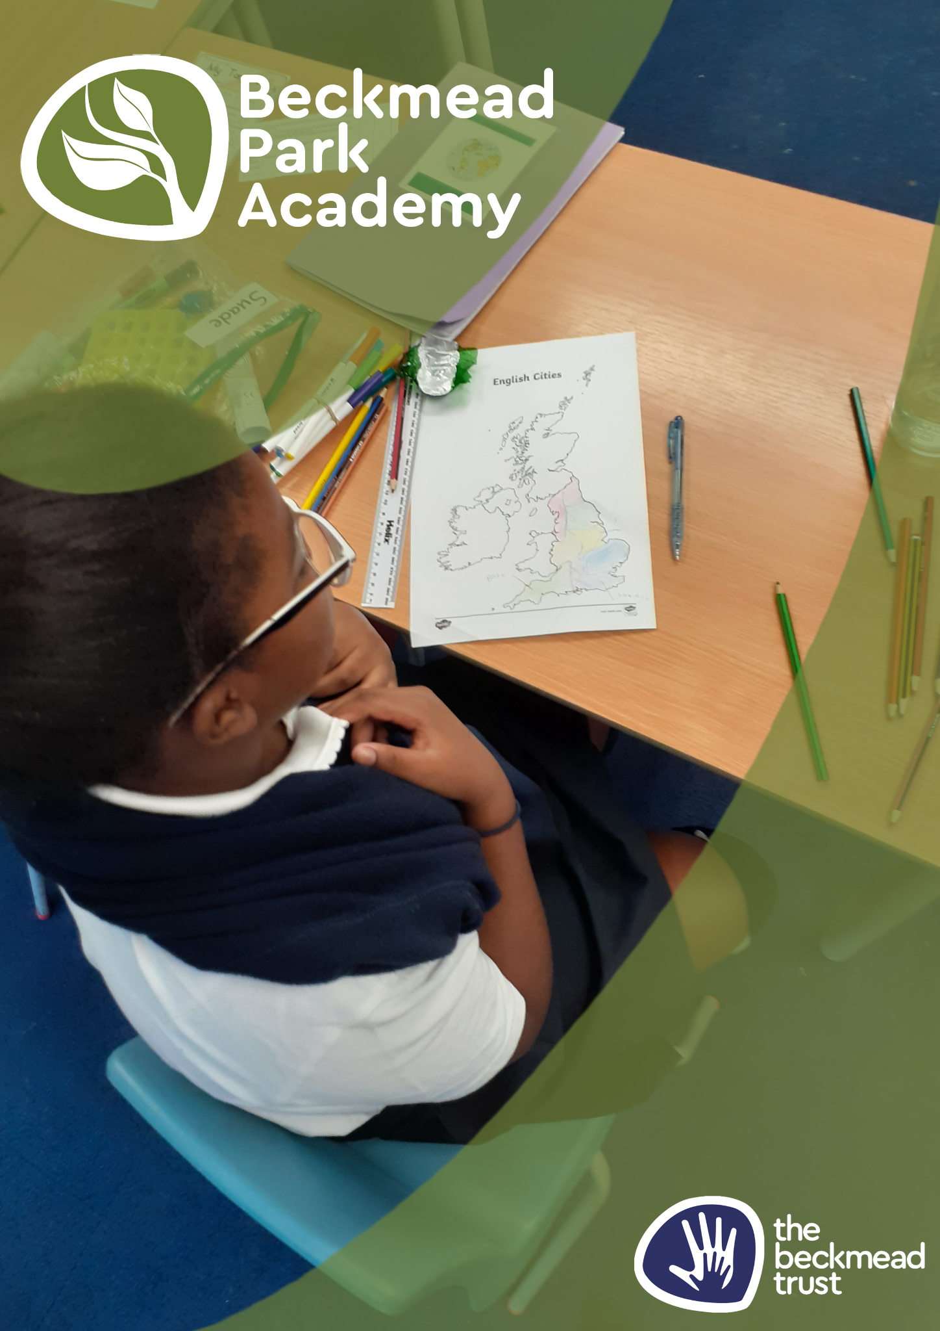
Accessibility Plan

Name of Policy | Accessibility Plan
Policy Level | Trust and school
Date of Issue | September 2025
Author | Samantha Hoyer
Date of Next Review | September 2026
Signature | Samantha Hoyer
Date of Signature | September 2025


Table of Contents
1. Aims 4
2. Legislation and guidance 4
3. Action plan 5
4. Monitoring arrangements 7
5. Links with other policies 7
Appendix 1: Accessibility audit 8

1. Aims

Schools are required under the Equality Act 2010 to have an accessibility plan. The purpose of the plan is to:
- Increase the extent to which disabled pupils can participate in the curriculum
- Improve the physical environment of the school to enable disabled pupils to take better advantage of education, benefits, facilities and services provided
- Improve the availability of accessible information to disabled pupils.
Our school aims to treat all its pupils fairly and with respect. This involves providing access and opportunities for all pupils without discrimination of any kind.
The plan will be made available online on the Trust website, and paper copies are available upon request.
Our school is also committed to ensuring staff are trained in equality issues with reference to the Equality Act 2010, including understanding disability issues.
The school supports any available partnerships to develop and implement the plan.
Our school’s complaints procedure covers the accessibility plan. If you have any concerns relating to accessibility in school, this procedure sets out the process for raising these concerns.
We have included a range of stakeholders in the development of this accessibility plan, including the Board of Trustees

2. Legislation and guidance

This document meets the requirements of schedule 10 of the Equality Act 2010 and the Department for Education (DfE) guidance for schools on the Equality Act 2010.
The Equality Act 2010 defines an individual as disabled if he or she has a physical or mental impairment that has a ‘substantial’ and ‘long-term’ adverse effect on his or her ability to undertake normal day to day activities.
Under the Special Educational Needs and Disability (SEND) Code of Practice, ‘long-term’ is defined as ‘a year or more’ and ‘substantial’ is defined as ‘more than minor or trivial’. The definition includes sensory impairments such as those affecting sight or hearing, and long-term health conditions such as asthma, diabetes, epilepsy and cancer.
Schools are required to make ‘reasonable adjustments’ for pupils with disabilities under the Equality Act 2010, to alleviate any substantial disadvantage that a disabled pupil faces in comparison with non-disabled pupils. This can include, for example, the provision of an auxiliary aid or adjustments to premises.
This plan complies with our funding agreement and articles of association.
3. Action plan

This action plan sets out the aims of our accessibility plan in accordance with the Equality Act 2010.
Aim | Current good practice | Objectives | Actions to be taken | Person responsible | Date to complete actions by | Success criteria
Increase access to the curriculum for pupils with a disability | All existing schools in our Trust offer a differentiated curriculum for all pupils.  We use resources in those schools tailored to the needs of pupils who require support to access the curriculum.  Curriculum resources include examples of people with disabilities.  Curriculum progress is tracked for all pupils, including those with a disability.  Targets are set effectively and are appropriate for pupils with additional needs.  The curriculum is reviewed to ensure it meets the needs of all pupils. | Work with curriculum leads in other Trust schools to understand scope and expectations of the Trust around curriculum intent, implementation and impact.  Work with other schools to procure a full range of resources to support our pupils.  Ensure that effective planning and assessment is in place to support the needs of individual pupils and their needs and to allow good levels of progression | Curriculum developed and audited with appointed teaching staff; costs of release time to be met where required  Procure all necessary resources to support needs within the school  Planning proformas and monitoring arrangements to be shared with all teaching staff  Ensure assessment system is fully installed and assessment cycle shared and implemented. | HT/Class Teachers  HT  HT/All teaching staff | Sept 2025  Sept 2025  Sept 2025  Dec 2025 | Monitoring and pupil feedback confirms all pupils are accessing teaching and learning  Monitoring ensures resources are in place and being used by staff/pupils  Planning proformas are completed successfully  Assessment data being collected and used for progression analysis
Improve and maintain access to the physical environment | The environment is adapted to the needs of pupils as required.  This includes:  - Ramps  - Elevators  - Corridor width  - Disabled parking bays  - Disabled toilets and changing facilities | Ensure maintenance of existing access  Communicate access arrangements as required | Update accessibility plan upon entry to both sites | HT/ESCC Building Maintenance/Beckmead Trust Facilities Manager | Sept 2025 | Pupils, staff and visitors are able to physically access the site
Improve the delivery of information to pupils with a disability | Our Trust uses a range of communication methods to ensure information is accessible. This includes:  - Internal signage  - Large print resources  - Pictorial or symbolic representations. | Check communication systems being used at other schools, adapt according to the needs of our pupils. | Visual timetables in all classrooms  Signage & labelling in place  Communicate in Print and other suitable software available to teaching staff  Requirements and recommendations of professional agencies for individual pupils are implemented | Sept 2024  HT/Class Teachers  HT/Trust IT Coordinator  HT/Class teachers | Class teachers  Sept 2025  Sept 2025  Sept 2025 | Monitoring – learning walks  ESCAL Communication Audit confirms best practice in place

4. Monitoring arrangements
This document will be reviewed every 3 years, but may be reviewed and updated more frequently if necessary.
It will be approved by the Board of Trustees.
At Beckmead Park Academy, the Plan will be reviewed by the Headteacher regularly and the objectives updated accordingly.

5. Links with other policies
This accessibility plan is linked to the following policies and documents:
- Risk assessment policy
- Health and safety policy
- Equality information and objectives (public sector equality duty) statement for publication
- Special educational needs (SEN) information report
- Supporting pupils with medical conditions policy
Appendix 1: Accessibility Audit: Monks Orchard Road site

Feature | Description | Actions to be taken | Person responsible | Date to complete actions by
Number of storeys | 2 floors | None | N/A | N/A
Corridor access | All corridors are accessible to all users | Ensure all corridors are kept clear | All staff | Ongoing
Lifts | 0 | None | N/A | N/A
Parking bays | All staff and visitors will park either onsite or off site via on street parking. | Advice given to visitors and staff | HT | Ongoing
Entrances | Entrance to the BPA Monks Orchard Site is via an external gate. This will be manned by staff in the morning to support pupil access; during the day it is accessible via telecom. There are no issues around wheelchair access into the site.  The school entrance is via a door with level access, allowing wheelchair users access as well. | Ensure all staff are aware of responsibilities around access onto school site | HT/All staff | Ongoing
Ramps | N/A | None | N/A | N/A
Toilets | 4 x pupil toilets (3 male, 1 female)  1 x Adult/disabled toilet | Ensure all toilets are clearly marked and accessible | HT | Sept 2025
Reception area | Reception area is a lobby, arranged in an ‘airlock’ system with inner door access controlled by electronic fob. | Ensure all staff have fob; ensure all protocols for entry and exit are communicated. | HT | Sept 2025
Internal signage | Signage will be installed as required | Quality assure all signage is in place | HT | Sept 2025
Emergency escape routes | Escape routes are all on the ground floor from reception and from classrooms, all on level access | Ensure all evacuation routes are suitably communicated and associated protocols are in place, available and shared as required. | HT/ESCC Building Maintenance and Support Service | Sept 2025
Appendix 2: Accessibility audit: Monks Orchard site

Feature | Description | Actions to be taken | Person responsible | Date to complete actions by
General | Due to the age of the buildings on site the environment will require | Detailed site audit to be undertaken by Headteacher and Facilities Manager to prepare a plan | Head Teacher  Facilities Mgr | As required
Number of storeys | Two - No lift | At present a lift is not available on site. First floor is not accessible to wheelchair users so alternative spaces and use of ground floor space will be adapted.  Facilities Manager to work with Executive Team and Head of School | Head Teacher  Facilities Mgr | As required
Corridor access | Due to the age of the building some corridors are narrower than the required 32 inches so would not facilitate wheelchair use | Route into the main building has been worked out for wheelchair users giving access to the gym, DDA toilet, food tech and teaching areas on the ground floor.  Audit access to other key areas to be reviewed.  SLT and caretaking team to ensure corridors and exits are kept clear at all times. Any issues to be reported to the Facilities Team asap. | Head Teacher  Facilities Mgr  School Caretaker | Ongoing
Lifts | N/A | No lift on site |  | -
Parking bays | 1 disabled bay in car park. On street parking available directly in front of the school site | Ensure disabled bay is  available in car park | School Caretaker | Ongoing
Entrances | Two main pedestrian entrances that are not wheelchair accessible due to width or the need of a ramp or subsequently narrow doorways and corridors to navigate.  Gates manned by staff in the morning to support pupils, or via intercom during the day.  Wheelchair access can also be via the double gate in the playground, the car park entrance, or main pedestrian gate | Caretaker & SLT to ensure access routes are maintained.  Communicate access arrangements that are required in advance  Review all entrances to ensure DDA compliance and access, the need for ramps and other access support required  Communicate access route for anyone with mobility issues | Facilities Manager/ Caretaker  Host/All Staff  Facilities Mgr  Facilities Mgr | Ongoing
Ramps | None | No ramps currently on site. Facilities Manager to investigate and seek advice to enable purchase of ones appropriate for the site. | Dee Fullerton | Sept 25
Toilets | 1 DDA/Adult toilet with changing and shower facilities | Located on the ground floor near the gym. Accessible from the main footpath via the gym or side entrance from the Food Tech Courtyard.  Yellow medical bin in place  Ensure all toilets are clearly marked | Host | Ongoing
Reception area | Small waiting area accessible via the main pedestrian path  Most external doors controlled by electronic fob | Reception waiting area will not accommodate a wheelchair due to door width. Arrangements will need to be made in advance to accommodate wheelchairs arriving on site so that a safe and comfortable waiting area is available.  Sign in screen installed at appropriate height for wheelchair users but not accessible by wheelchair users - alternative plan required ie ipad?. | Head Teacher  Assistant Headteacher | Sept 25
Internal signage | Some signage in place | Facilities Manager to audit the site to ensure appropriate signage is in place to cover a variety of additional needs. i.e. large print, pictorial or symbolic representations or audit, specialist recommended equipment according to the needs of pupils, staff and visitors. | Facilities Manager caretaker | Sept 25
Emergency escape routes | Many escape routes throughout the site in various locations | Escape routes checked daily by caretaker  Personal Emergency Evacuation Plans (PEEP) prepared as required. Audit planned Sept 25 by Facilities Manager share  All staff to be given induction including emergency exits and evacuation meeting point ad other protocols around emergencies | Headteacher | As required

