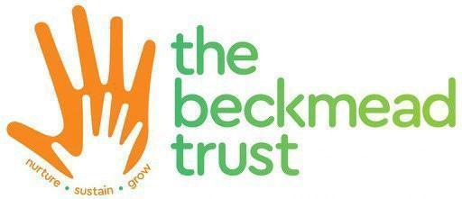

Roundwood School and Community Centre Governors

Full Name | Date of Appointment | Date  stepped down | Term of Office | Appointed by
Nicola Harmer | 1 Sept 2021 | 05/02/2025 | 4 years | Trust
Shirley Parks | 20 Sept 2022 | 6th Dec 2023 | 4 years | Trust
Nagla Salama | 29 Sept 2022 | N/A | 4 years | School
Elisabeth Sinclair | 1 Sept 2021 | 26/09/2024 | 4 years | Trust
Nataliya Kharina | 1 Sept 2021 | 27/11/2023 | 4 years | Trust
Serita Kwofie | 25 Jan 2024 | N/A | 4 years | Trust
Matthew Burrage | 04/09/2024 | N/A | 4 years | Trust
Patricia Neves | 25.02/2025 | N/A | 4 years | Trust
Mark Malcolm | 01/05/2025 | N/A | 4 years | Trust

