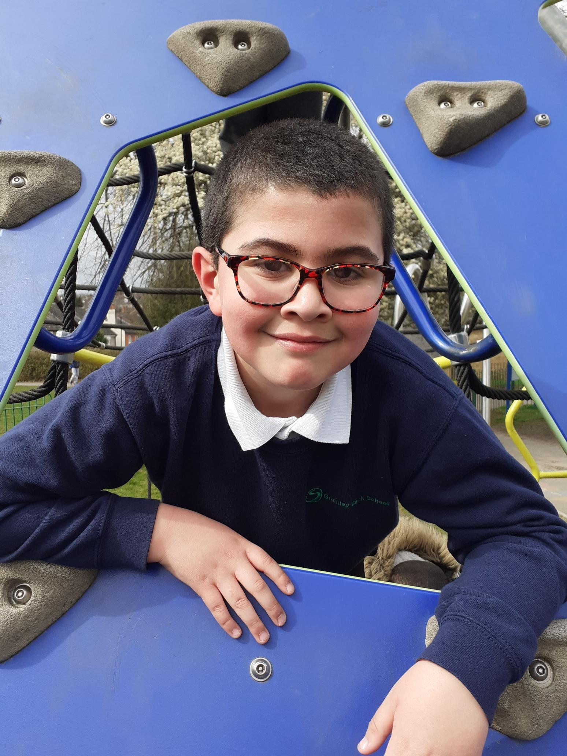

Approved on: | 26th February 2026
Approved by: | Trustees
Last reviewed on: | July 2026
Reviewed by: | Phil Edkins
Next review due by: | February 2027

Summary of Changes
[Use the table below to insert any changes made to the document since the last approval. Please delete text as appropriate]

Date | Updates | Page No.
July 2026 | Added school name | 3

Contents
Aims 1
The purpose of this policy is to: 1
What is bullying? 2
Forms of Bullying 2
Reasons for being a victim of bullying may include 3
Reasons for being a bully may include: 3
Early Signs of Distress 3
Strategies for Reducing and Eliminating Bullying 3
Constructing and maintaining an Anti-Bullying Ethos 4
How to Recognise the Difference Between Bullying and; Bossy / Boisterous 5
Investigating and Monitoring 6
Desired Outcome 6
Use of Mobile Phones, Social Media and Online Communication 6
Support for children 8
Evaluation and Review 8

Aims
At St. George’s House, we aim to provide a safe, welcoming and empathetic environment for all members of the school. This is dependent on maintaining high standards of behaviour, care, and control so that all students within The Beckmead Trust have the right to enjoy learning, free from intimidation, both inside and outside the classroom and within the surrounding community. Bullying deprives people of the right to progress and achieve their potential. Specifically, it deprives students of the right to an education within a safe, secure and positive environment. Our community will not tolerate any form of bullying.
We say NO to bullying – Reject it – Report it – Remove it.
Here at St. George’s, we regard bullying as very serious and always take firm action against it. We encourage children to work against it and to report any incidents of bullying.

The purpose of this policy is to:
• Prevent bullying from happening between children and young people who are a part of our organisation or take part in our activities
• Make sure bullying is stopped as soon as possible if it does happen, and that those involved receive the support they need
• Inform all staff, volunteers, children and their families about what we should all do to prevent and deal with bullying.
This policy statement applies to anyone working on behalf of The Beckmead Trust, including senior managers and the board of trustees, paid staff, volunteers, sessional workers, agency staff, and students.

What is bullying?
Bullying can be physical, verbal or emotional by a single person or a group of people. Incidents of bullying can include:
● Name calling
● Malicious gossip
● Damaging or stealing property
● Coercion into acts they do not wish to do
● Violence and assault
● Punching/kicking
● Jostling
● Teasing
● Intimidation
● Extortion
● Ostracising
● Damaging school work and equipment
The term ‘bullying’ has changed over time. The Department for Children, Schools and Families defines bullying as:
● Repetitive, wilful or persistent behaviour intended to cause harm, although one-off incidents can in some cases also be defined as bullying
● Intentionally harmful behaviour, carried out by an individual or a group
● An imbalance of power leaves the person bullied feeling defenceless.

The Anti-Bullying Alliance defines bullying as:
● Intentional, repetitive or persistent
● Hurting of one person by another, where the relationship involves an imbalance of power

Forms of Bullying
Bullying can take many forms and can be short-term or continuing over a longer period of time. It can be physical or verbal but can also be psychological, which is more subtle.
Research has suggested that there is a gender difference in how boys and girls bully their peers. This trend develops as pupils grow older. Boys are twice as likely as girls to use physical violence, whereas girls are three times more likely to use gossip and name-calling.

Reasons for being a victim of bullying may include
- Any difference, such as age, disability, gender reassignment, marriage and civil partnership, pregnancy and maternity, race, religion or belief, sex, and sexual orientation. These differences are classed as protected characteristics and fall under the Equality Act 2000
- Family composition/living arrangements
- New child in school
- A child with a family crisis
- They are likely to be children who are not assertive (timid), unlikely to fight back, loners with few friends, anxious or fearful, younger children, and those outside a group.

Reasons for being a bully may include:
● Victim of violence
● Enjoyment of power / creating fear
● Copying behaviour seen at home or on TV
● It occurs in children from all backgrounds, cultures, races, sexes, from nursery through to 6th Form/adult.

Early Signs of Distress
- Withdrawn
- Deterioration of work
- Spurious illness
- Isolation
- Desire to remain with adults
- Erratic attendance
- General unhappiness/anxiety/fear
- Late arrivals
- Bed-wetting and other signs are noted in our Special Educational Needs Policy

Strategies for Reducing and Eliminating Bullying
We firmly believe that prevention is better than cure, so we:
- Encourage the caring and nurturing side of children through positive behaviour management strategies
- Teach safety online and teach each child to be responsible for keeping others safe online. This work on cyberbullying ensures that it includes all devices and provides clear guidance on apps.
- All school devices are filtered using the LGFL systems.

- Work to a caring, co-operative ethos (such as through paired and group work, assemblies, Personal Social, Health & Citizenship Education curriculum).
- Discuss friendships and positive relationships regularly.
- Actively celebrate differences of all kinds regardless of Race, Religion or Belief, Gender or Gender Identity, Disability, Sexual Orientation or class.
- Ensure adequate supervision in the playground and training of all school staff on behaviour management (including the prevention of bullying).
- Positively encourage caring and actively discourage bullying.
- Buy in specialist support in the form of social skills groups, anger management and individual therapy for pupils.
- Regular class circle time, which is used to address bullying and explore issues of feelings /friendship / asking for help when needed.
- All staff are ready to deal with bullying incidents sensitively and responsively.
- Pupils are regularly reminded of our referral systems for bullying: self-referral (this is when a child is directly involved in an incident); peer referral (when a child has witnessed an incident but is not directly involved); parent/carer referral (when a parent raises a concern about bullying). We have clear referral routes for all pupils if they feel victimised.
- We actively follow up on incidents as this is crucial to pupils feeling confident that the school has taken the incident seriously and that action will be taken.

Constructing and maintaining an Anti-Bullying Ethos
The Beckmead Trust will endeavour to set positive role models in all relationships within the trust’s community.
All staff will regularly reiterate the message that bullying is unacceptable. Bullying will feature in the PSHE programme regularly.
Staff will refer to the unacceptable, negative impact of bullying during informal interactions with the pupils.

Advice for Parents / Carers:
Don’t give permission for bullying by saying:
- You must have done something to deserve it
- Go and hit him / her back
- Don’t be a wimp
- Boys will be boys
- It will sort itself out
- It is part of growing up
- Got to take it like a man
- Must learn to look after themselves
- Don’t tell tales

Procedure for Dealing with Bullying
- All complaints go to the Class Teacher before being reported to the SLT. Class teachers are best placed to have a deeper understanding of the situation and to investigate.
- Record all incidents and discussions with all children involved.
- Involve parents and explain the action taken, why it was taken, and what they can do to reinforce and support. Communicate reports to parents.
- Stress that watching and doing nothing is supporting (some children prefer this as an option).
- Be aware and directly tackle any language that is racist, sexist, anti-religious, homophobic or offensive on the grounds of disability.
- Give support to both the victim and the bully. The victim needs self-esteem and self-value, while the Bully needs to learn to work with others (co-operation rather than competition). Do not bully the bully; instead, find out why they are bullying.
- Reward non-aggressive behaviour.
- Follow up to support the victim and prevent reoccurrence (monitor closely).
- Make clear to parents the unacceptability of bullying, eg. no ‘hit him back’ attitude.
- Use peer group pressure, approbation and disapproval.
- Help children to see other points of view: “How would you feel if …?”

How to Recognise the Difference Between Bullying and; Bossy / Boisterous

Behaviour Bullying
- Is an imbalance of power - Focussed on younger, smaller and timid children increasingly relying on threat and force. Can be constant unkind comments or comments deliberately targeted to upset the victim
- Is an imbalance of power – is a group of children focussing on one or two possibly on younger, smaller and timid children increasingly relying on threat and force. Can be constant unkind comments or comments deliberately targeted to upset the victim
- Wilful, conscious desire to hurt, threaten and frighten.
- Play spoiling other children’s activities, showing violence and hostility.
- Rough intimidating behaviour

Bossiness / boisterous
- Bossing whoever is around at the time.
- Usually grows out of it as they mature and learn social skills.
- More natural and uncontrolled (not vindictive), high spirits, not unfriendly

Investigating and Monitoring
- All allegations of bullying will be investigated thoroughly and sensitively. If a teacher is unsure how to deal with a bullying incident, they will seek advice from more experienced staff or the SLT.
- An online allegation will involve an investigation of the whole interaction. To this end, the SLT will ask to see the whole “chat” etc to ascertain the entire picture and decide if the unkindness was equal
- Students will always be given feedback if they have made allegations of bullying.
- If allegations are made that a teacher is bullying a student, the Head of School must be informed and will then decide on the most appropriate course of action.
- All parties involved in any incident, including parents, will be kept informed at all stages in the investigation.
- Departmental managers/SLT are to monitor to ensure the bullying has not resumed.
- Persistent or violent bullying can lead to more serious disciplinary measures, including suspension or possible permanent exclusion.

Desired Outcome
Incidents of bullying will be pursued until the situation is resolved and all parties can return to the safe and caring environment that best supports effective teaching and learning.

Use of Mobile Phones, Social Media and Online Communication
In line with Keeping Children Safe in Education (KCSiE) and our safeguarding responsibilities, the school recognises that online activity forms part of pupils’ lived experience and that online behaviour can have a direct impact on safety, wellbeing and relationships in school.

Parental Responsibility for Devices and Access
Parents and carers are reminded that the decision to allow a child to use a mobile phone, mobile data or any web-enabled device (including devices accessing Wi-Fi) rests with the family.
Any device provided to a child remains the responsibility of the parent/carer, regardless of where or when it is used. This expectation reflects KCSiE guidance that safeguarding is a shared responsibility between school and home.
Parents are strongly encouraged to:
- Apply and regularly review parental controls and privacy settings on all devices (these can be found here: Apple , Android – Google, Samsung, One+, etc. – all phones not manufactured by Apple
- Supervise and monitor app use in an age- and developmentally appropriate way
- Talk regularly with their child about online behaviour, safety and reporting concerns

Age Restrictions and Safeguarding Expectations
Most social media and messaging apps that include a chat, messaging or direct communication function (for example Snapchat, WhatsApp, TikTok, Instagram and similar platforms) set a minimum user age of 13+.
In practice, this means that the earliest year group where pupils typically meet the minimum age requirement is Year 8.
In line with safeguarding guidance:
- Minimum age limits are set by the platform providers, not by the school
- Reaching the minimum age does not automatically mean a child is socially or emotionally ready
- Early or unsupervised access increases exposure to risks including bullying, coercion, grooming and harmful content
Parents are encouraged to follow guidance from NSPCC, which provides clear advice on online safety, parental controls and conversations with children, which can be found here

SEND Considerations
The school recognises that pupils with SEND needs may be at increased risk online, in line with KCSiE guidance.
This may include:
- Impulsivity, leading to rapid or emotionally driven responses
- Social communication differences, including difficulty interpreting tone, humour or intent
- Increased vulnerability to peer pressure, manipulation or online conflict
- Challenges with emotional regulation, which can escalate online interactions quickly
For these reasons, pupils with SEND needs may require:
- Later or more gradual access to social media
- Higher levels of adult supervision
- Explicit teaching around online behaviour, boundaries and repair of relationships
Decisions about access should be based on individual need rather than age alone.
Additional information can be found in the Digital Policy

School Response to Online Incidents
In accordance with KCSiE, the school will take action where online behaviour poses a safeguarding concern or impacts the wellbeing of pupils within the school community, even when incidents occur off-site.
To ensure concerns are handled fairly and proportionately:
- The school may request to view the full context of online communications, rather than isolated screenshots
- This allows staff to distinguish between bullying, peer conflict, and mutual unkind behaviour
Where incidents reflect conflict rather than bullying, the school will focus on:
- Restorative approaches
- Teaching safer online communication
- Supporting pupils to rebuild relationships and make better choices
Where behaviour meets the definition of bullying, safeguarding procedures and appropriate sanctions will be applied in line with school policy.

Support for children
We understand how difficult it is for children to talk about bullying, but we ensure that children can always identify an adult in the school they can speak to. We also show that helplines such as Childline can be contacted 24/7. Calls to 0800 1111 are free and confidential. Children can also contact Childline online.
Childline has lots of advice about different types of bullying and a tool to support children impacted by bullying.

Evaluation and Review
This policy will be reviewed regularly and reflect national advice and guidance.

