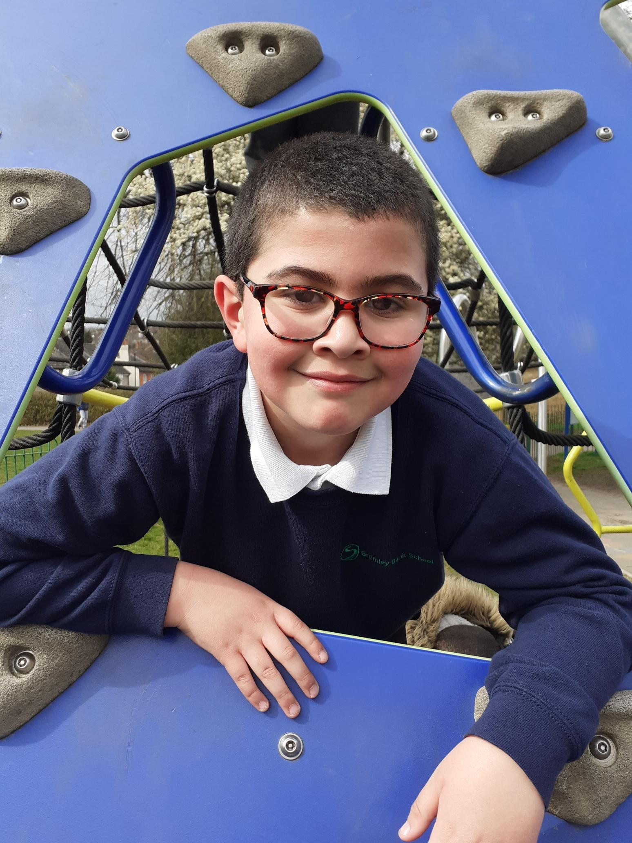

Approved on: | 26th February 2026
Approved by: | Trustees
Last reviewed on: | July 2026
Reviewed by: | Phil Edkins
Next review due by: | February 2027

Summary of Changes
[Use the table below to insert any changes made to the document since the last approval. Please delete text as appropriate]

Date | Updates | Page No.
July 2026 | Add front STGH Page and updated footer. | NA
July 2026 | Add Poster for STGH - uniform | Last
The Trust acknowledges that many of our pupils present with social, emotional and mental health needs and are neurodivergent, including autistic pupils and those with ADHD. For some learners, standard uniform expectations can create significant sensory, emotional, or regulatory barriers that impact their ability to feel safe, calm, and ready to learn. In recognition of this, each Trust school operates its own uniform policy, tailored to the needs of its pupil cohort and local community, while remaining aligned to shared Trust principles of inclusion, dignity, and safeguarding.
Uniform expectations are therefore applied with flexibility and compassion, and reasonable adjustments are routinely made to reduce anxiety, support emotional regulation, and promote positive engagement. This approach reflects our commitment to trauma-informed practice, equality of opportunity, and enabling all pupils to attend, participate, and succeed in school.
Many of our schools that don’t have a uniform have a dress code. Some dress codes are formal and some are casual. Organisations decide on the most appropriate code to reflect their image and purpose. People tend to behave differently and have a different attitude depending on what they wear and so, some items of clothing that are too casual are best left for personal time as it is not good to have an approach to work or learning that is too casual.
Spirit and Purpose
At Beckmead Trust, we operate a casual dress code for staff (see staff code of conduct), and each school adopts its own approach to student uniform, reflecting the needs of its community. We deliberately avoid strict or overly formal dress expectations. Instead, we provide clear guidance to support staff and students in making appropriate, respectful choices that promote safety, dignity, inclusion, and a calm learning environment focused on academic success.
Uniform and dress expectations are applied proportionately and flexibly, with reasonable adjustments made where required to support pupils with SEMH needs, autism, ADHD, sensory sensitivities, medical needs, or cultural and religious requirements.
Our Code
- Headwear may be worn indoors only where it is required for religious, cultural, medical, or agreed individual support reasons.
- Dangly jewellery should not be worn during practical lessons due to health and safety risks.
- Health and safety is a priority. Students should wear full-length T-shirts, tops, jumpers, or shirts to ensure compliance with safety requirements in subjects such as science, design and technology, and food preparation.
- Logos, images, or graphics must not be offensive or inappropriate, including swear words or references to illegal activities such as drugs or weapons.
- All bottoms (including trousers, joggers, and similar items) must be worn securely on the waist/hips.
- Shorts should be mid-length, such as football-style or knee-length shorts.
- Footwear:
  - In certain lessons, specific footwear is required due to health and safety regulations.
  - Open-toed shoes are not permitted for students or staff where they present a safety risk.
  - Generally, comfortable, flat, closed footwear is advised.
Where dress expectations present a barrier to learning, engagement, or emotional regulation, schools will work with students and families to agree appropriate adjustments that prioritise safety, inclusion, and readiness to learn.


