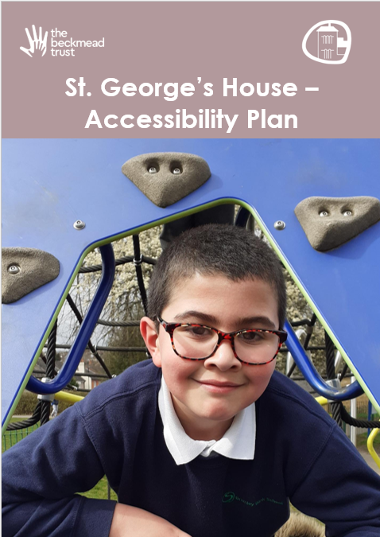

Approved on: | April 2026
Approved by: | Trustees
Last reviewed on: | July 2026
Reviewed by: | Phil Edkins
Next review due by: | April 2029

Summary of Changes
[Use the table below to insert any changes made to the document since the last approval. Please delete text as appropriate]

Date | Updates | Page No.
July 2026 | Added Front cover for STGH and edited Footnote | NA

Table of Contents
1. Aims 5
2. Legislation and guidance 5
3. Action plan Error! Bookmark not defined.
4. Monitoring arrangements 10
5. Links with other policies 10
Appendix 1: Accessibility audit Error! Bookmark not defined.

1. Aims
Schools are required under the Equality Act 2010 to have an accessibility plan. The purpose of the plan is to:
- Increase the extent to which disabled students can participate in the curriculum
- Improve the physical environment of the school to enable disabled students to take better advantage of education, benefits, facilities and services provided
- Improve the availability of accessible information to disabled students.
Our school aims to treat all its students fairly and with respect. This involves providing access and opportunities for all students without discrimination of any kind.
The plan will be made available online on the Trust website, and paper copies are available upon request.
Our school is also committed to ensuring staff are trained in equality issues with reference to the Equality Act 2010, including understanding disability issues.
The school supports any available partnerships to develop and implement the plan.
Our school’s complaints procedure covers the accessibility plan. If you have any concerns relating to accessibility in school, this procedure sets out the process for raising these concerns.
We have included a range of stakeholders in the development of this accessibility plan, including the Board of Trustees.

2. Legislation and guidance
This document meets the requirements of schedule 10 of the Equality Act 2010 and the Department for Education (DfE) guidance for schools on the Equality Act 2010.
The Equality Act 2010 defines an individual as disabled if he or she has a physical or mental impairment that has a ‘substantial’ and ‘long-term’ adverse effect on his or her ability to undertake normal day to day activities.
Under the Special Educational Needs and Disability (SEND) Code of Practice, ‘long-term’ is defined as ‘a year or more’ and ‘substantial’ is defined as ‘more than minor or trivial’. The definition includes sensory impairments such as those affecting sight or hearing, and long-term health conditions such as asthma, diabetes, epilepsy and cancer.
Schools are required to make ‘reasonable adjustments’ for students with disabilities under the Equality Act 2010, to alleviate any substantial disadvantage that a disabled student faces in comparison with non-disabled students. This can include, for example, the provision of an auxiliary aid or adjustments to premises.
This plan complies with our funding agreement and articles of association.

3. Action Plan
This action plan sets out the aims of our accessibility plan in accordance with the Equality Act 2010.
Aim | Current good practice | Objectives | Actions to be taken | Person responsible | Date to complete actions by | Success criteria
Increase access to the curriculum for students with a disability | All existing schools in our Trust offer a differentiated curriculum for all students.  We use resources in those schools tailored to the needs of students who require support to access the curriculum.  Curriculum resources include examples of people with disabilities.  Curriculum progress is tracked for all students, including those with a disability.  Targets are set effectively and are appropriate for students with additional needs.  The curriculum is reviewed to ensure it meets the needs of all students. | Work with curriculum leads in other Trust schools to understand scope and expectations of the Trust around curriculum intent, implementation and impact.  Work with other schools to procure full range of resources to support our students.  Ensure that effective planning and assessment is in place to support the needs of individual students and their needs and to allow good levels of progression | Curriculum developed and audited with appointed teaching staff; costs of release time to be met where required  Procure all necessary resources to support needs within the school  Planning proformas and monitoring arrangements to be shared with all teaching staff  Ensure assessment system is fully installed and assessment cycle shared and implemented. | HT/Class Teachers  HT  HT/All teaching staff | March 2026  March 2026  March 2026  March 2026 | Monitoring and student feedback confirms all students are accessing teaching and learning  Monitoring ensures resources are in place and being used by staff/students  Planning proformas are completed successfully  Assessment data being collected and used for progression analysis
Improve and maintain access to the physical environment | The environment is adapted to the needs of students as required.  This includes:  - Ramps  - Elevators  - Corridor width  - Disabled parking bays  - Disabled toilets and changing facilities | Ensure maintenance of existing access  Communicate access arrangements as required |  | HT/B&H Building Maintenance/Beckmead Trust Facilities Manager | March 2026 | Students, staff and visitors are able to physically access the site
Improve the delivery of information to students with a disability | Our Trust uses a range of communication methods to ensure information is accessible. This includes:  - Internal signage  - Large print resources  - Braille  - Induction loops  - Pictorial or symbolic representations. | Ensure that RA replicates and builds upon communication systems being used at other schools, according to needs of our students. | Visual timetables in all classrooms  Signage & labelling in place  Communicate in Print and other suitable software available to teaching staff  Requirements and recommendations of professional agencies for individual students are implemented | March 2026  March 2026  Sept 2026  March 2026 | Class teachers  HT/Class Teachers  HT/Trust IT lead  HT/Class teachers | Monitoring – learning walks

4. Monitoring arrangements
This document will be reviewed every 3 years, but may be reviewed and updated more frequently if necessary.
It will be approved by the school’s local management committee.

5. Links with other policies
This accessibility plan is linked to the following policies and documents:
- Risk assessment policy
- Health and safety policy
- Equality information and objectives (public sector equality duty) statement for publication
- Special educational needs (SEN) information report
- Supporting students with medical conditions policy

Appendix 1: Accessibility Audit – St. George’s House

Feature | Description | Actions to be taken | Person responsible | Date to complete actions by
Number of storeys | 2 storey | None | N/A | N/A
Corridor access | All corridors are accessible to all users | Ensure all corridors are kept clear | All staff | Ongoing
Lifts | N/A | None | N/A | N/A
Parking bays | Parking on site for 8 vehicles. | Signage in car park relating to owners’ risk, | HT | Ongoing
Entrances | Entrance to The St. George’s site is via an external gate(Maglock). This will be manned by staff in the morning to support student access; during the day it is accessible via telecom. There are no issues around wheelchair access into the site.  The school entrance is via a door with flat access, allowing wheelchair users access as well. | Ensure all staff are aware of responsibilities around access onto school site | HT/All staff | Ongoing
Ramps | N/A | None | N/A | N/A
Toilets | 2 x male toilets  1 x Adult/female only staff toilet  1x Female pupil only toilet | Ensure all toilets are clearly marked and accessible | HT | March 2026
Reception area | Reception area is a lobby, arranged in an ‘airlock’ system with inner door access controlled by electronic fob. | Ensure all staff have fob; ensure all protocols for entry and exit are communicated. | HT | March 2026
Internal signage | Signage will be installed as required | Quality assure all signage is in place | HT | March 2026
Emergency escape routes | There are 2 exits points on the ground floor – one to the rear sensory garden with access around to carpark and assembly point. One via the front entrance. Only the front entrance exit is wheelchair accessible. On the first floor there is on access to a fire escape – this locked door has automatic release in case of fire alarm activation or staff override – it exists to the rear of the building and joins the exit route of the ground floor exit. | Ensure all evacuation routes are suitably communicated and associated protocols are in place, available and shared as required. | HT/ESCC Building Maintenance and Support Service | March 2026

