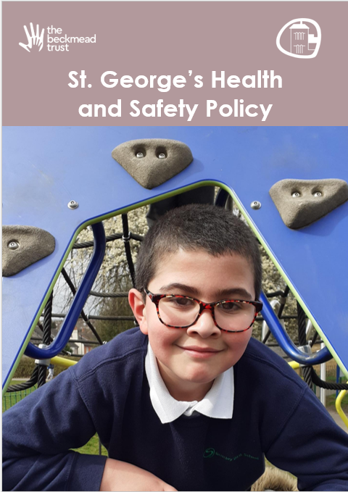

Approved on: | April 2026
Approved by: | Trustees
Last reviewed on: | July 2026
Reviewed by: | Phil Edkins
Next review due by: | April 2027

Summary of Changes
[Use the table below to insert any changes made to the document since the last approval. Please delete text as appropriate]

Date | Updates | Page No.
July 2026 | Added STGH front page and edited footer | NA

CONTENTS

PART 1: STATEMENT OF INTENT
PART 2: RESPONSIBILITIES FOR HEALTH AND SAFETY
- The Board of Trustees
- Central Trust Committee
- Regional Hub Committees (London, Croydon, East Sussex, Essex)
- Academy Principals / Headteachers
- Compliance Managers & Estates Representatives
- All Staff

PART 3: SAFE SYSTEMS OF WORK (SSOW) ARRANGEMENTS
- Communication
- Mental Health and Wellbeing
- Risk Assessment
- Health & Safety Training
- Violence & Aggression
- Contractors
- Asbestos Management
- Legionella and Water Hygiene
- Curriculum Health and Safety (Science, DT, PE)
- First Aid
- Fire Safety
- Accident and Incident Reporting (Online/RIDDOR)
- Manual Handling
- Display Screen Equipment (DSE)
- Lone Working
- COSHH (Control of Substances Hazardous to Health)
- Personal Protective Equipment (PPE)
- Electricity and Gas Safety
- Work Equipment (PUWER)
- Work at Height
- Smoking and Vaping
- Driving for Work
- Dogs in Academies
- Educational Visits and Off-site Activities
- Site Security and Emergency Planning
- Minibus Safety
- Clinical and Hazardous Waste

PART 4: MONITORING
- Internal Monitoring (Curriculum Sheets)
- Independent External Audits
- Training Records (National Collage)
- Policy Review

PART 1: STATEMENT OF INTENT
The CEO and the Board of Trustees of The Beckmead Trust acknowledges its legal and moral responsibilities as the primary Duty Holder to ensure, so far as is reasonably practicable, the health, safety, and welfare of its employees, students, contractors, and visitors.
To achieve our safety objectives, the Trust has transitioned to a Regional Hub Model. This model ensures that regional expertise is supported by a localised committee structure, allowing for high-level representation from every school while maintaining rigorous central governance and independent validation.
The Trust is committed to:
  - Regional Governance: Empowering the London, Croydon, East Sussex, and Essex Hubs to manage local H&S performance.
  - Compliance & Validation: Meeting all statutory provisions and subjecting our systems to annual independent external audits.
  - Risk Management: Utilising the hierarchy of risk control to provide safe premises, equipment, and systems of work.
  - Consultation: Engaging with staff and union representatives to foster a proactive safety culture.

Signed: (CEO) | Date: April 2026

PART 2: RESPONSIBILITIES FOR HEALTH AND SAFETY
- The Board of Trustees/CEO
The Board holds ultimate legal accountability. They ensure the H&S policy is effectively implemented, set the strategic direction, and allocate the necessary financial resources for Trust-wide compliance.

Central Trust Committee
The Central Trust Committee provides strategic oversight of the four regional hubs. It acts as the primary reporting link to the Board. It is responsible for reviewing termly hub data and managing the contract with the Independent H&S Auditing Firm.

Regional Hub Committees (London, Croydon, East Sussex, Essex)
Each hub manages the schools within its geographic region. The Hub Committee meets once per term and consists of:
  - H&S Professional (Technical Advisor, Policy review)
  - Member from the Central Directorate (Strategic Link, staff wellbeing)
  - SLT Member from a school (Operational Voice, Emergency Planning, educational visit)
  - Union Representative (Employee Relations)
  - Technical Representative (Curriculum Specialist)
  - Staff Representative (Front-line Feedback)
  - Compliance Representative (Statutory Data, minibus logs)
  - Estates Representative (Building Safety, Security)

Academy Principals / Headteachers
The Principal is the Academy Duty Holder. They are responsible for the day-to-day implementation of H&S procedures, ensuring the Curriculum Compliance sheets are accurate, and representing their school’s needs to the Hub Committee.

Compliance Directorate & Estates Directorate
These departments manage the "hard" compliance (Asbestos, Fire, Water, Gas, Electric) and ensure the site remains physically safe. They upload evidence to the central tracker for Hub review.

All Staff
Every employee must take reasonable care of themselves and others, follow the Safe Systems of Work detailed in Part 3, and report any defects or hazards immediately via the helpdesk.

PART 3: SAFE SYSTEMS OF WORK (SSOW) ARRANGEMENTS
- Communication: H&S information is cascaded via the Beckmead staff home page, staff inductions, and termly regional hub newsletters. Safety is a standing agenda item for all staff meetings.
This policy should be read in conjunction with the Trust’s Safeguarding Policy, Pets onsite Policy, Food Safety and Hygiene Policy, and First Aid Policy"

Mental Health and Wellbeing:
The Trust is committed to a proactive approach to staff and student mental health.
  - Stress Risk Assessment: The Trust utilises the HSE Management Standards to identify and mitigate organisational stressors (Demands, Control, Support, Relationships, Role, and Change).
  - Support Systems: Staff have access to confidential Employee Assistance through our HR department.
  - Workload: The Trust will monitor staff workload and "Work-Life Balance" as a standing item in health and safety committee meetings.
- Risk Assessment: Written risk assessments are required for all significant hazards. Principals must ensure they are reviewed annually or after an incident.
- Health & Safety Training: All staff must complete mandatory training (Fire, First Aid, Manual Handling) via the online system. Hub Committees monitor compliance targets of 95%+.
- Violence & Aggression: All incidents are logged and reviewed by the Hub Committee to identify if additional behavioral interventions are required.
- Contractors: All contractors are vetted (RAMS) and must sign in. High-risk activities require a formal "Permit to Work" issued by the Estates Department.
- Asbestos Management: Buildings built before 2000 have an Asbestos Management Plan (AMP)outlining procedures to manage risks from asbestos-containing materials(ACMs). No staff may drill or disturb any fabric of the building without consulting the AMP.
- Legionella and Water Hygiene: Sites undergo a professional risk assessment every 2 years. Monthly temperature checks and flushing are recorded in the site logbook.
- Curriculum Health and Safety: Science and DT must follow CLEAPSS guidelines. PE equipment is inspected annually by an external certified body.
- First Aid: Each site maintains a sufficient number of First Aiders and Pediatric First Aiders (where applicable). First aid kits and AEDs are checked monthly.
- Fire Safety: Each Academy must have a Fire Risk Assessment (FRA) reviewed annually. A minimum of three fire drills (one per term) must be conducted and logged.
- Accident and Incident Reporting: Accidents are recorded online. The Regional H&S Professional is responsible for submitting RIDDOR reports to the HSE.
- Manual Handling: Staff are trained to avoid lifting where possible. Handling aids (trolleys) are provided, and specific risk assessments are required for moving heavy loads.
- Display Screen Equipment (DSE): Office-based staff must complete a DSE self-assessment. The Trust provides ergonomic adjustments (chairs, risers) as required.
- Lone Working: Staff working outside normal hours must follow local check-in/out procedures. High-risk activities (e.g. working at height) are prohibited during lone working.
- COSHH: All hazardous substances are to be kept in dedicated secure storage cabinets with updated Material Safety Data Sheets (MSDS) held on site.
- Personal Protective Equipment (PPE): PPE is provided free of charge where risk cannot be eliminated. Staff must report damaged PPE to the Compliance Rep for replacement.
- Electricity and Gas Safety: Fixed wiring is tested every 5 years; PAT testing is annual. Gas appliances receive an annual safety certificate.
- Work Equipment (PUWER): All work equipment (lifts, machinery, ladders) is subject to a regular inspection regime and maintenance log.
- Work at Height: Ladders are for short-term use only. Any work over 2 meters requires a specific risk assessment and appropriate equipment (towers/scaffolding).
- Smoking and Vaping: All TBT sites are strictly non-smoking and non-vaping.
- Driving for Work: Staff using personal cars for work must provide evidence of business insurance and a valid MOT to the Hub Directorate member annually.
- Dogs in Academies: Therapy dogs are permitted only with written permission from the Academies Director and a specific risk assessment. All other dogs are prohibited.

Educational Visits and Off-site Activities:
The Trust acknowledges that learning outside the classroom is an essential part of the curriculum but carries distinct risks.
  - Educational Visits Coordinator (EVC): Each Academy must appoint a trained EVC to oversee all off-site trips.
  - Risk Assessment: A specific risk assessment must be completed for every trip and approved via EVOLVE. High-risk activities (e.g., water sports, residential) require Trust-level notification.
  - Competence: Staff leading trips must be suitably experienced and qualified.
  - First Aid: At least one qualified first aider and a fully stocked first aid kit must accompany every off-site visit.
  - Emergency Contacts: A 'Home Contact' must be designated for every trip to provide 24/7 support in the event of an incident.
  - The Trust ensures all Alternative Provision (AP) placements are subject to a robust health, safety, and safeguarding check prior to and during the placement, in line with DfE 2025 guidance

Site Security and Emergency Planning
Each Academy must maintain a site-specific Emergency Plan that covers more than just fire evacuation.
  - Access Control: All visitors must sign in via the electronic visitor system and wear a visible ID lanyard at all times.
  - Lockdown Procedures: Academies must have a "Lockdown" protocol for threats such as an intruder on site or a major environmental hazard nearby.
  - Invacuation: Procedures must be in place to move students from outdoor areas to the safety of the building quickly.
  - Testing: Lockdown and Invacuation drills must be conducted and recorded (reported to at least once per academic year as per the Martyn's law guidance in addition to standard fire drills.

Minibus Safety
Minibus Safety The safety of pupils and staff during transport is paramount.
  - Driver Qualification: No staff member may drive a Trust minibus unless they hold a valid license or have successfully completed MiDAS (Minibus Driver Awareness Scheme) training.
  - Vehicle Checks: Drivers must perform and record a pre-journey "walk-around" check (lights, tyres, fluid levels).
  - Supervision: Risk assessments must determine the appropriate staff-to-pupil ratio for journeys, considering the specific needs of the pupils involved.
  - Maintenance: Vehicles must undergo a professional safety inspection every 10–12 weeks, in addition to an annual MOT.

Clinical and Hazardous Waste
All Clinical and Hazardous Waste All hazardous waste must be managed to prevent infection or injury.
  - Segregation: Clinical waste (e.g., used dressings, bodily fluids) must be placed in yellow "clinical waste" bags and never in general waste bins.
  - Sharps: Needle-stick/sharp items must be disposed of in approved yellow "Sharps Boxes," which are kept out of reach of pupils.
  - Collection: Disposal must only be carried out by a licensed waste contractor, and "Consignment Notes" must be retained for at least three years as proof of legal disposal.

Playground and Outdoor Safety
Outdoor play equipment is inspected daily by site staff and annually by a specialist external body and be certified

PART 4: MONITORING
- Internal Monitoring
Curriculum H&S performance is monitored using the TBT Curriculum Sheet. Results are presented termly to the Hub Committee and analysed for regional trends.

Independent External Audits
To ensure unbiased oversight, an Independent H&S Firm (RPA) will conduct an annual audit of each Regional Hub. They will verify compliance, audit closure rates, and the effectiveness of Hub Committee governance. Findings are reported directly to the Central Trust Committee and the Board of Trustees.

Training Records
The Compliance Directorate maintains records of all training. The national college system alerts managers when refresher training is due. Hub Committees review training to ensure no region falls behind on statutory training.
- Policy Review This policy will be reviewed annually in March by the Board of Trustees. However, an interim review will be triggered immediately following:
  - Any significant change in health and safety legislation or Department for Education (DfE) guidance.
  - A "RIDDOR" reportable accident or a "near miss" of a serious nature.
  - Any significant change in the Trust’s organizational structure or the nature of its operations.
  - Findings from an internal or external audit that indicate a fundamental failure in current policy.

Appendix 1: Health & Safety Organisational & Reporting Chart
This chart outlines the reporting lines and accountability structure under the Hub Model. It ensures that every school has a direct voice via their Regional Hub, while the Board of Trustees maintains ultimate strategic oversight through the Central Trust Committee and independent validation.

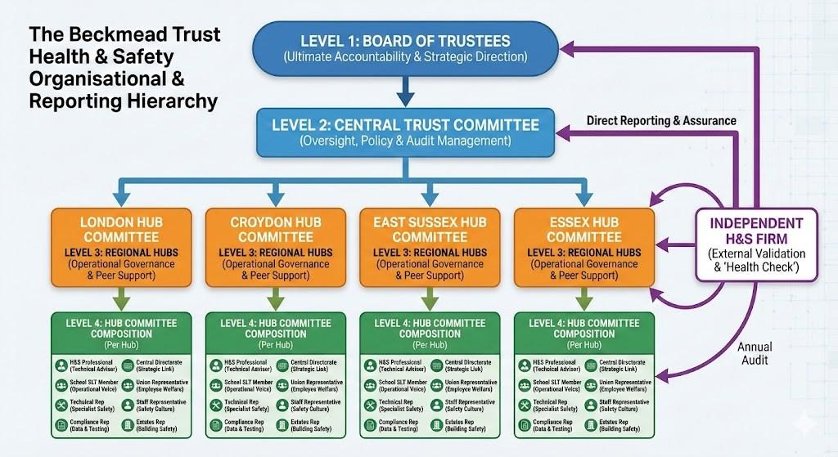

Level 1: Board of Trustees
  - Accountability: Ultimate legal responsibility for Trust-wide H&S compliance.
  - Function: Reviews strategic H&S performance and ensures adequate resource allocation based on reports from the Central Trust Committee.

Level 2: Central Trust Committee
  - Accountability: Strategic management of H&S across the Trust.
  - Function: Receives and synthesises termly reports from the four Regional Hubs. Directly manages the relationship and findings of the Independent H&S Auditing Firm.

Level 3: Regional Hubs (London, Croydon, East Sussex, Essex)
  - Accountability: Regional operational governance and compliance monitoring.
  - Function: Acts as the primary forum for joint employer/employee safety consultation for the schools within that specific geographic region.

Level 4: Hub Committee Composition (Per Hub)

Representative | Core Responsibility
Health & Safety Professional | Technical guidance, legislative updates, and RIDDOR oversight. Policy Reviews
Central Directorate Member | Alignment with Trust-wide strategic objectives and central funding.
SLT Member (from school) | Operational leadership and implementation of safety on the ground.
Union Representative | Employee welfare and formal consultation on safety matters.
Technical Representative | Subject-specific safety (e.g., Science, PE, DT, Forest School).

Staff Representative | On-the-ground feedback and promotion of a safety-first culture.
Compliance Representative | Monitoring statutory testing, minibus logs (Fire, Water, Asbestos, Electric).
Estates Representative | Managing physical site safety, maintenance, and contractors.
Each of the four Hubs is governed by a committee made up of representatives from the schools in that region. This ensures a 360-degree view of safety:

Independent Assurance
  - Independent H&S Firm: Conducts annual external audits of each Regional Hub.
  - Reporting Line: Reports findings directly to the Central Trust Committee and the Board of Trustees to provide unbiased validation that the Hub Model is operating effectively.

